Team 2

goCart

Team Members

Apil Parajuli

Abit Mahato

Bibek Shah

Bibek Maharjan

Pratish Joshi

Contents

01) Project Planning

Project Charter

Team Contract

02 Planning Phase

Belbin Analysis

Individual Belbin analysis

Team Belbin Analysis

Skill Audit

Individual Skill Audit

Skill Audit

Individual Skill Audit

Team Skill Audit

MS Project

Gantt Chart

Task Sheet

Resource Sheet

Calendar

Change Working Time

Timeline

Meeting Minutes **Error! Bookmark not defined.**

Communication Tools Used

Discord

Gdrive

Gmail

02) Product Designing

Entity Relationship Diagram

ERD

Composite ERD

Logical ERD

Use Case Diagram

Overview Use Case Diagram

Customer Use Case Diagram

Trader Use Case Diagram

Admin Use Case Diagram

Requirement Catalogue

Functional Requirements

Non Functional Requirements

Website Logo

Wireframe

Customer wireframes

Trader Wireframes

03) Product Development

Screenshots

User (php)

Trader (PHP)

Trader (Oracle)

Admin (PHP)

Admin (Oracle)

04) Product Testing

User Interface (PHP)

Register

Login

Shop

Product Description

Cart

Evaluation:

Trader Interface (PHP)

Register/Login

Shop

Product

Profile

Evaluation:

Trader Dashboard (Oracle)

Login

Trader Dashboard

Report

Products and stocks

Evaluation

Admin Interface (PHP)

Evaluation:

Admin Dashboard (Oracle)

Evaluation-106

**Project Charter**

|  |
| --- |
| Project Title: goCart  Project Manager: Rohit Raj Pandey  Sponsor: The British College Customer: Citizens of Cleckhuddersfax |

**Version Control**

|  |  |  |
| --- | --- | --- |
| Version | Date | Summary of changes |
| 1 | 05/02/2021 | Initial Project Plan |
|  |  |  |

**Project Justification**

|  |
| --- |
| ‘goCart’ is an e-commerce website that assures the availability of different local traders along with their products in a single platform. People nowadays find it difficult to manage their time, so ‘goCart’ can assist them in shopping for their necessities during their busy work schedule. With just a few multiple clicks, they will be able to shop during their busy work schedule from their local and trusted sellers with a fast, safe, and convenient method.  ‘goCart’ will be equipped with a web interface where traders can manage their shop and product information with their login credentials through the portal. All items will have a unique ID that will be affiliated with a trader which will be consisting of a short name, description, an item price, quantity per item, stock available, minimum order, and maximum order. Traders can also access the database regularly to view reports on orders, stock levels, and other details. Traders will be provided with a unique username that only gives them access to their respective account information and to update it as per their need. Any of the trader's accounts can be accessed via admin login.  Customers will be able to browse items by product type or shop as they prefer. All the products will have their unique id and trader’s name, so it will be easy for the customers who would like to make their purchase from a particular trader. Customers will also have something new to experience as they will be shifting from old traditional ways of shopping to online shopping where customer’s goods are delivered to the provided addresses instead. ‘goCart’ will be viewable on all types of devices ranging from computers, laptops to mobile phones and tabs. Customers can add different products from different traders in a single cart and make their payments as a whole. Before placing an order, users must be registered into the system. Users who are registered will have access to place an order, account information and will be able to check and update it as per their desire. Registration and account changes should ideally be verified through email contact. If users are not registered in our system, they will be unable to access their order cart. Hence, making them unable to proceed with further procedures. At last, we will be using PayPal as our primary way to make payments which will help customers to pay online.  Customer's and trader's working hours tally most of the time. Traders cannot increase opening hours  without losing out on family life and it is hard for customers to go to the market to buy their stuff after a long and tense day. So for the betterment of the customers along with the traders ‘goCart’ intends to save their valuable time so that they can use it somewhere fruitful. Customers need not visit different shops physically as they will be exploring all the products and purchasing them online. With just some clicks, they will be saving their time along with avoiding the crowds. Traders will also have great relief from checking the stock levels frequently in their stores as comparing to the automatically generated reports via the website. Traders will not have a limited opening hour which will smoothly grow their business. |

**Project Scope**

|  |
| --- |
| SMART GOALS  Major Objectives:     * To create an e-commerce website that includes several local stores of Cleckhuddersfax having distinct product lines. By exposing our website to audiences of different age groups, our website will gradually increase trader’s profit by having a huge amount of sales with a reduced amount of effort, saving time. * Trader Interface Benefit   + Traders can manage their products and information on their shops using their respective trader’s account.  + Traders can view reports on multiple categories.     * Management Interface Benefit   + Traders will be provided with daily, weekly, monthly reports via Dashboard on different categories.   * User-Friendly Website for Customer’s and Trader’s   + Attracts more audiences  + More Revenue   * Data and Transaction   + Analysis and Evaluation of the Report and Record  Time:  Start Date: 05/02/2021  Work in Progress: 06/09/2021   End Date: 07/02/2021 |

|  |
| --- |
| Customer Interface:   * Responsive website consisting of simple navigation features. * Product lines and products are unique within the traders. * Registration and login system for customers. * Customers must be registered to buy the products. * Cart function to place the order for logged-in users. * Customers can review and update their account details. * Customers can collect their products in a different timeline. * Payment through the credit card system to be considered, including PayPal.   Trader Interface:  - An admin login system to access trader’s account  - A proper web interface to manage products and view reports  - An admin login that can access any of the trader accounts / whole systems  Management Interface:   * A management dashboard for traders to access daily and periodic reports. * Traders will be able to run the report on the orders placed for their goods. * Reports can be organized using several formats. |

**Team Contract**

**Duration**

|  |
| --- |
| Start Date: 05/02/2021 Work in Progress: 06/09/2021  Final Presentation: 07/02/2021  Team Portfolio: 07/12/2021 |

**Estimated Budget**

|  |  |  |  |
| --- | --- | --- | --- |
| Name | Working Day | Working Hour | Total Working Hour |
| Pratish Joshi | 4 | 10 | (10 hour * 10 weeks) = 100 |
| Bibek Maharjan | 4 | 9 | (9 hour * 10 weeks) = 90 |
| Apil Parajuli | 4 | 9 | (9 hour * 10 weeks) = 90 |
| Abit Mahato | 4 | 9 | (9 hour * 10 weeks) = 90 |
| Bibek Shah | 4 | 9 | (9 hour * 10 weeks) = 90 |

**Roles and Responsibilities**

|  |  |
| --- | --- |
| Name | Role |
| Pratish Joshi | Primary Role (Co-ordinator), Secondary Role (Specialist), Least Likely Role (Completer Finisher) |
| Bibek Maharjan | Primary Role (Resource Investigator), Secondary Role (Plant), Least Likely Role (Completer Finisher) |
| Apil Parajuli | Primary Role (Shaper), Secondary Role (Implementer), Least Likely Role (Monitor Evaluator) |
| Abit Mahato | Primary Role (Monitor Evaluator), Secondary Role (Completer Finisher), Least Likely Role (Specialist) |
| Bibek Shah | Primary Role (Team Worker), Secondary Role (Plant), Least Likely Role (Co-ordinator) |

This is a team contract of Group 5 to develop an e-commerce prototype website. This team contract is used to ensure that the team members will be held accountable for any consequences, setbacks or mistakes. This contract also shows how the team functions and what sort of actions the team will take in securing the completion of the project.

Project Team Name: goCart

Project Team Name: goCart

|  |  |  |  |
| --- | --- | --- | --- |
|  | Team Member Name | Email | Phone |
| 1 | Pratish Joshi | joshipratish997@gmail.com | 9860802472 |
| 2 | Bibek Maharjan | bibekmaharjan65@gmail.com | 9860722698 |
| 3 | Apil Parajuli | parajuliapil7@gmail.com | 9861331622 |
| 4 | Abit Mahato | abitmahato712@gmail.com | 9808079576 |
| 5 | Bibek Shah | shahbibek17@gmail.com | 9810473791 |

A. Team Structure:

1. Leadership structure:

- Team leadership will be handled by a particular individual throughout the project so that we can have single individual who can make logical decisions that can be worked throughout the whole project.

- Pratish Joshi will be responsible for the proper leadership of the team because of his ability to take charge and properly lead the team.

2. Decision-making policy:

- The decisions will be made primarily using consensus.

- If every team member cannot agree on a particular topic a voting system will take place.

3. Who is the team Recorder/Documentation Manager/Maintainer of team activity?

- The person responsible for recording, managing the documentation and maintaining team activities will be done by Pratish Joshi.

4. Day, time, and place for regular team meetings:

- There will be formal meetings 3 days a week.

- We will be holding team meetings on Wednesday 4:30pm - 6:00pm, Thursday 4:30pm - 6:00pm and Friday 4:30pm - 6:00pm.

- Meetings and Daily Discussions will take place in Discord.

- Link: <https://discord.gg/FbjjtnDeFk>

5. Usual method of communication:

- Discord will be used as the usual method of communication.

- Google Drive will be used to share documents and files.

B. Team Procedures:

1. Method for setting and following meeting agendas:

- The meeting agendas will be set by our team leader.

- Team leader will be taking full responsibility and making sure that the team is following the meeting agendas during the team meeting.

- All the team members will be notified about the team meeting ahead of the time using Gmail and Discord.

2. Method of record keeping:

- Recording and Spreading of the information will be assigned to Pratish Joshi.

- All the Agendas and Actions will be distributed through Google Drive, Discord that are accessible by every team member.

3. Procedures in the absence of a team member:

- The team meeting will not commence if two or more team members are absent. Hence, the meeting will be postponed until further notice.

C. Team Participation:

6. Strategies to ensure cooperation and equal distribution of tasks:

- Team members will get the chance to select the tasks they would like to perform in an allocated time.

- Team members can help each other if they get any issues while performing their tasks and can help other members if someone finishes their tasks before deadlines.

- Members will be asked to provide a rough weekly report.

7. Strategies for encouraging/including ideas from all team members:

- Every team member can share their ideas and opinions in the meetings and can raise voice if they have any confusion.

- Decisions will be taken in the favor of all team members either by consensus or voting.

8. Strategies for keeping on task:

- The team leader will check the work done by everyone at the end of the week.

- In every meeting, deadline of the tasks will be reminded.

D. Personal Accountability:

1. Expected individual attendance, punctuality, and participation at all team meetings:

- Team members should have at least 80% of attendance.

- Interruption is only allowed after the member who is speaking finished his/her statement so that every member will be able to share his/her views.

- Team members will be penalized if any members are to join the meeting late.

- Every team member should actively participate in each and every meeting.

2. Expected level of responsibility for fulfilling team assignments, timelines, and deadlines:

- We will have our initial deadline two weeks before the actual deadline so that we can finish our assignments prior to the final deadline.

- Every member from the team is expected to guide and help each other if required.

- Every member should finish their assigned task within the given time period.

3. Expected level of communication with other team members:

- If any member faces difficulties while doing the task then he/she can ask for the help from other team members.

- If there is any urgent concern then every member from the group should be notified.

- Team members are expected to communicate with each other via discord.

- Team meetings will be conducted on the discord server and every member should join the meeting room, ten minutes prior to issued meeting time.

4. Expected level of commitment to team decisions and tasks.

- Team decision will be only finalized after every member from the team agrees to the decision. Each member will commit equally to the team’s decision so that none of the team members are given more importance than other.

- If contribution of any member is not seen or violates the contract then after week 6, that member will not be contributing to the project anymore.

E. Consequences of breach of contract:

Consequences will be based upon how a team or a certain individual performs. In order to ensure the proper work by honoring the contract, everybody's full commitment is a must. For every consequence a strike program is implemented for maintaining a consistent and proper flow of the work.

Due to various reasons strikes may be given:

- Low commitment, misconduct or dishonest work presented during assigned tasks.

- Not attending meetings, not performing the task on given time without notifying the team members or the instructor.

F. Certification by team members:

In appending your signatures below, you are stating that:

a) You participated in formulating the standards, roles, and procedures of this contract.

b) You have agreed to abide by these terms and conditions of this contract.

c) You understand that you will be subject to the consequences specified above and may be subject to reduction in overall grade in the event that you do not fulfil the terms of this contract.

|  |  |  |  |
| --- | --- | --- | --- |
| Name | Pratish Joshi |  |  |
| Signature | https://lh3.googleusercontent.com/gjjs1zC5FNaVFaIXiwDay0Ptifvk_zqpxD9Wb-oUQnqz1o4h5ZdS3rtwK3iNFnWLq2aDYJB2aH_GBMiNZgVQ84qidzsm7YcovFM3fpxCKTBef2Ev1U8TBdBBjKDbBKiBu7IRm-rR | Date | 05/05/2021 |
| Name | Bibek Maharjan |  |  |
| Signature | https://lh4.googleusercontent.com/ljqRsfAfWymLlh4bvmqKHw9Ar6UMD1LJnpdN9X8qh6kVFPgrni2HhJBst8EhItaiEO9z8snj6-FL4Q9NyHqh_dohRVTo4A3St-qBm6ezzkK5WjLr0N8RIbUYj-fkHG9tXP4wPW7H | Date | 05/05/2021 |
| Name | Apil Parajuli |  | |
| Signature | https://lh6.googleusercontent.com/ZHaCN9ZcTizUMa3T_O8f8sYKAdMtLvuPmYtF3dHerKyWNwLVde-F5jdmbZ0WTx6XRA0e7d2HHxZadOoD2iBFgzXqNdwyMWDABrqAeoMPh-rhTKbXiUG_VKxURXn-qhE42AYpeO_N | Date | 05/05/2021 |
| Name | Abit Mahato |  |  |
| Signature | https://lh3.googleusercontent.com/mOTKHgB-it-7iwK49c4Gr5yQNCU5kX4KuyO71E6FzsQanfoHfufFGe9GO-fqdxqmQvzRsJzlK1juVGSVKhgYd5gnMILrKewI3ioBON2bz0UPl5qb93XrYrFQR_QjhvT9ZVucDK5r | Date | 05/05/2021 |
| Name | Bibek Shah |  |  |
| Signature | https://lh3.googleusercontent.com/mzQ2IBQ4kai8-Ohsat-Jup9yzQnDM6P_ASyCPZq62DWcmc7bkRkgQXNDwzdReZwBn0ff7AB250uOfHx0rj_jYJ7E6coQY4zIo03yaxt3TC2R1ec5EAFjKxJ6zuy8V_hcwURPMH0h | Date | 05/05/2021 |

G. Acceptance of contract by tutor:

|  |  |  |  |
| --- | --- | --- | --- |
| Name | Rohit Raj Pandey | Date |  |
| Signature |  |

02) Planning Phase

**Belbin Analysis**

**Individual**

|  |  |  |
| --- | --- | --- |
| Version:1.0 **Belbin’s Analysis** Date reviewed:30/6/2021 | | |
| Primary role |  | Monitor Evaluator |
| Secondary role |  | Completer Finisher |
| Least likely role |  | Specialist |

**Abit Kumar Mahato**

|  |  |  |
| --- | --- | --- |
| Do you think the descriptions of these roles are an accurate description of your behaviour in teams? How do you see yourself differently? |  | My Primary role in the team is as Monitor Evaluator who can analyse problems,can give logical ideas and suggestions to enhance the project,can make better judgements when required.So, I think the descriptions of these roles are an accurate description of my behaviour in my team.  I see myself differently as I have best co-ordination with my team members and can give more ideas. |
| Are there roles identified by Belbin that you might like to develop in yourself more? Which ones and why? |  | Yes I would like to develop the role of Resource investigator in my self because it will help me to explore varities of resources for the project and I can come up with best resources and ideas for project development. |
| What possible situations in the coming months can you identify where you could work on developing these skills? |  | This is a group project so, we will be sharing our ideas,problems and solutions to each other which will help me to know learn more and execute my role in team in better way and also getting ideas about how to perform other roles to from my teammates. |
| Considering your team working, how do you think you could improve your effectiveness in group work and in contributing to the success of teams that you work in? |  | I can improve my effectiveness in group work by completing the tasks on time and sharing and learning ideas from my teammates along with helping my teammates and asking them mto help me too when required. |
| Are the results of this inventory consistent with how you worked in the Foundation Project in your small groups for discussions and presentations? |  | No, the results were not good and excepted  In the foundation project in our small groups for discussions and presentations.So more hard work and team co-ordinations is required for the project. |
| How well do you want to contribute to group presentations? |  | I want to be more confident for the presentation and give ideas to make the presentation clean,knowledgeful and to finish presenting on the given time period. |

Team Belbin Analysis

|  |  |  |
| --- | --- | --- |
| Version:1.0 **Belbin’s Analysis** Date reviewed:2/27/2020 | | |
| Primary role | Apil Parajuli | Shaper |
| Bibek Maharjan | Resource Investigator |
| Pratish Joshi | Co-ordinator |
| Abit Mahato | Monitor Evaluator |
| Bibek Shah | Team Worker |
| Secondary role | Apil Parajuli | Implementer |
| Bibek Maharjan | Plant |
| Pratish Joshi | Specialist |
| Abit Mahato | Complete Finisher |
| Bibek Shah | Plant |
| Least likely role | Apil Parajuli | Monitor Evaluator |
| Bibek Maharjan | Complete Finisher |
| Pratish Joshi | Complete Finisher |
| Abit Mahato | Specialist |
| Bibek Shah | Co - Ordinator |
| Do you think the descriptions of these roles are an accurate description of your behavior in teams? How do you see yourself differently? | Apil Parajuli | My key role in the team is Shaper who can work under pressure, imaginative, bring quick ideas and solve difficult problems when team members cannot. As I am looking after front-end development and documentaion I must be creative and imaginative. So, I think I fit in role of “Shaper”.  I believe I can work great under pressure for front end problems |
| Bibek Maharjan | My key role in the team is Resource Investigator who are innovative and curious. As I am creative person and love to explore many options, find ideas and develop as many as contact to help my team to meet our objectives. As I am looking after front end and backend process so for that I need to do a lot of research, explore many ideas that’s I think I fit in role of “Resource Investigator”. |
| Pratish Joshi | Yes, the descriptions of these roles provided above are accurate. I will be guiding our team towards our primary objective and will be assigning tasks as per their strengths.  I am different because I can make rational decisions based on logic. Furthermore, I can help my teammates focus onto our primary goal with a clear picture of what to do next. |
| Abit Mahato | My Primary role in the team is as Monitor Evaluator who can analyse problems,can give logical ideas and suggestions to enhance the project,can make better judgements when required.So, I think the descriptions of these roles are an accurate description of my behaviour in my team.  I see myself differently as I have best co-ordination with my team members and can give more ideas |
| Bibek Shah | Yes,the description of the roles is accurate as I will guide the team in what they excel to reach our obejective in a smoother way.I see myself differently as I will check the task daily and recognize the value of each team member to bring on the table. |
| Are there roles identified by Belbin that you might like to develop in yourself more? Which ones and why? | Apil Parajuli | Yes, I would like improve as Monitor Evaluator as I believe it provides logical eye for making certain unbiased decisions and help in further team improvement and project. |
| Bibek Maharjan | Yes, I would like improve as complete finisher as they ensure that there have been no any errors in the project plus they pay attention to the smallest details. They are all-rounder in project can work in any fields and help their teammates to accomplish the task and make sure that job is completed on given time. |
| Pratish Joshi | Yes, I would like to improve as a Co-Ordinator as I believe a good leader is someone that can bring out the best within their teammates while having a plan to achieve the goal |
| Abit Mahato | Yes I would like to develop the role of Resource investigator in my self because it will help me to explore varities of resources for the project and I can come up with best resources and ideas for project development. |
| Bibek Shah | I like to improve on the specialist.It not only makes me better but also my level of confidence increases by helping the team in checking the team work and helping in documentation. |
| What possible situations in the coming months can you identify where you could work on developing these skills? | Apil Parajuli | I believe I got a good amount of experience working as the “Shaper” Role. I believe I can enrich my skills more on working on tough time and conditions and provide a helping hand to my team. |
| Bibek Maharjan | I believed that I have received a good amount of working experience as a “Resource Investigator”. I believe that I can enrich my skills more by finding necessary information required for a decision and being very good at networking with other teams from which I can help my teammates. |
| Pratish Joshi | I believe I received a good amount of experience working as the “Co-Ordinator”. I believe I can enrich my skills more by having a steady and planned approach towards our project with the help of my teammates. |
| Abit Mahato | This is a group project so, we will be sharing our ideas,problems and solutions to each other which will help me to know learn more and execute my role in team in better way and also getting ideas about how to perform other roles to from my teammates. |
| Bibek Shah | Since,there will be meetings of each member and listening to problems and creating solutions will gradually build my skills on specialist and complete finisher. |
| Considering your team working, how do you think you could improve your effectiveness in group work and in contributing to the success of teams that you work in? | Apil Parajuli | As I am a good team player I can easily get well with my team and have capacity to maintain professional work environment for the team. As being front-end developer of the team, I can show my versatility on making unique UIs and pages which will contribute my team further for the successful completion of the project. |
| Bibek Maharjan | As I am a good team player I can easily get well with my team and I also have a professional working behaviour with my team mates. As I am working on front end and backend part of the project, I will try my best to help my team mates to solve the any problems regarding the project. |
| Pratish Joshi | As I am a good team player and a good communicator, I can easily get along with my team. I also have a tendency to maintain professional work environment for the team. As I am handling both the front-end and the back-end, I can consistently help my team with their problems regarding the project as well as do my part of the work at the same time for our teams’ success. |
| Abit Mahato | I can improve my effectiveness in group work by completing the tasks on time and sharing and learning ideas from my teammates along with helping my teammates and asking them mto help me too when required. |
| Bibek Shah | I can improve my effectiveness in group work by completing the tasks on time and improving the time management day by day .listening the problems of team member and working on them. I guess with these qualities there will success in our team work. |
| Are the results of this inventory consistent with how you worked in the Foundation Project in your small groups for discussions and presentations? | Apil Parajuli | I believe every work should be done with full commitment, passion, dedication and should be completed in the given time condition. |
| Bibek Maharjan | I believe that everyone works with the full commitment, passion, dedication and should complete the given task at the given deadline. |
| Pratish Joshi | I believe every one should work with full commitment, passion and dedication. With these, it is certain that the project will be a success, given the time condition. |
| Abit Mahato | No, the results were not good and excepted  In the foundation project in our small groups for discussions and presentations.So more hard work and team co-ordinations is required for the project. |
| Bibek Shah | No, the results were not good and excepted.a lot of hard work is needed in the project to make it better than before. |
| How well do you contribute to group presentations? | Apil Parajuli | I want to give my full dedication, contribution and make the presentation worth appreciation. |
| Bibek Maharjan | I will give my best contribution towards the group presentation and will make sure that my presentation will be worth appreciation. |
| Pratish Joshi | I will be giving my best towards the group presentations. Furthermore, I will also be helping my team members so that the presentation will be a success. |
| Abit Mahato | I want to be more confident for the presentation and give ideas to make the presentation clean,knowledgeful and to finish presenting on the given time period. |
| Bibek Shah | I want to make sure that things are unique and well designed.Also. I will look forward to improve my presentation skills. |

Skill Audit

Individual Skill Audit

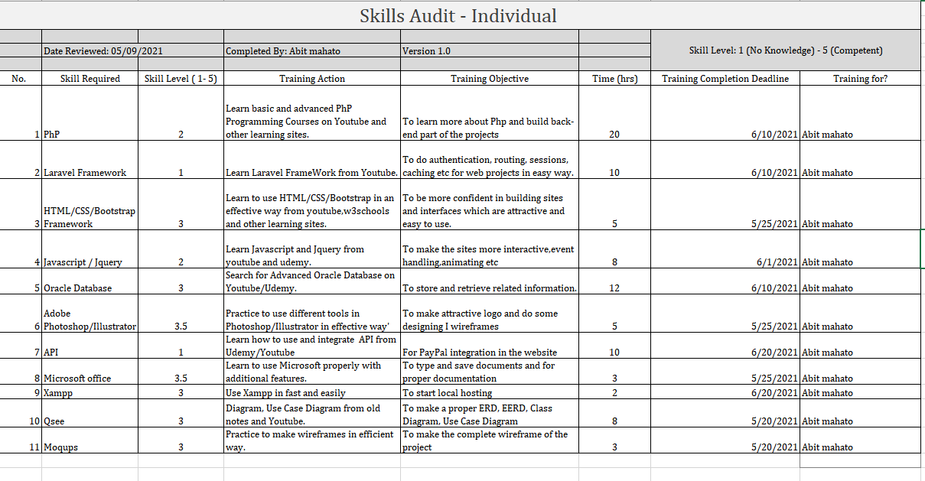

Team Skill Audit

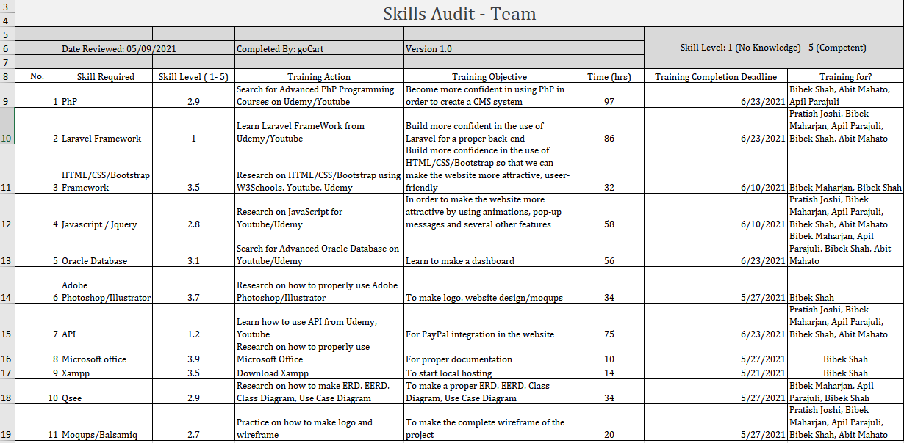

MS Project

This is our calendar for the May 2021.

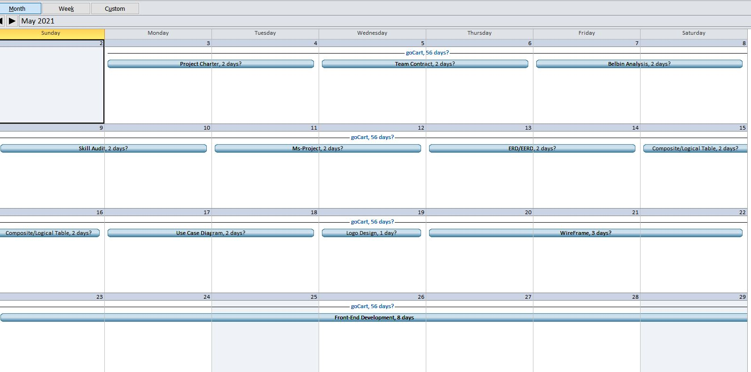

This is our calendar for the June and all the activities done are listed.

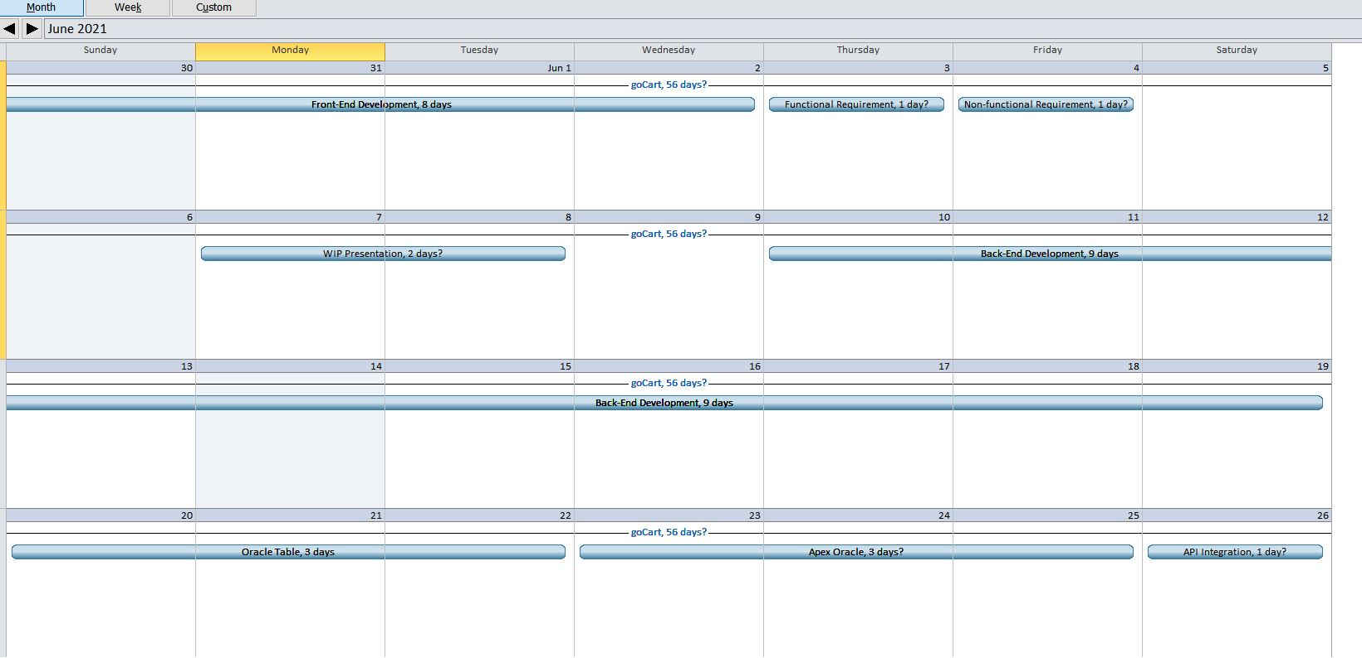

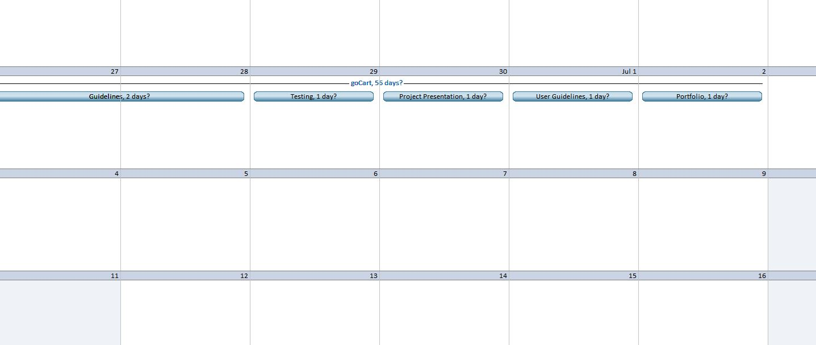

Change Working Time

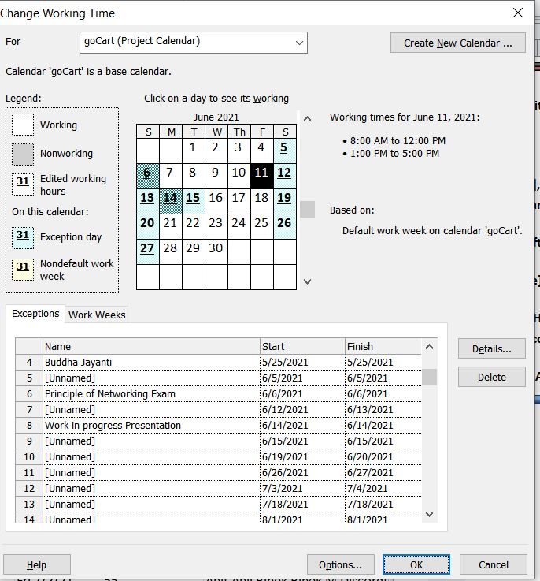

Gnatt Chart

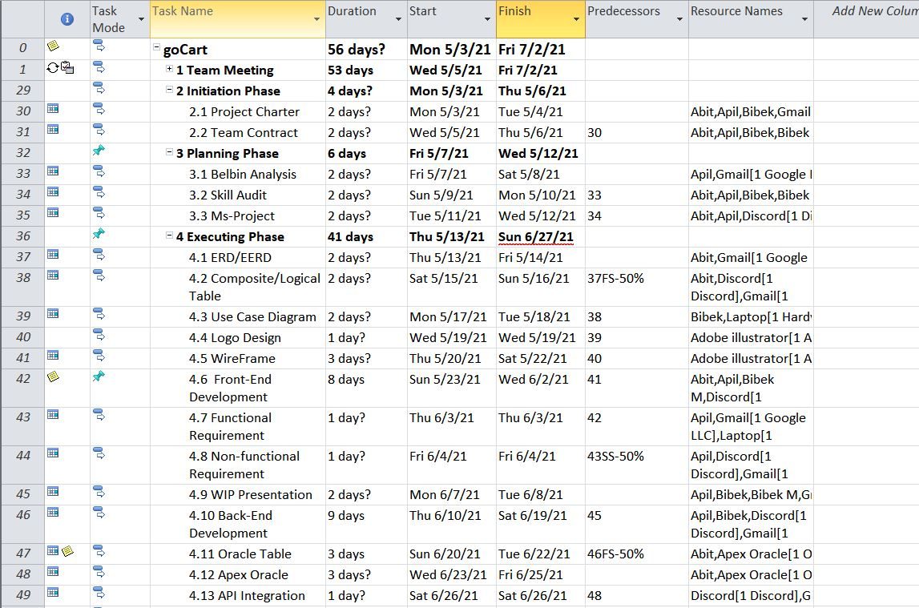

Gnatt Chart 2

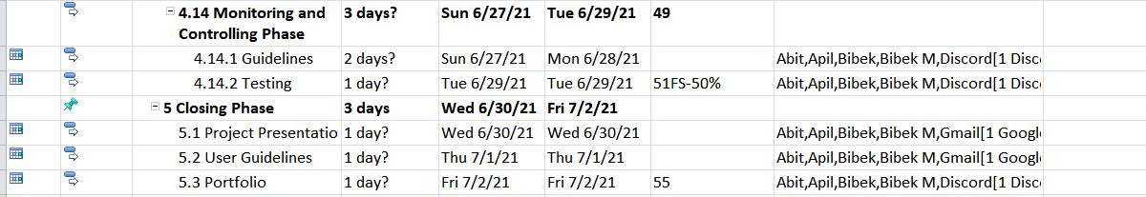

Gnatt Chart 3

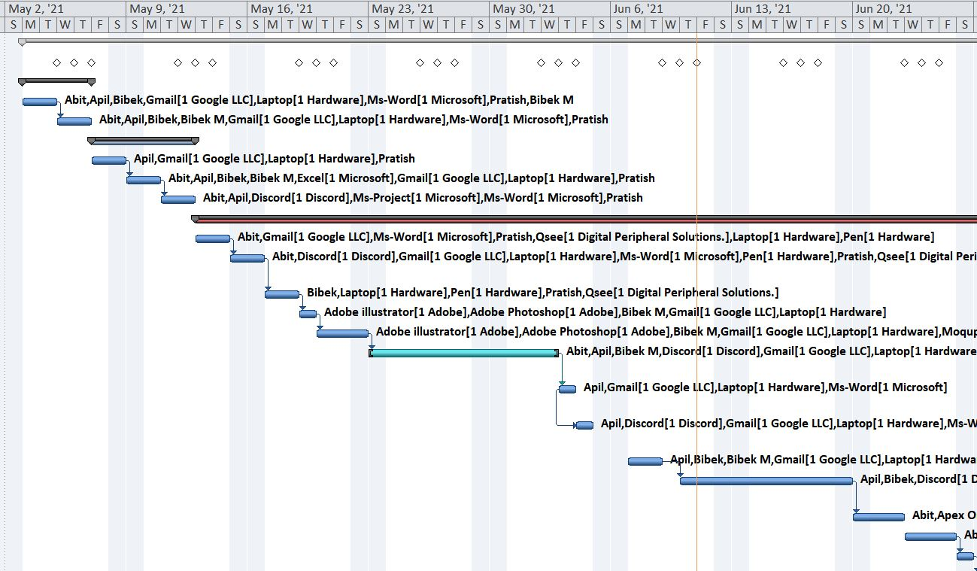

Gnatt Chart 4

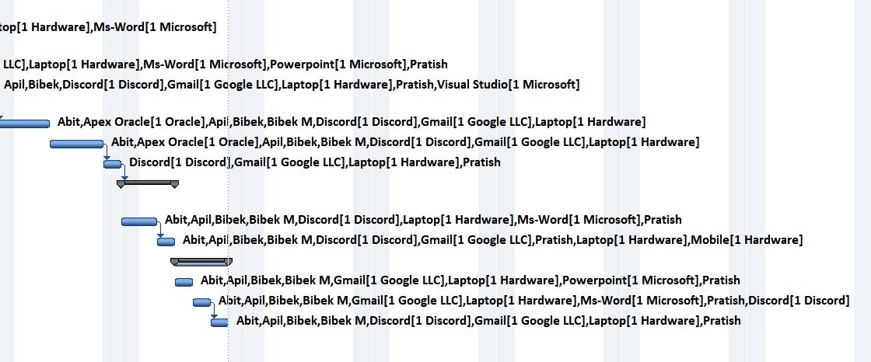

Resource Sheet

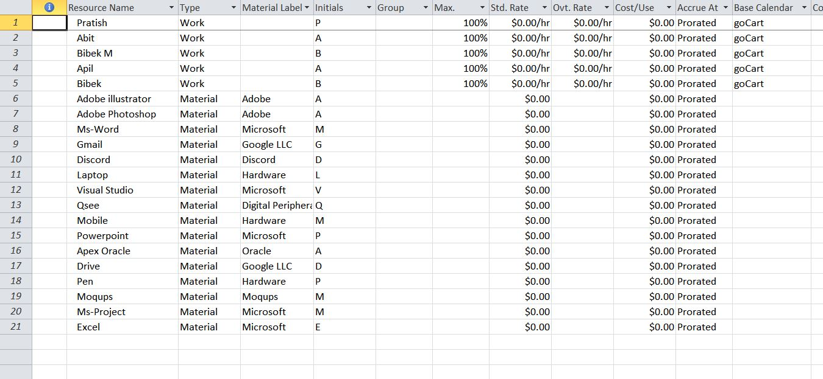

Team Sheet

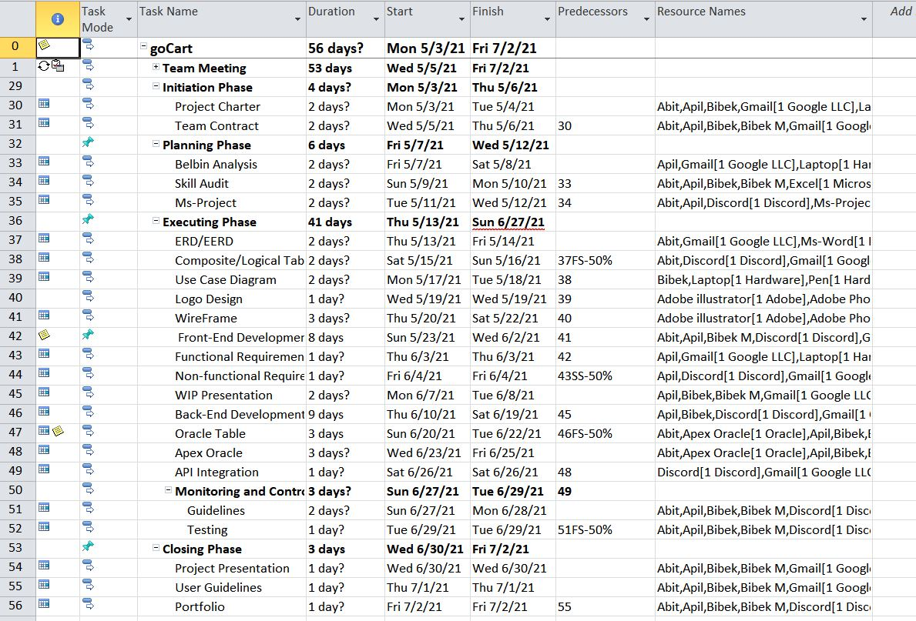

Timeline

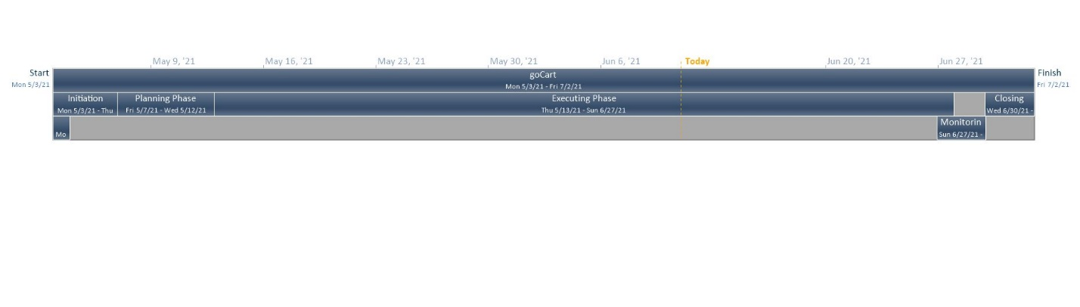

Meeting Minutes

Meeting Minutes

|  |  |  |  |  |
| --- | --- | --- | --- | --- |
| **Date** | **Participants** | **Meeting Agenda** | **Location** | **Duration(minutes)** |
| 5/5/2021 | Apil Parajuli, Bibek Maharjan, Pratish Joshi, Abit Mahato, Bibek Shah | Organizing the team. | Discord | 70 |
| 6/5/2021 | Apil Parajuli, Bibek Maharjan, Pratish Joshi, Abit Mahato, Bibek Shah | Distributing roles. | Discord | 64 |
| 7/5/2021 | Apil Parajuli, Bibek Maharjan, Pratish Joshi, Abit Mahato, Bibek Shah | Confirming the roles and responsibility. | Discord | 55 |
| 17/5/2021 | Apil Parajuli, Bibek Maharjan, Pratish Joshi, Abit Mahato, Bibek Shah | Project Charter | Discord | 58 |
| 19/5/2021 | Apil Parajuli, Bibek Maharjan, Pratish Joshi, Abit Mahato, Bibek Shah | Project Charter | Discord | 69 |
| 20/5/2021 | Apil Parajuli, Bibek Maharjan, Pratish Joshi, Abit Mahato, Bibek Shah | Project Charter | Discord | 68 |
| 24/5/2021 | Apil Parajuli, Bibek Maharjan, Pratish Joshi, Abit Mahato, Bibek Shah | Skill Audit and Belbin Analysis | Discord Room | 59 |
| 26/5/2021 | Apil Parajuli, Bibek Maharjan, Pratish Joshi, Abit Mahato, Bibek Shah | Skill Audit and Belbin Analysis | Discord | 68 |
| 27/5/2021 | Apil Parajuli, Bibek Maharjan, Pratish Joshi, Abit | Skill Audit and Belbin Analysis | Discord | 69 |
| 2/6/2021 | Apil Parajuli, Bibek Maharjan, Pratish Joshi, Abit Mahato, Bibek Shah | MoSCow, EERD, ERD, composite ERD | Discord | 62 |
| 4/6/2021 | Apil Parajuli, Bibek Maharjan, Pratish Joshi, Abit Mahato, Bibek Shah | MoSCoW, EERD, ERD, composite ERD | Discord | 69 |
| 5/6/2021 | Apil Parajuli, Bibek Maharjan, Pratish Joshi, Abit Mahato, Bibek Shah | MoSCoW, EERD, ERD, composite ERD | Discord | 73 |
| 9/6/2021 | Apil Parajuli, Bibek Maharjan, Pratish Joshi, Abit Mahato, Bibek Shah | Duiscussed use case diagrams | Discord | 60 |
| 11/6/2021 | Apil Parajuli, Bibek Maharjan, Pratish Joshi, Abit Mahato, Bibek Shah | Use Case diagrams | Discord | 130 |
| 12/6/2021 | Apil Parajuli, Bibek Maharjan, Pratish Joshi, Abit Mahato, Bibek Shah | Work In Progress(Wireframes, logo, documentation) | Discord | 64 |
| 16/6/2021 | Apil Parajuli, Bibek Maharjan, Pratish Joshi, Abit Mahato, Bibek Shah | Work In Progress | Discord | 63 |
| 18/6/2021 | Apil Parajuli, Bibek Maharjan, Pratish Joshi, Abit Mahato, Bibek Shah | Work In Progress | Discord | 65 |
| 19/6/2021 | Apil Parajuli, Bibek Maharjan, Pratish Joshi, Abit Mahato, Bibek Shah | Adjusting to the online meetings and tasks | Discord | 39 |
| 20/6/2021 | Apil Parajuli, Bibek Maharjan, Pratish Joshi, Abit Mahato, Bibek Shah | Customer Interface (Website interface, register, login, email verification, product page ) | Discord | 59 |
| 21/6/2021 | Apil Parajuli, Bibek Maharjan, Pratish Joshi, Abit Mahato, Bibek Shah | Customer Interface (Product page, view categories) | Discord | 67 |
| 23/6/2020 | Apil Parajuli, Bibek Maharjan, Pratish Joshi, Abit Mahato, Bibek Shah | Customer Interface(Add to cart, view cart, remove cart) | Discord | 56 |
| 24/6/2020 | Apil Parajuli, Bibek Maharjan, Pratish Joshi, Abit Mahato, Bibek Shah | Customer Interface (Search and sort, review and rating) | Discord | 68 |
| 25/6/2021 | Apil Parajuli, Bibek Maharjan, Pratish Joshi, Abit Mahato, Bibek Shah | Customer Interface(Add/view/remove order, update profile) | Discord | 62 |
| 26/6/2021 | Apil Parajuli, Bibek Maharjan, Pratish Joshi, Abit Mahato, Bibek Shah | Customer Interface (Transaction, invoice, paypal API) | Discord | 63 |
| 27/6/2021 | Apil Parajuli, Bibek Maharjan, Pratish Joshi, Abit Mahato, Bibek Shah | Trader Dashboard ( Login/ Register, logout, , approve email), Admin Dashboard (Trader approve) | Discord | 73 |
| 30/6/2021 | Apil Parajuli, Bibek Maharjan, Pratish Joshi, Abit Mahato, Bibek Shah | Trader Dashboard (Add/update/delete shop, add/update/delete products) | Discord | 59 |
| 1/7/2021 | Apil Parajuli, Bibek Maharjan, Pratish Joshi, Abit Mahato, Bibek Shah | Trader Dashboard (Search product/shop, view/edit profile) | Discord | 61 |
| 2/7/2021 | Apil Parajuli, Bibek Maharjan, Pratish Joshi, Abit Mahato, Bibek Shah | Trader Dashboard (Update stock, total ordered product, total earning) | Discord | 67 |
| 3/7/2021 | Apil Parajuli, Bibek Maharjan, Pratish Joshi, Abit Mahato, Bibek Shah | Finalize on Customer interface and Trader dashboard | Discord | 90 |
| 4/7/2021 | Apil Parajuli, Bibek Maharjan, Pratish Joshi, Abit Mahato, Bibek Shah | OCI connection | Discord | 55 |
| 5/7/2021 | Apil Parajuli, Bibek Maharjan, Pratish Joshi, Abit Mahato, Bibek Shah | Finalize on Customer interface and Trader dashboard | Discord | 76 |
| 6/7/2021 | Apil Parajuli, Bibek Maharjan, Pratish Joshi, Abit Mahato, Bibek Shah | Admin Dashbard ( Add/delete/ update category) | Discord | 66 |
| 8/7/2021 | Apil Parajuli, Bibek Maharjan, Pratish Joshi, Abit Mahato, Bibek Shah | Admin Dashboard (View/remove customer, view/remove trader) | Discord | 61 |
| 8/7/2021 | Apil Parajuli, Bibek Maharjan, Pratish Joshi, Abit Mahato, Bibek Shah | Admin Dashboard (Search product/customer/trader) | Discord | 63 |
| 9/7/2021 | Apil Parajuli, Bibek Maharjan, Pratish Joshi, Abit Mahato, Bibek Shah | Finalize of admin dashboard | Discord | 77 |
| 9/7/2021 | Apil Parajuli, Bibek Maharjan, Pratish Joshi, Abit Mahato, Bibek Shah | Oracle Trader Dashboard (Oracle application, trader authentication scheme) | Discord | 68 |
| 10/7/2021 | Apil Parajuli, Bibek Maharjan, Pratish Joshi, Abit Mahato, Bibek Shah | Oracle Trader Dashboard (Trader weekly/monthly/yearly report, trader dashboard) | Discord | 70 |
| 10/7/2021 | Apil Parajuli, Bibek Maharjan, Pratish Joshi, Abit Mahato, Bibek Shah | Oracle Admin Interface (Admin authentication) | Discord | 69 |
| 10/7/2021 | Apil Parajuli, Bibek Maharjan, Pratish Joshi, Abit Mahato, Bibek Shah | Oracle Admin Interface (Admin reports, admin dashboard) | Discord | 68 |
| 10/7/2021 | Apil Parajuli, Bibek Maharjan, Pratish Joshi, Abit Mahato, Bibek Shah | Oracle dashboard (Line graph, pie chart, bar graph/statistics) | Discord | 61 |
| 11//2021 | Apil Parajuli, Bibek Maharjan, Pratish Joshi, Abit Mahato, Bibek Shah | Finishing up the project | Discord | 90 |
| 11/7/2021 | Apil Parajuli, Bibek Maharjan, Pratish Joshi, Abit Mahato, Bibek Shah | Finalizing the project | Discord | 98 |
| 11/7/2021 | Apil Parajuli, Bibek Maharjan, Pratish Joshi, Abit Mahato, Bibek Shah | Final presentation | Discord | 65 |
| 12/7/2021 | Apil Parajuli, Bibek Maharjan, Pratish Joshi, Abit Mahato, Bibek Shah | Final presentation, Team portfolio | Discord | 69 |
| 12/7/2021 | Apil Parajuli, Bibek Maharjan, Pratish Joshi, Abit Mahato, Bibek Shah | Team portfolio | Discord | 63 |
| 12/7/2021 | Apil Parajuli, Bibek Maharjan, Pratish Joshi, Abit Mahato, Bibek Shah | Team portfolio | Discord | 70 |

Signatures:

|  |  |  |  |
| --- | --- | --- | --- |
| Name | Pratish Joshi |  |  |
| Signature | https://lh3.googleusercontent.com/gjjs1zC5FNaVFaIXiwDay0Ptifvk_zqpxD9Wb-oUQnqz1o4h5ZdS3rtwK3iNFnWLq2aDYJB2aH_GBMiNZgVQ84qidzsm7YcovFM3fpxCKTBef2Ev1U8TBdBBjKDbBKiBu7IRm-rR | Date | 05/05/2021 |
| Name | Bibek Maharjan |  |  |
| Signature | https://lh4.googleusercontent.com/ljqRsfAfWymLlh4bvmqKHw9Ar6UMD1LJnpdN9X8qh6kVFPgrni2HhJBst8EhItaiEO9z8snj6-FL4Q9NyHqh_dohRVTo4A3St-qBm6ezzkK5WjLr0N8RIbUYj-fkHG9tXP4wPW7H | Date | 05/05/2021 |
| Name | Apil Parajuli |  | |
| Signature | https://lh6.googleusercontent.com/ZHaCN9ZcTizUMa3T_O8f8sYKAdMtLvuPmYtF3dHerKyWNwLVde-F5jdmbZ0WTx6XRA0e7d2HHxZadOoD2iBFgzXqNdwyMWDABrqAeoMPh-rhTKbXiUG_VKxURXn-qhE42AYpeO_N | Date | 05/05/2021 |
| Name | Abit Mahato |  |  |
| Signature | https://lh3.googleusercontent.com/mOTKHgB-it-7iwK49c4Gr5yQNCU5kX4KuyO71E6FzsQanfoHfufFGe9GO-fqdxqmQvzRsJzlK1juVGSVKhgYd5gnMILrKewI3ioBON2bz0UPl5qb93XrYrFQR_QjhvT9ZVucDK5r | Date | 05/05/2021 |
| Name | Bibek Shah |  |  |
| Signature | https://lh3.googleusercontent.com/mzQ2IBQ4kai8-Ohsat-Jup9yzQnDM6P_ASyCPZq62DWcmc7bkRkgQXNDwzdReZwBn0ff7AB250uOfHx0rj_jYJ7E6coQY4zIo03yaxt3TC2R1ec5EAFjKxJ6zuy8V_hcwURPMH0h | Date | 05/05/2021 |

Communication Tools Used

**Discord:** 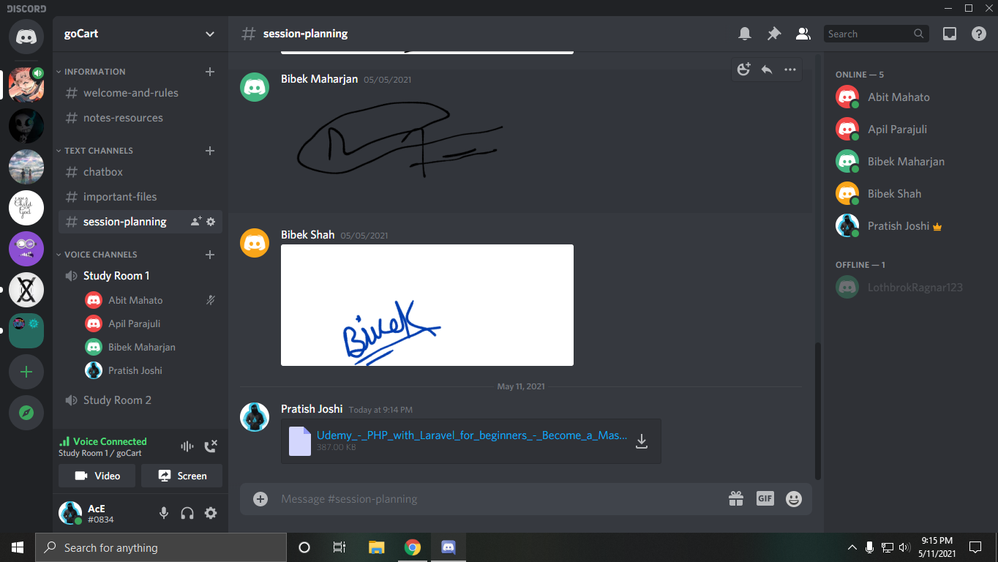

**Google Drive:**

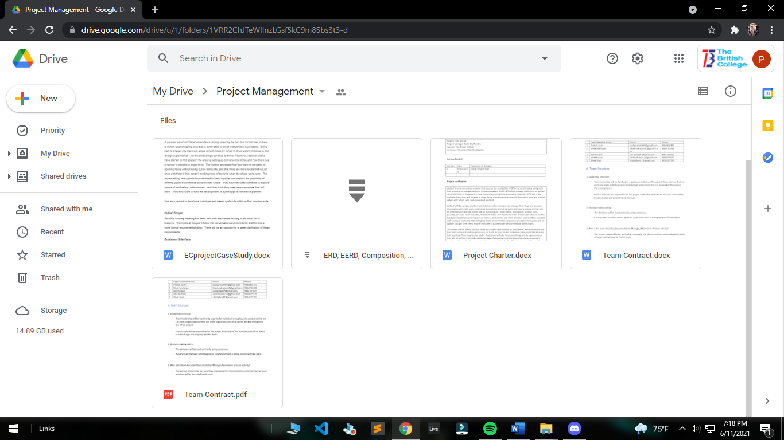

**Gmail:**

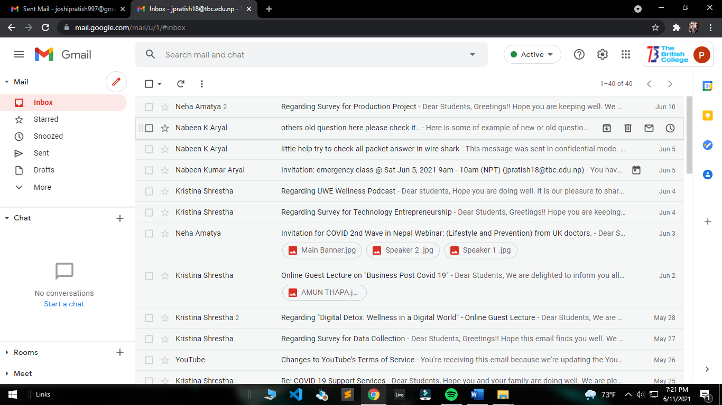

02) Product Designing

Entity Relationship Diagram

**ERD**

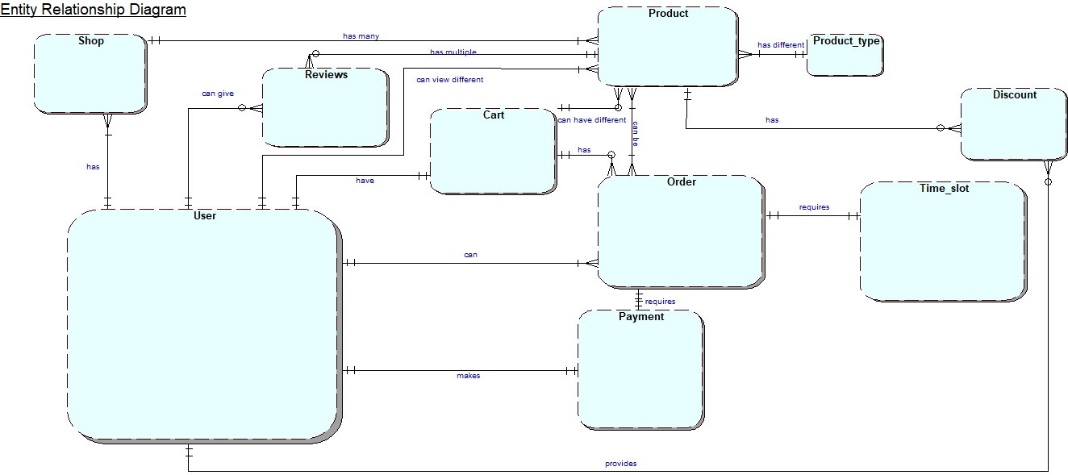

**EERD**

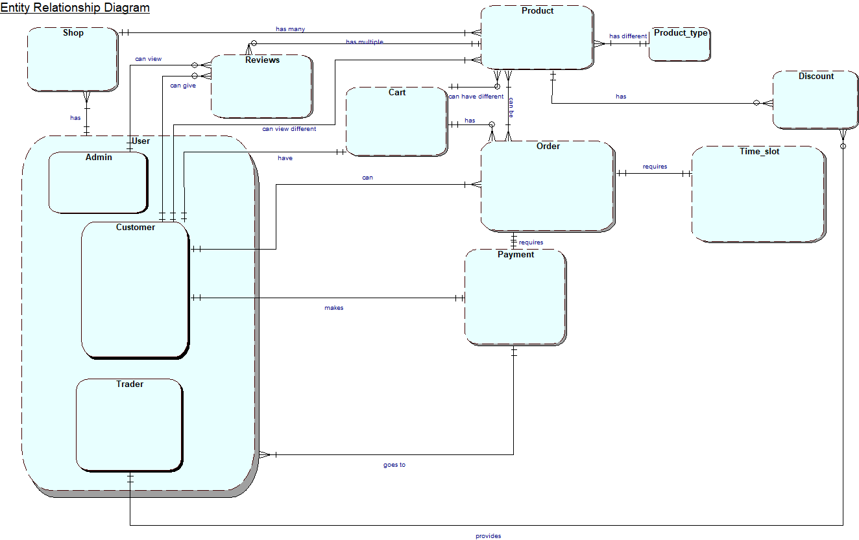

**Composite ERD**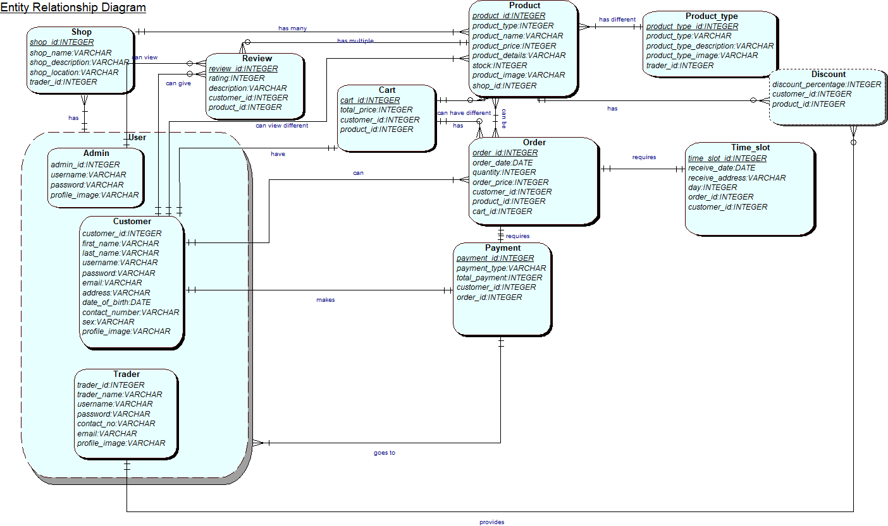

**Logical ERD**

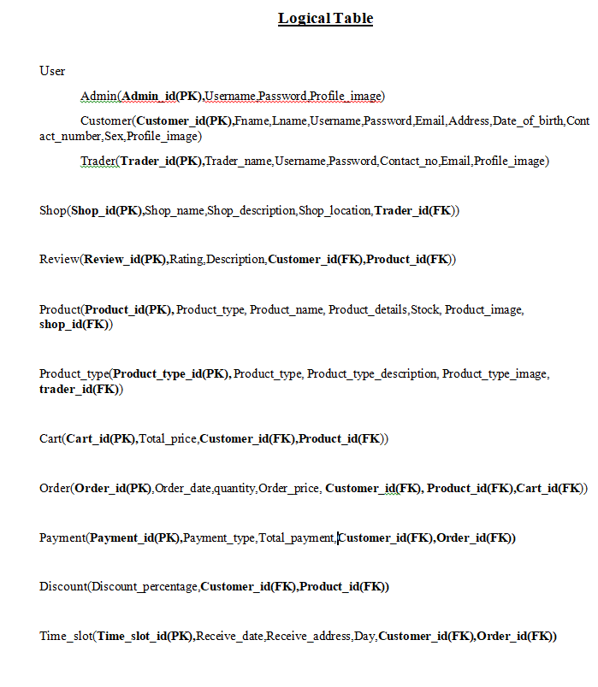

## Use Case Diagram

### Overview Use Case Diagram

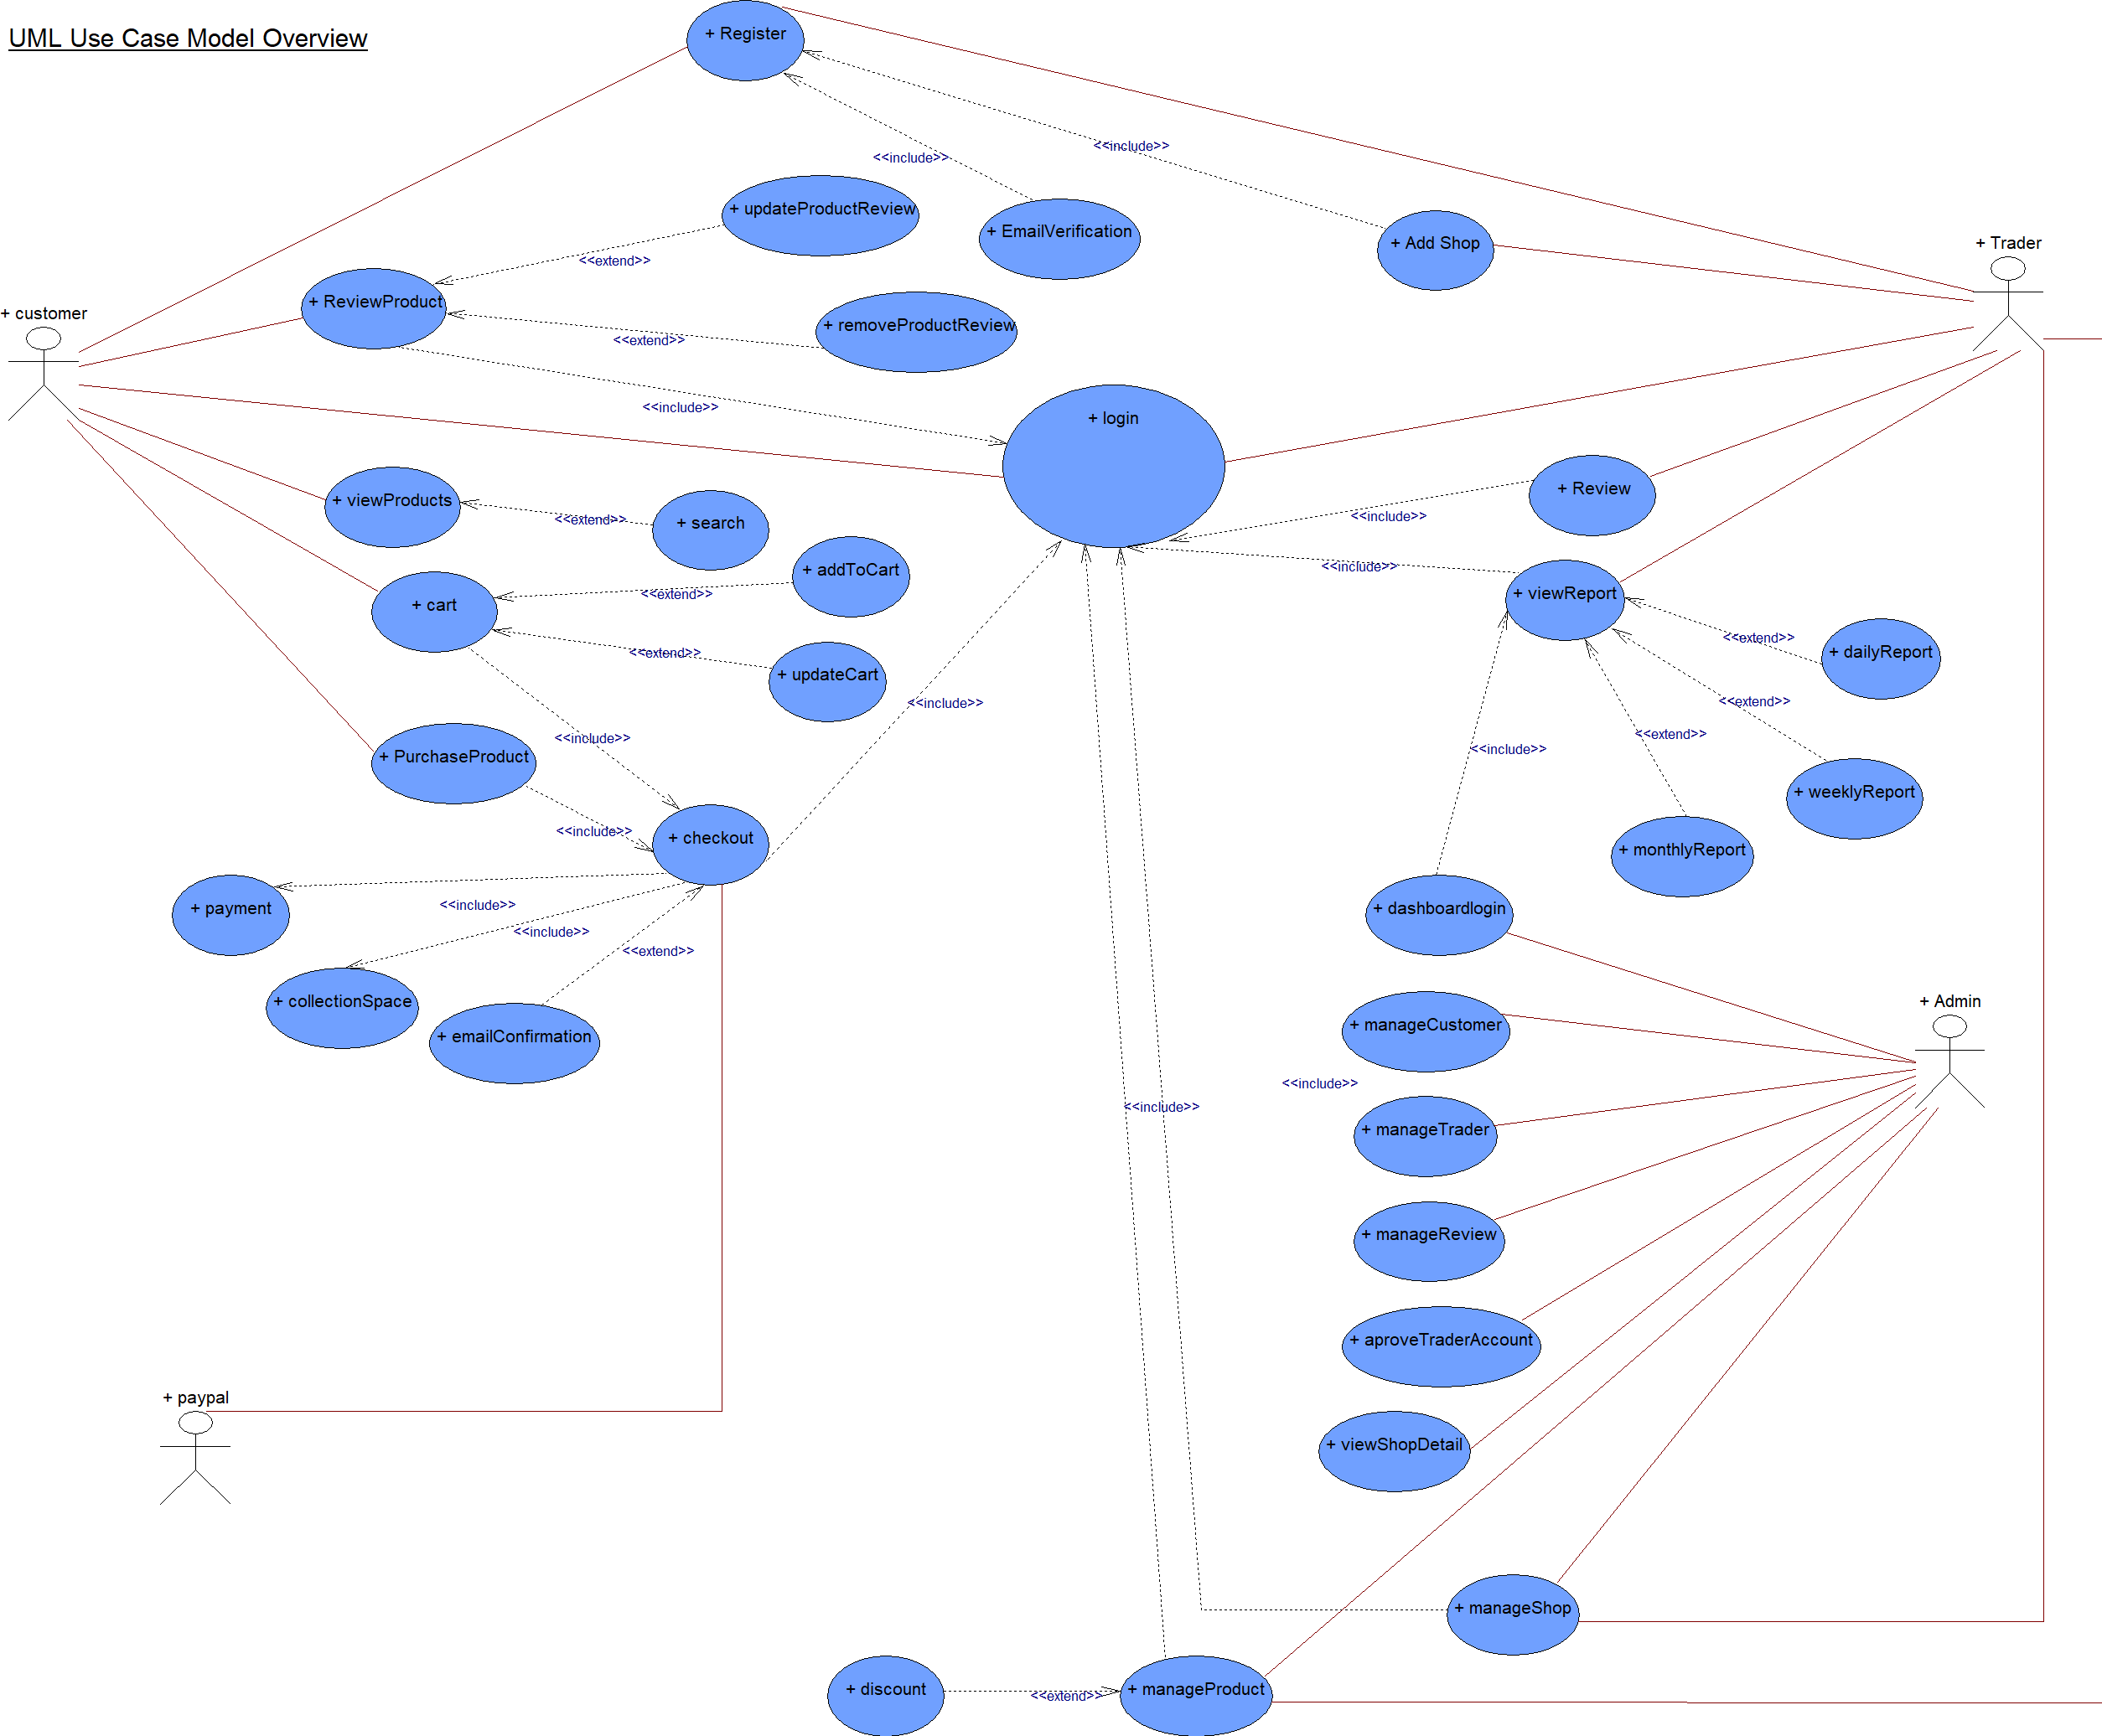

### Customer Use Case Diagram

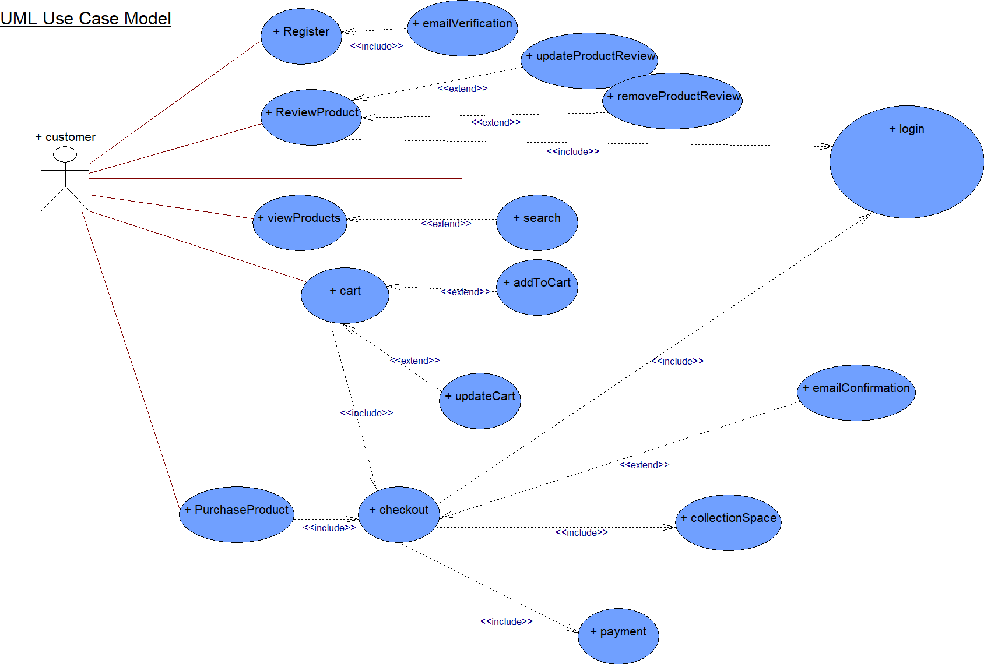

### Trader Use Case Diagram

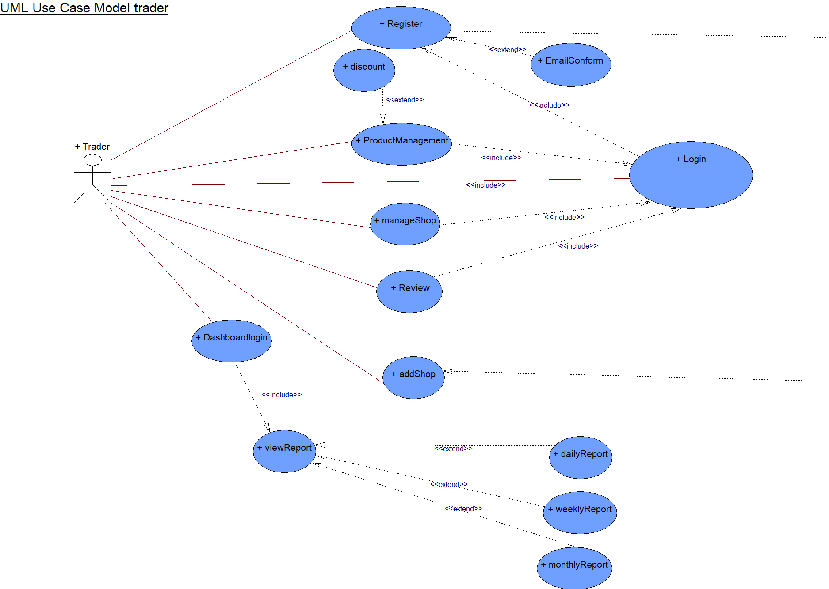

### Admin Use Case Diagram

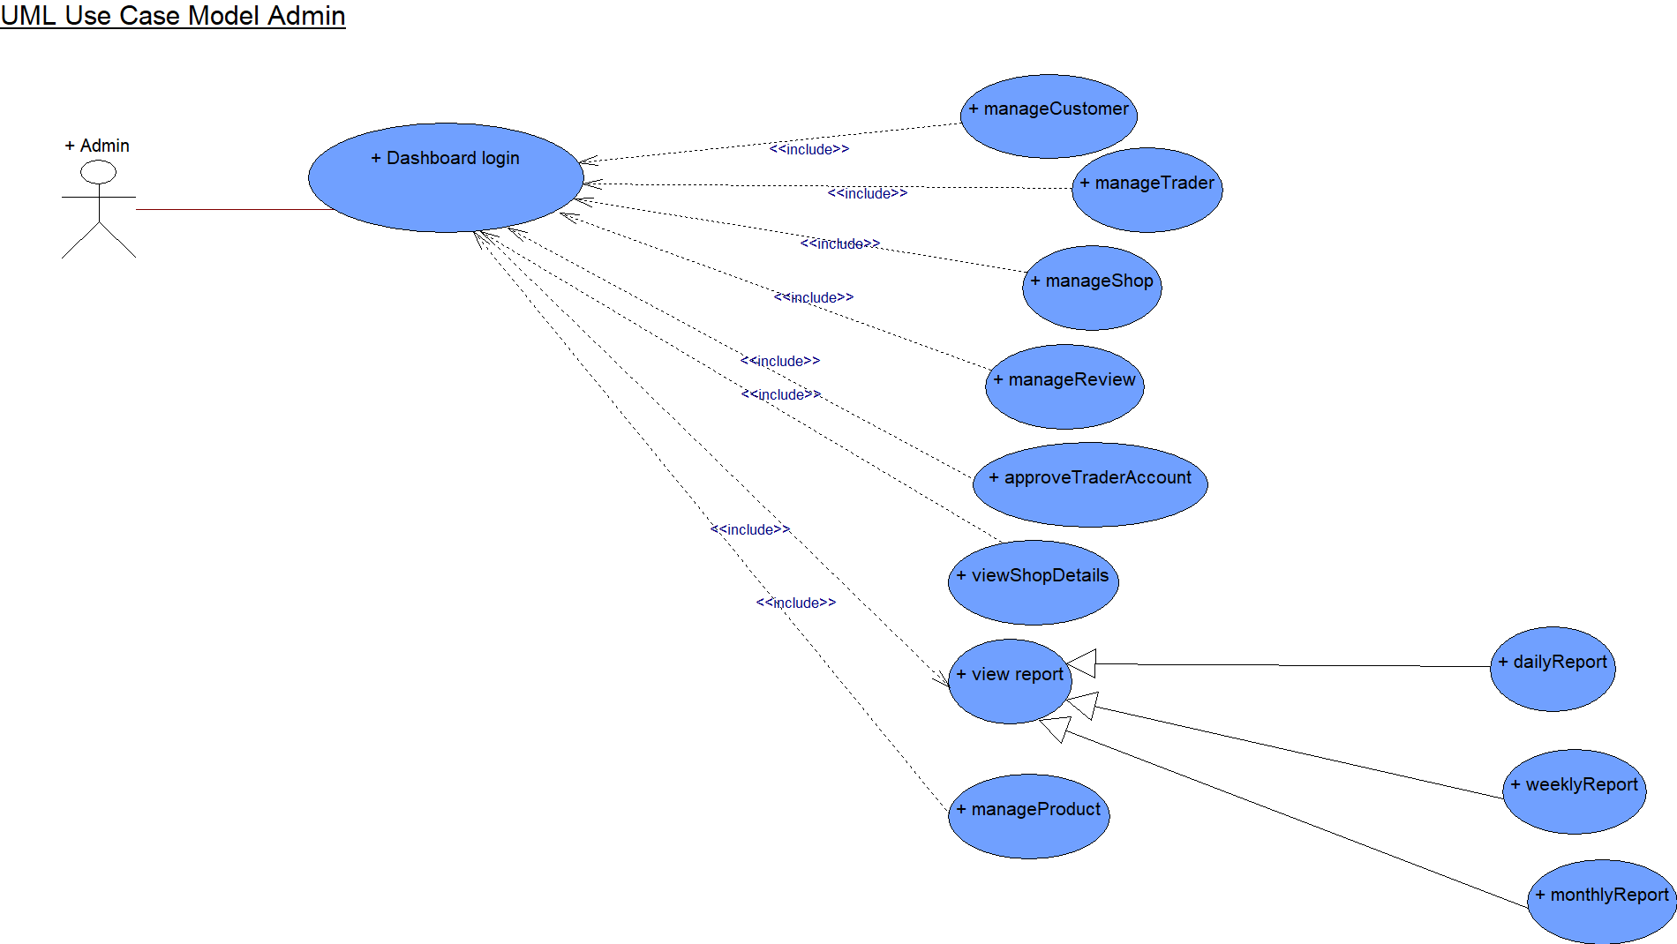

## Requirement Catalogue

### MoSCoW Requirements

**PART A: Customer Interface**

|  |  |  |
| --- | --- | --- |
| ***Requirement ID*** | ***Description*** | ***MoSCoW*** |
| **A1** | **Website interactions** |  |
| A1-1 | Users should be able to access to products by shop or by product type. | M |
| A1-2 | The site should be responsive and should be viewable on mobile as well as desktop devices and viewable on the most popular browsers. | M |
| A1-3 | A basket function that keeps goods that spans all traders and requires a single payment for every user. | M |
| A1-4 | The system should be able to keep a maximum of 10 shops(traders). | S |
| A1-5 | The design of the website should be based on Cleckhuddersfaxtheme. | S |
| A1-6 | The cart and totals reported to the traders should include a breakdown of goods ordered and payment acquired by trader. |  |
| A1-7 | There should be a maximum of 20 orders per slot. | S |
| **A2** | **User’s interactions in the website** |  |
| A2-1 | Users should be required to register on the website before they can place an order and be logged in with their account to access the basket. | M |
| A2-2 | There will be 3 collection slots 10-13,13-16, 16-19 which will be available Wednesday, ThursdayandFriday respectively. | M |
| A2-3 | When placing and paying for their order users should identify a collection slot, which must be at least 24 hours after placing the order. | M |
| A2-4 | PayPal will be used as a form of payment. | M |
| A2-5 | Users should be able to view and manage their account details. | W |
| A2-6 | Registration and account updates should be confirmed via interaction with emails. | W |

**PART B: Trader Interface**

|  |  |  |
| --- | --- | --- |
| ***Requirement ID*** | ***Description*** | ***MoSCoW*** |
| **B1** | **Trader interactions with the website** |  |
| B1-1 | Traders should be able to control their products and data on their shops via a web interface. | M |
| B1-2 | Traders should be able to update/delete/add their required products. | M |
| B1-3 | Traders will login to the database on a daily basis to view reports on orders and stocks information etc. | M |
| B1-4 | Traders should have a trader login that allows them access to their details only. | M |
| B1-5 | Traders should be able to view and supervise the details of their separate trader account. | M |
| B1-6 | All products will have a unique ID, be associated with a trader, have a short name, a description, an item price, quantity per item, stock available, min order, max order and allergy information. | C |

**Part C: Management Interface**

|  |  |  |
| --- | --- | --- |
| ***Requirement ID*** | ***Description*** | ***MoSCoW*** |
| **C1** | **Admin Dashboard and reports.** |  |
| C1-1 | There should be a separate guidance dashboard for an admin. | M |
| C1-2 | An Adminlogin which can access any of the trader accounts. | M |
| C1-3 | Traders will be provided with a monthly data/statistic on their amount of product sales. | M |
| C1-4 | The daily report will identify the goods, quantities that have been ordered and the collection time slot. | S |
| C1-5 | Traders will be provided with a weekly finance record which will recognize payments to be made to them resulting from the remainders of 7 days orders. | S |
| C1-6 | Traders will be able to pass this report ordered in a number of ways: by alphabetically, by total number of orders per product and by total cost per product. | S |
| C1-7 | Dashboard will give a range of daily and monthly reports. | C |

**PART D: Product Interface**

|  |  |  |
| --- | --- | --- |
| ***Requirement ID*** | ***Description*** | ***MoSCoW*** |
| **D1** | **The specifications for products kept on the website** |  |
| D1-1 | Each product will have its own required attributes. I.e.,product name, product ID, description, allergy information, price and product image. | M |
| D1-2 | Each product will have an add to cart option | M |
| D1-3 | Each product will have its own review section. | C |

**PART E: Non-Functional**

|  |  |  |
| --- | --- | --- |
| ***Requirement ID*** | ***Description*** | ***MoSCoW*** |
| **E1** | **The website will comply with the following nonfunctional requirements.** |  |
| E1-1 | HTML/CSS/ JavaScriptwill be used for building the website. | M |
| E1-2 | The sites files and folders will be properly managed, with a guide for Authorized people to access it. | M |
| E1-3 | PHP with Oracle Database will be used to build the site. | S |
| E1-4 | Template is used to view dashboard | S |

## Website Logo



## Wireframe

### Customer Wireframes

Cart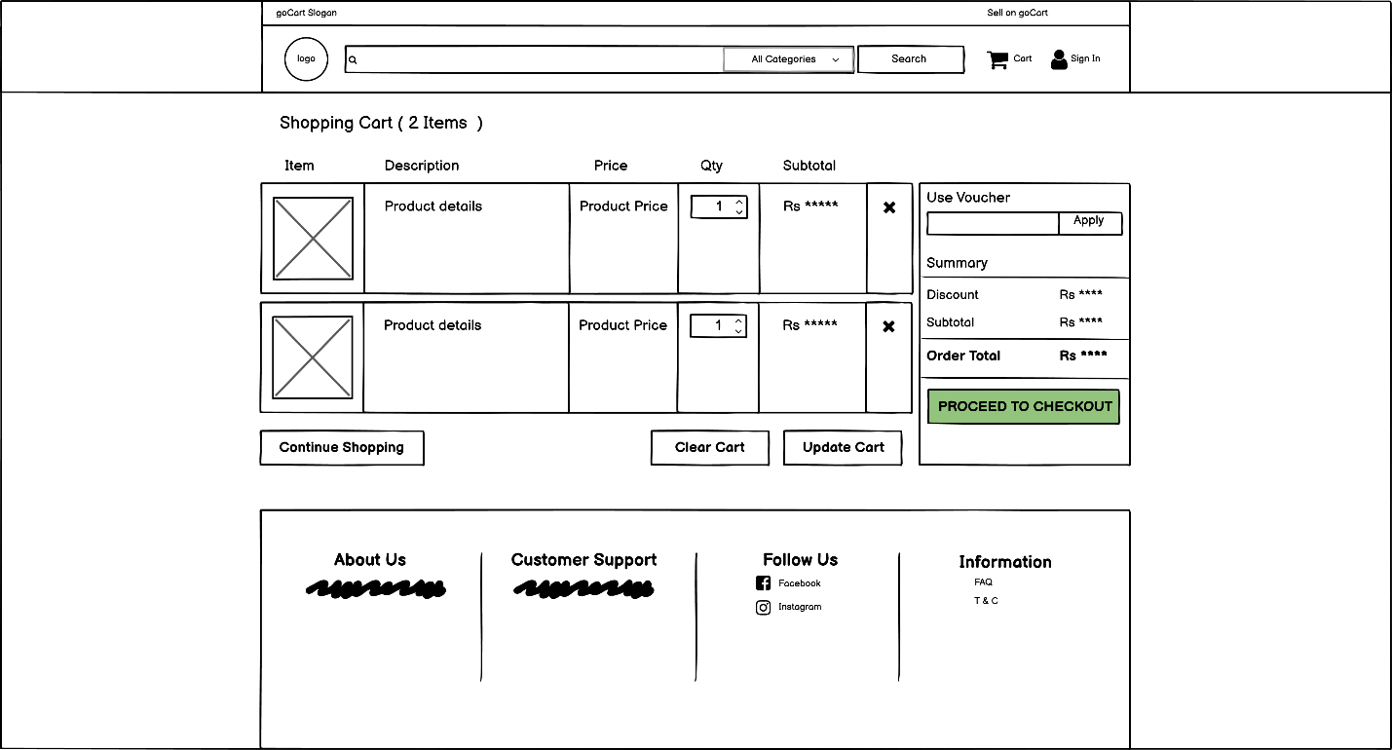

Checkout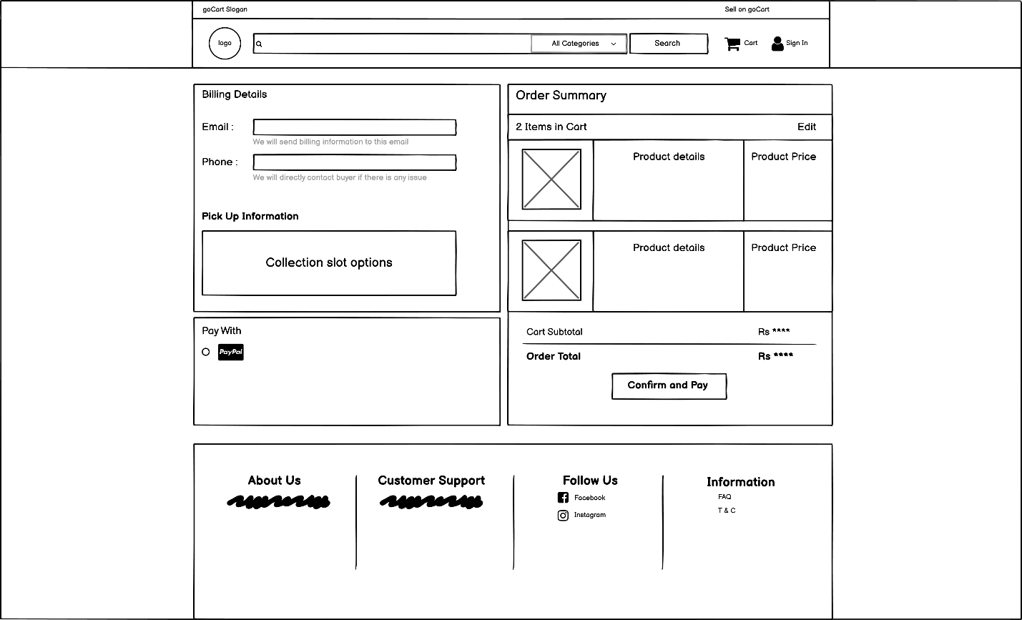

Customer Profile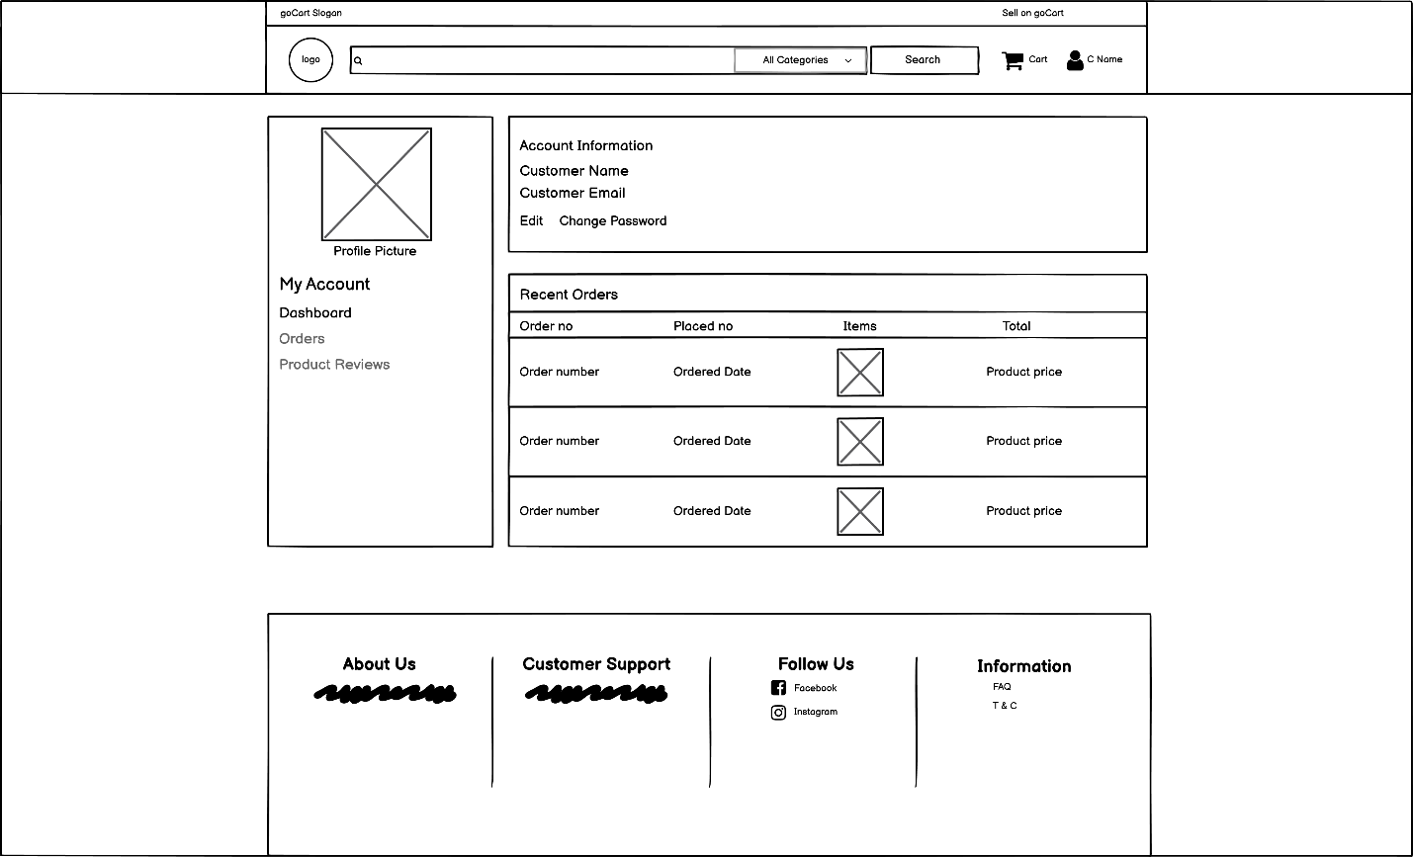

Edit Profile

Homepage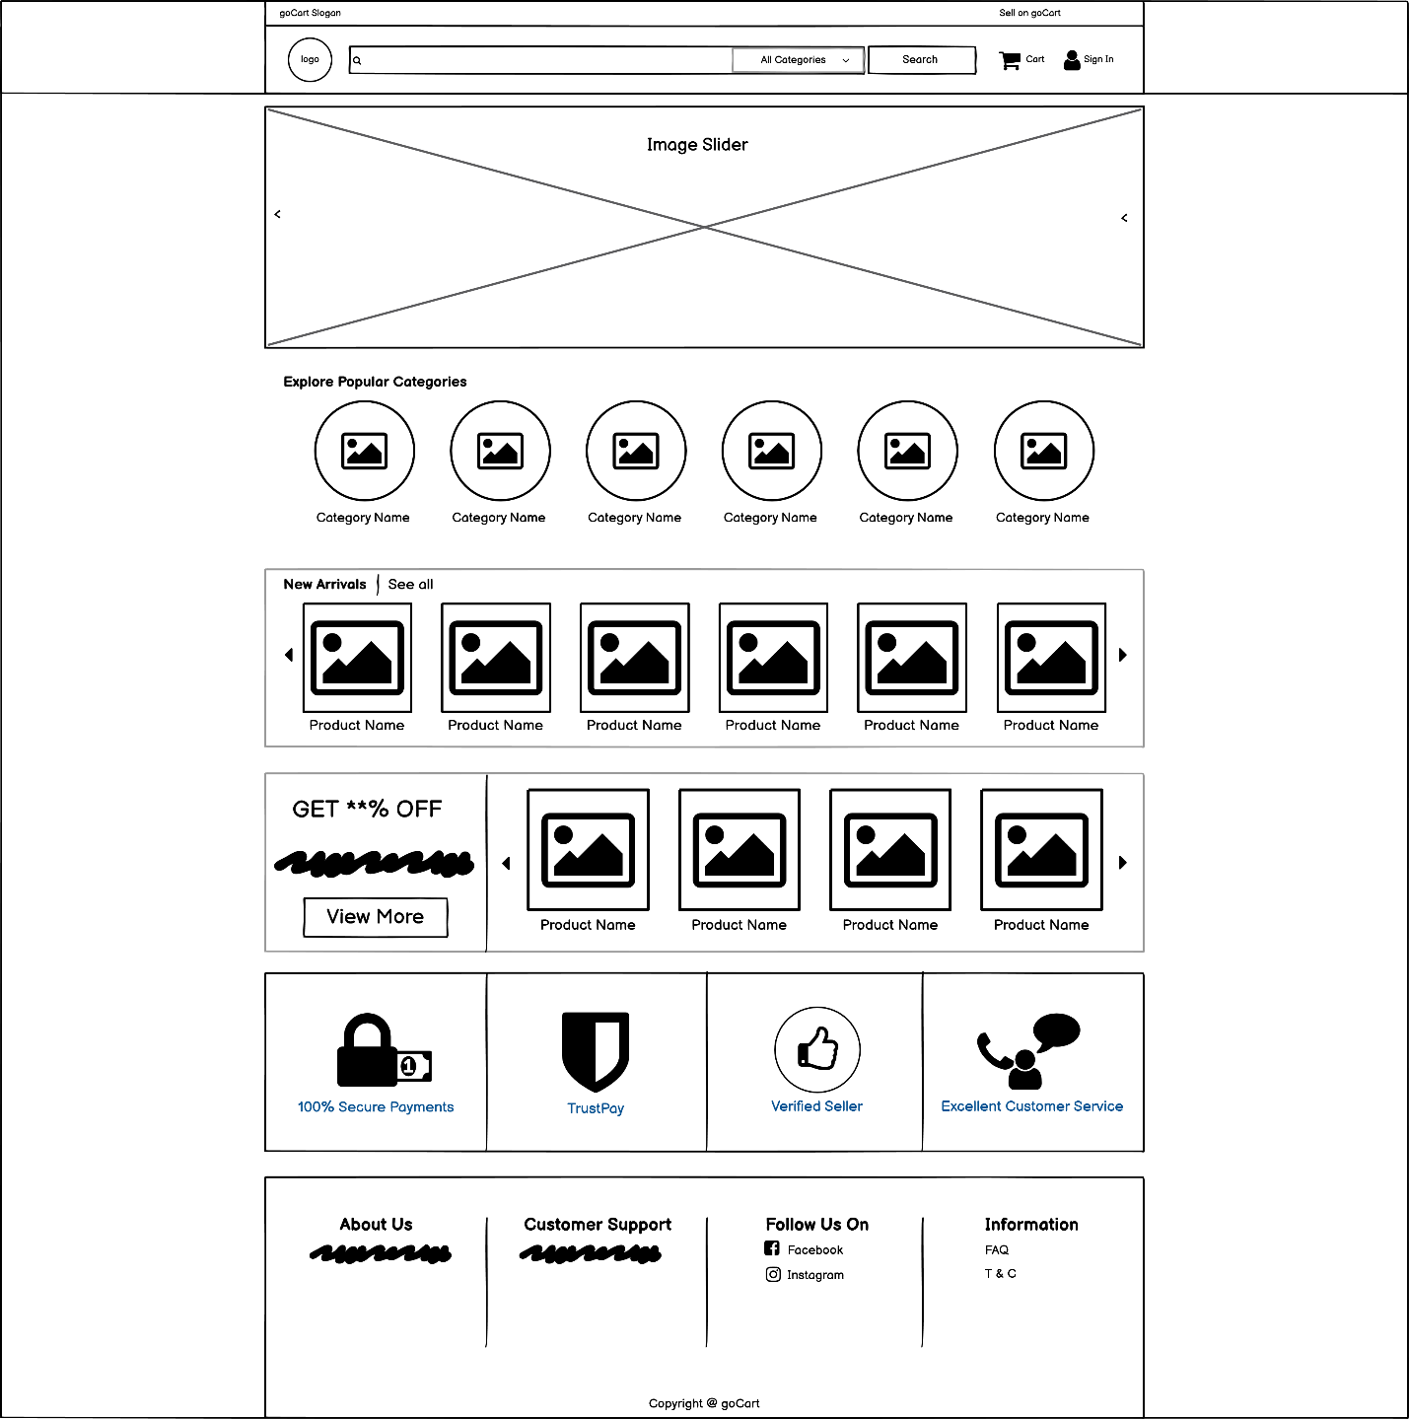

My Orders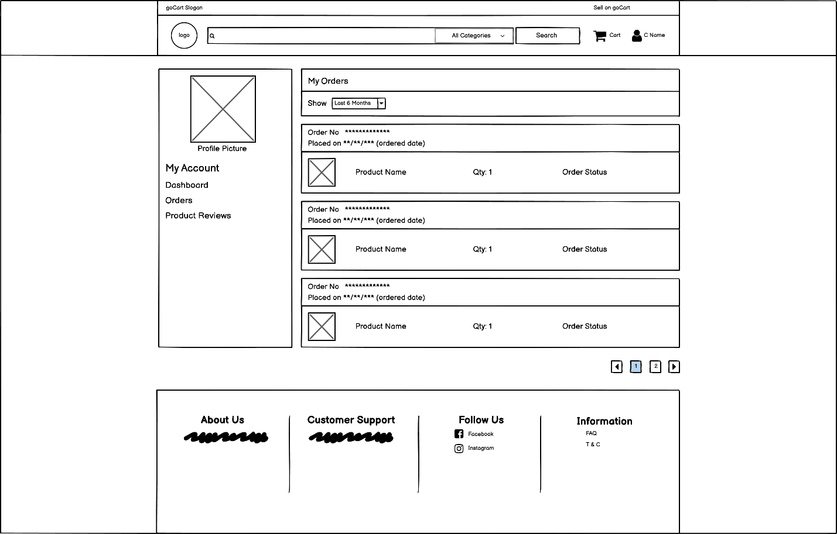

My Reviews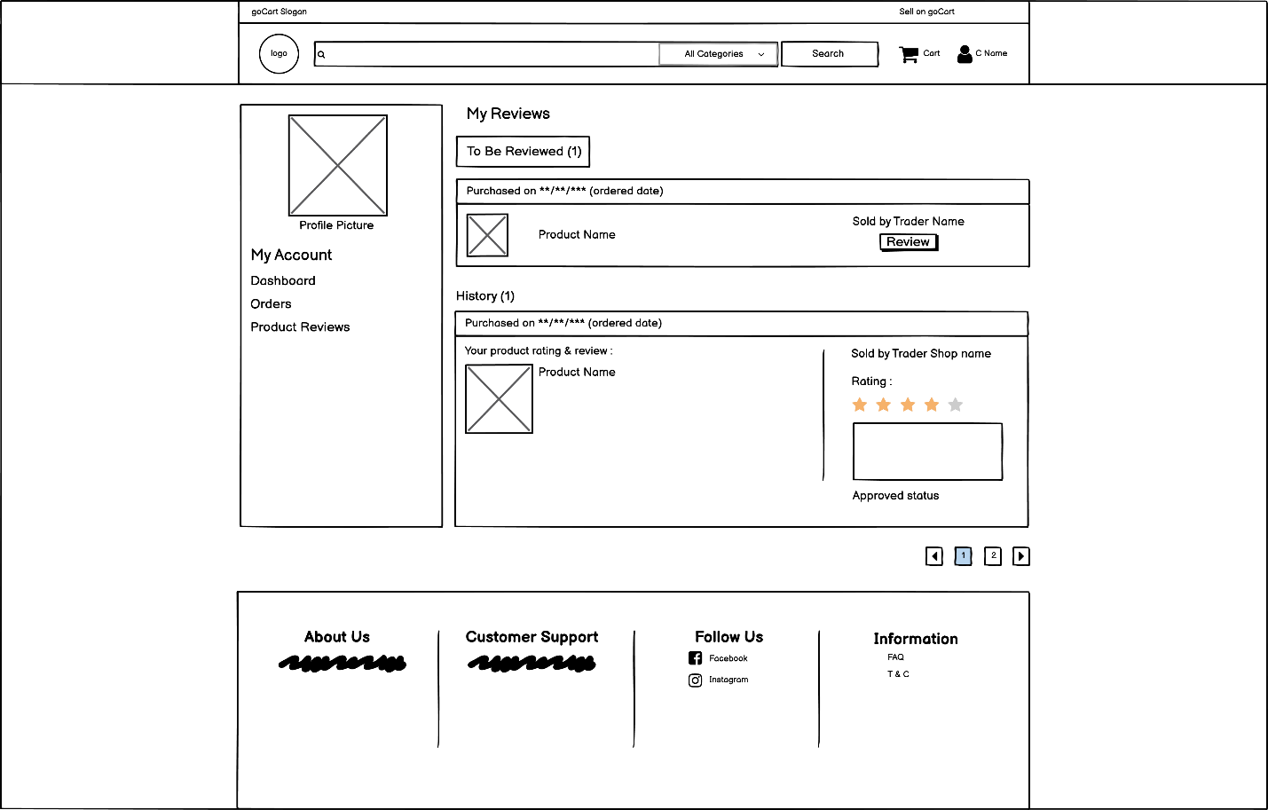

Product Details

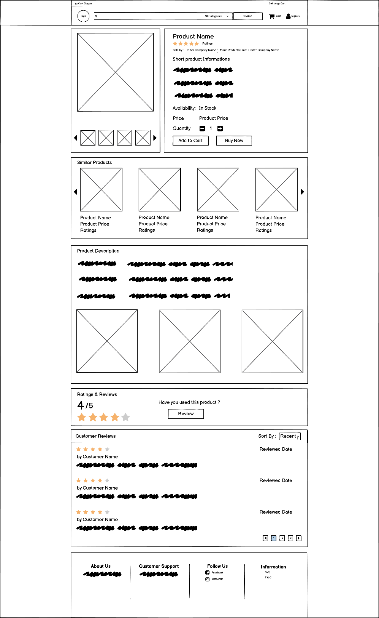

Search Product Result

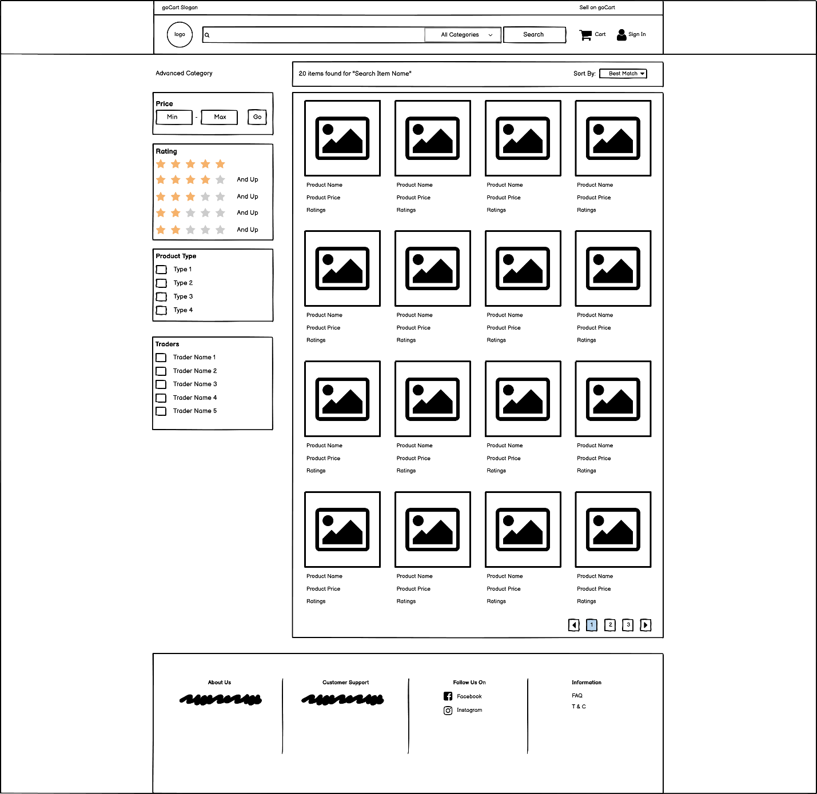

Sing In Customer

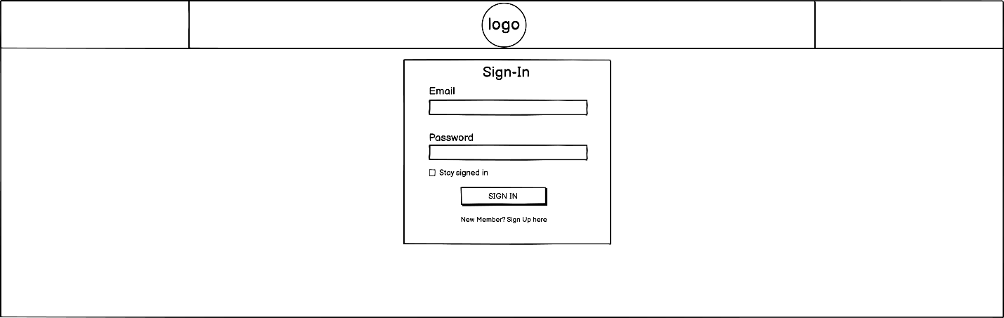

Sign Up Customer

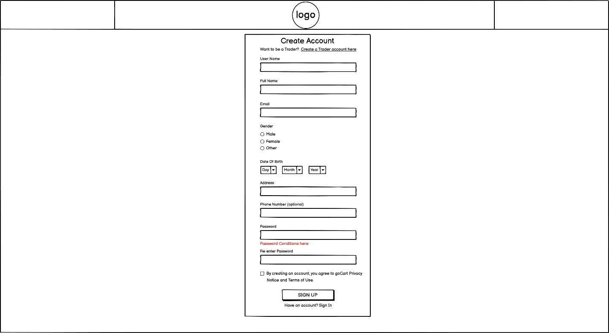

Successful Checkout

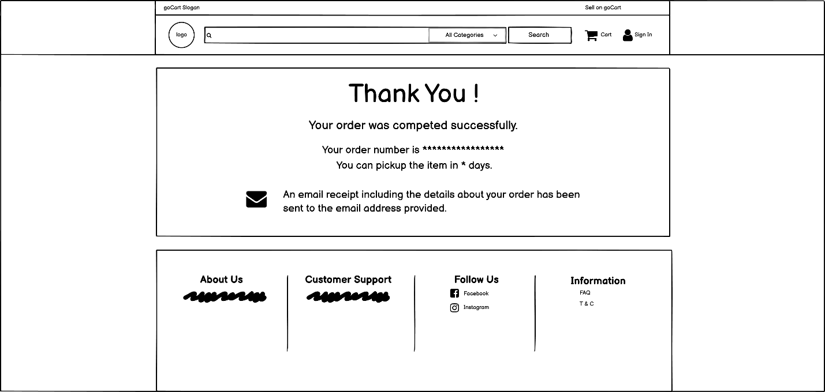

### Management Wireframes

Management New Products Approval

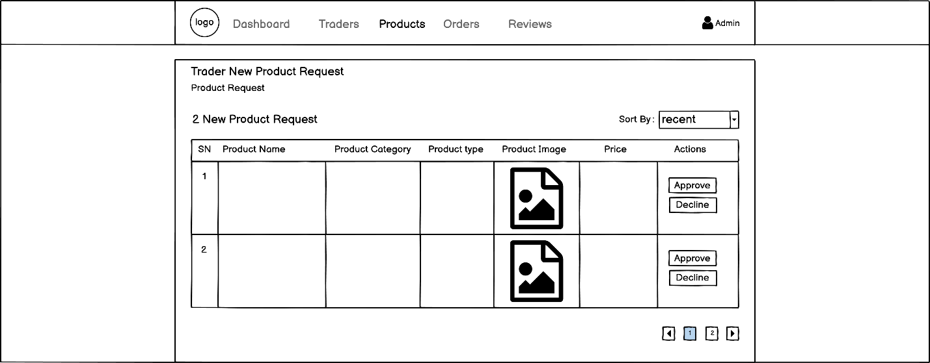

Management power to disable products

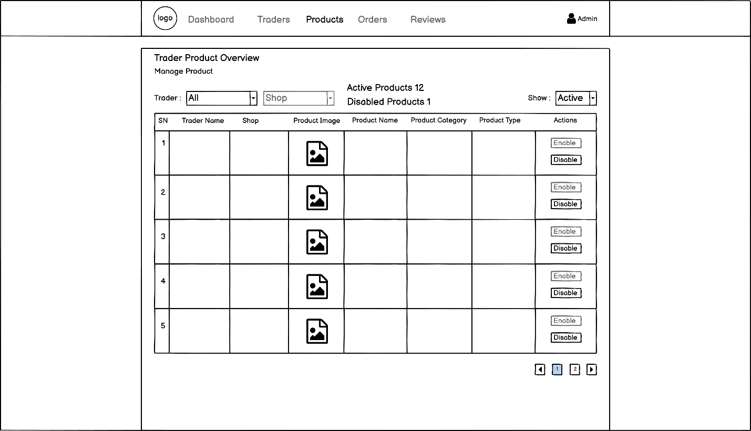

Management reviewers comment approve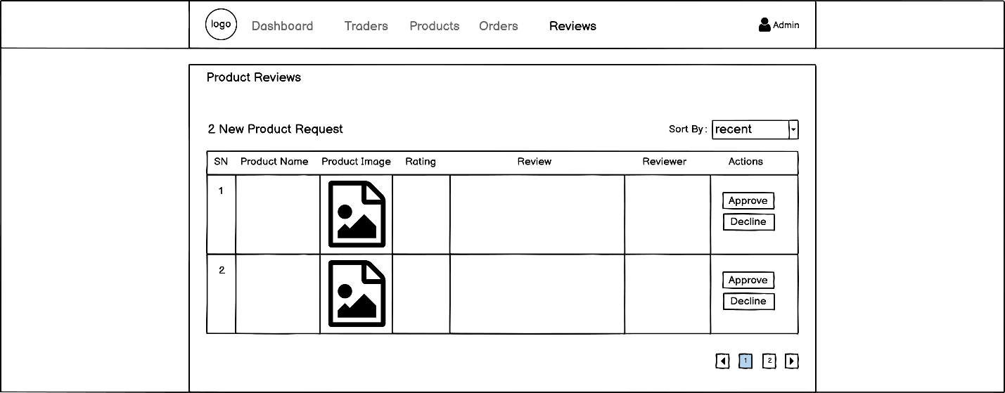

Management seller new account or shop request

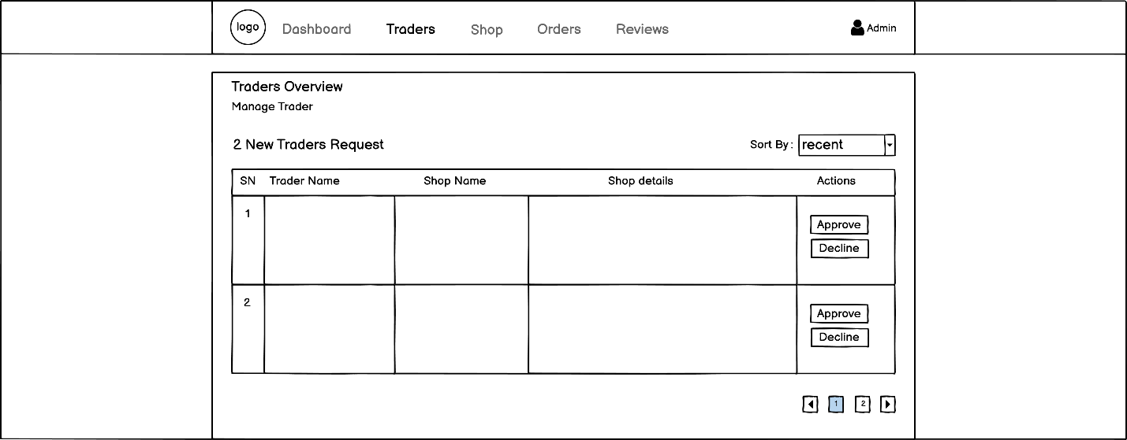

### Trader Wireframes

Add Product

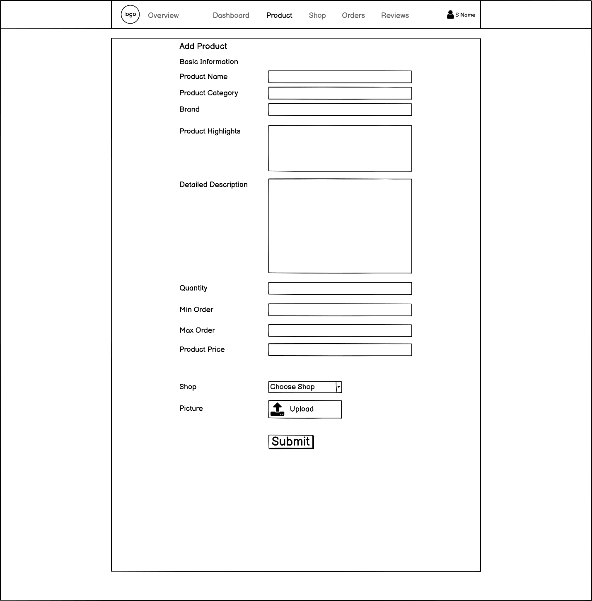

Edit Product

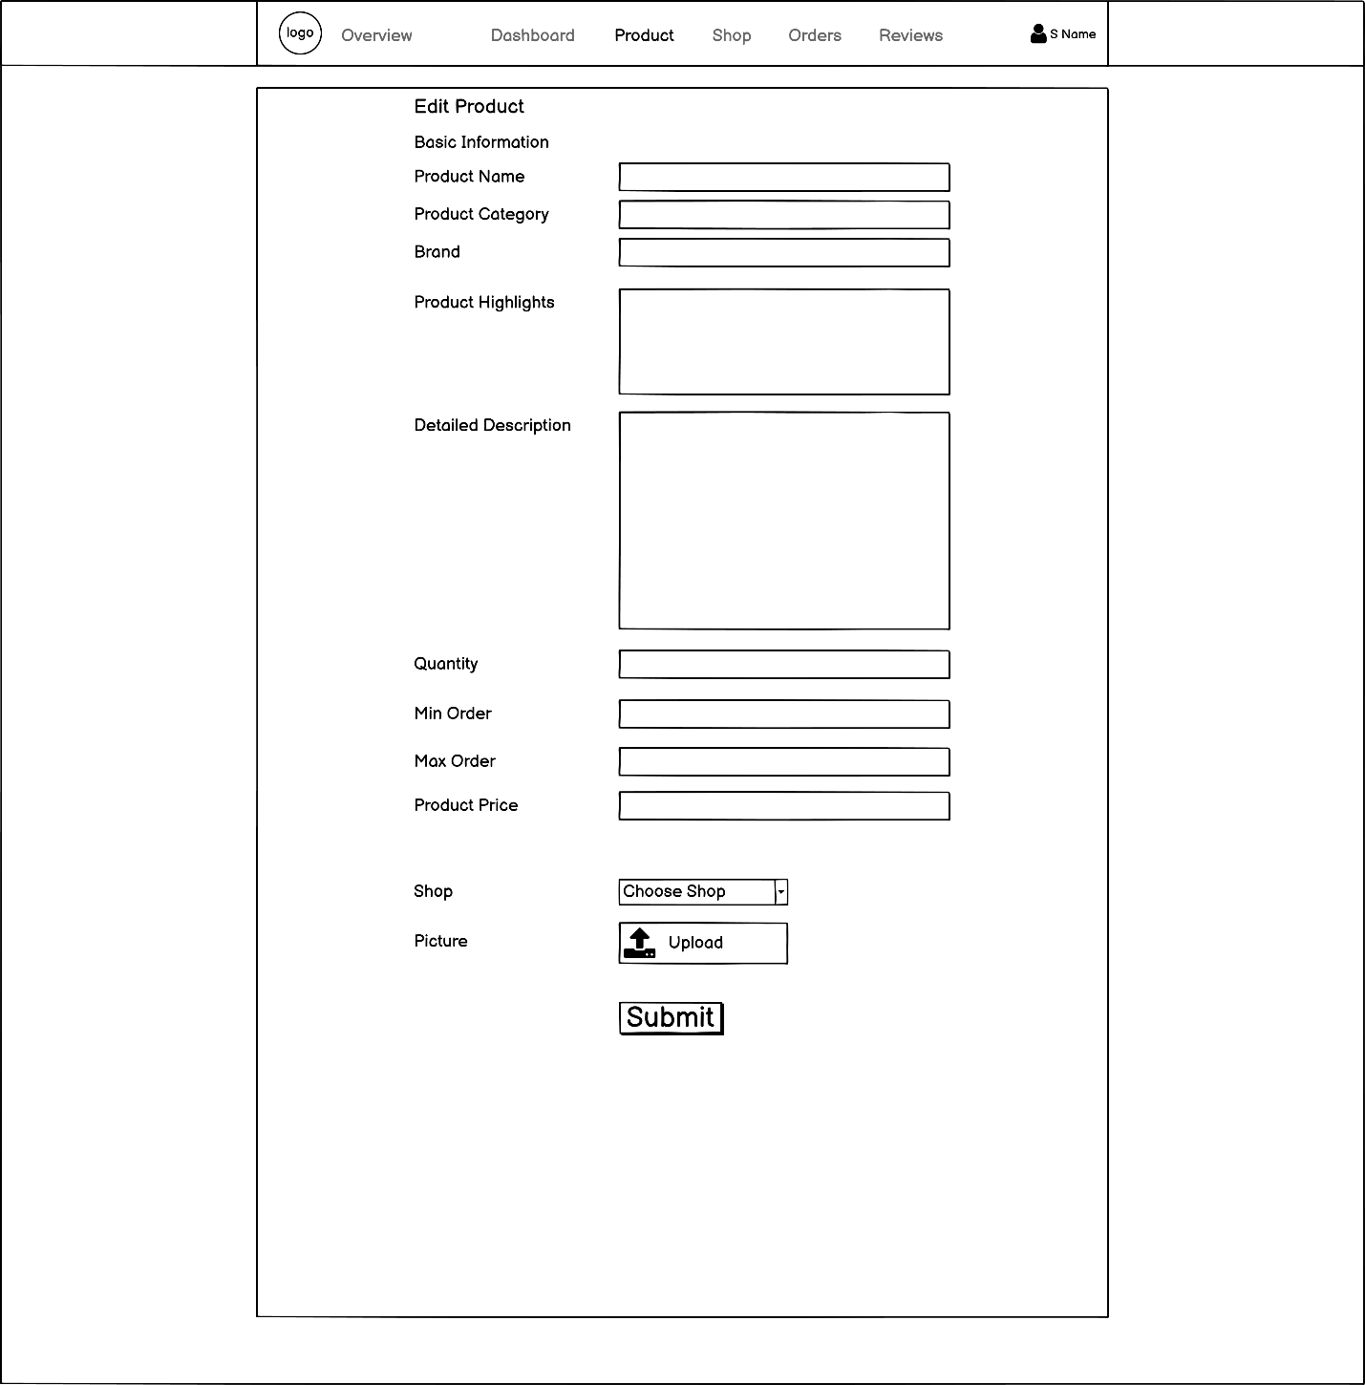

Sign In Trader

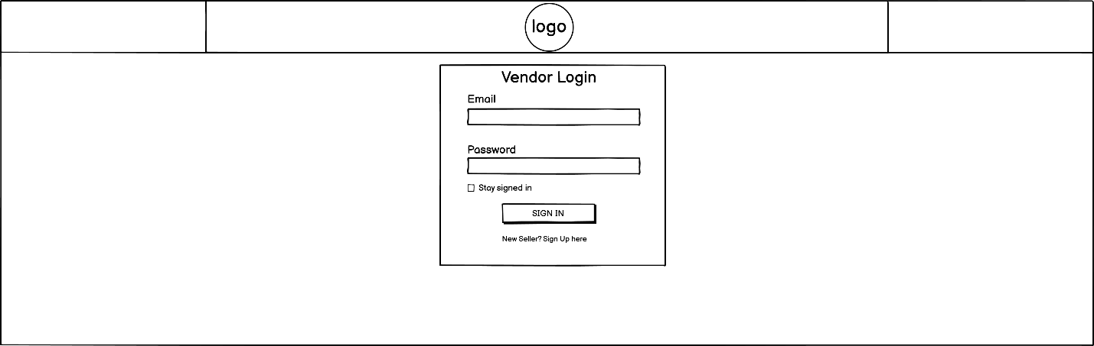

Sign up Trader

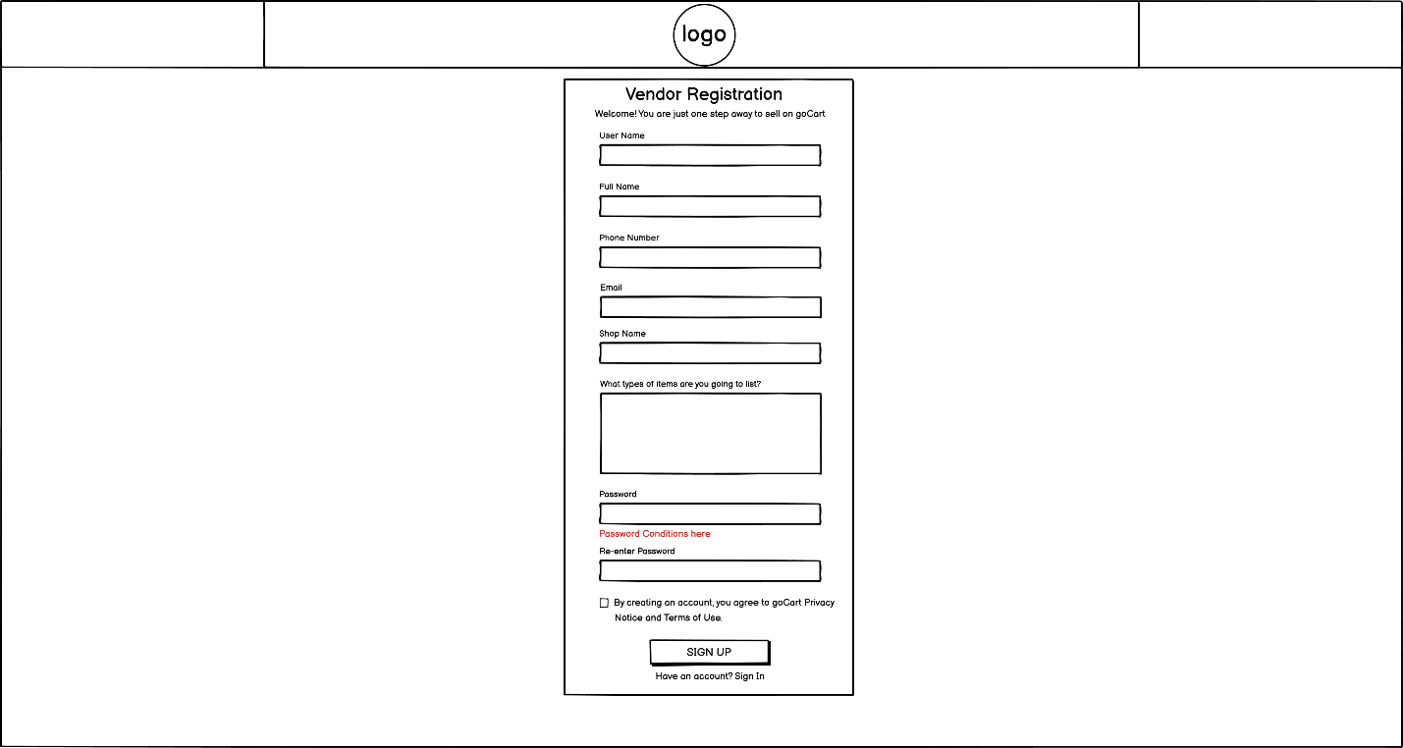

Trader add shop

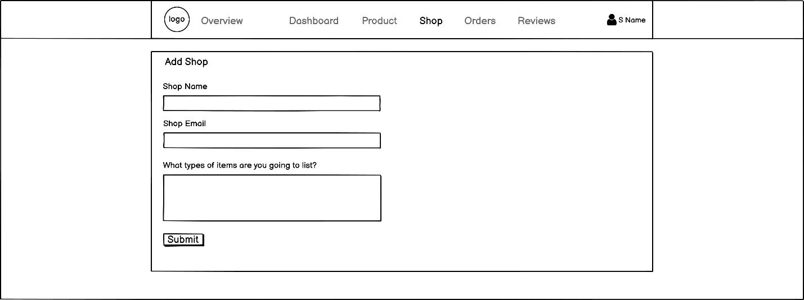

Trader edit profile

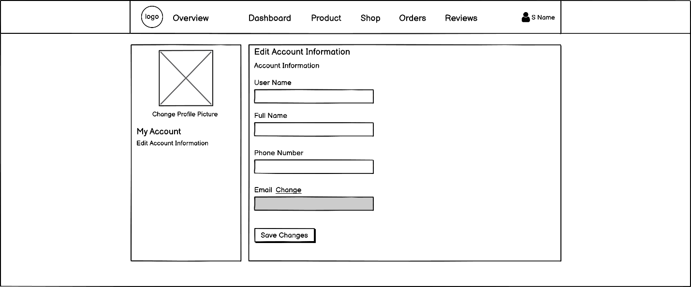

Trader Home

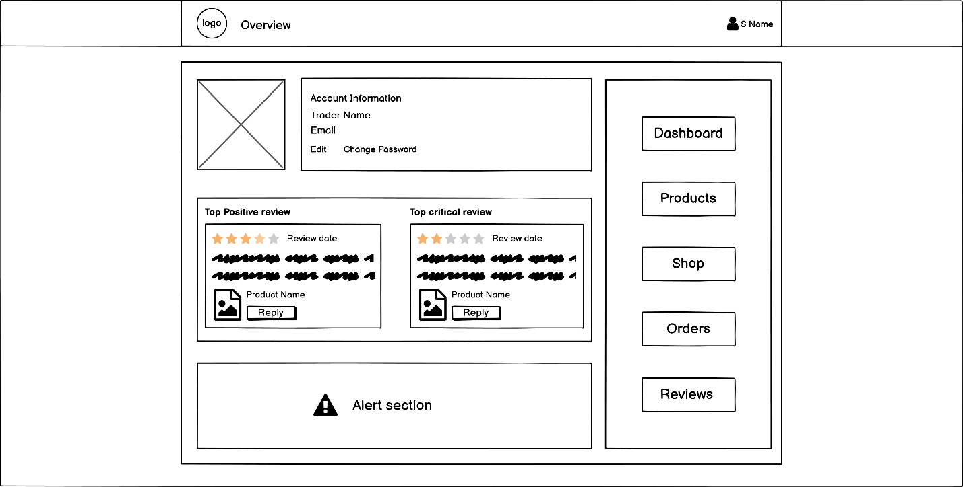

Trader orders

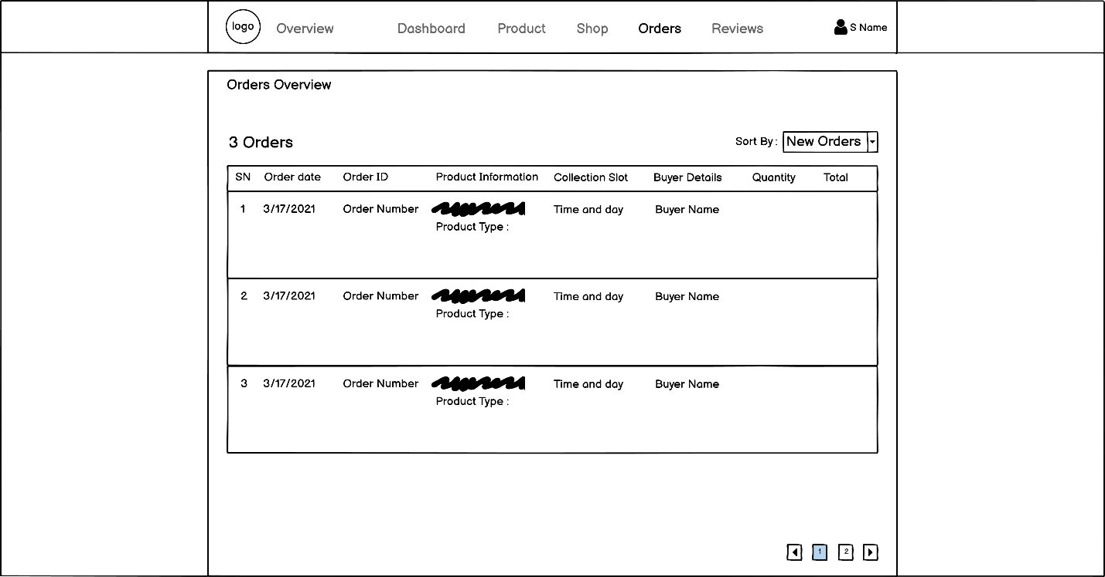

Trader Product CRUD

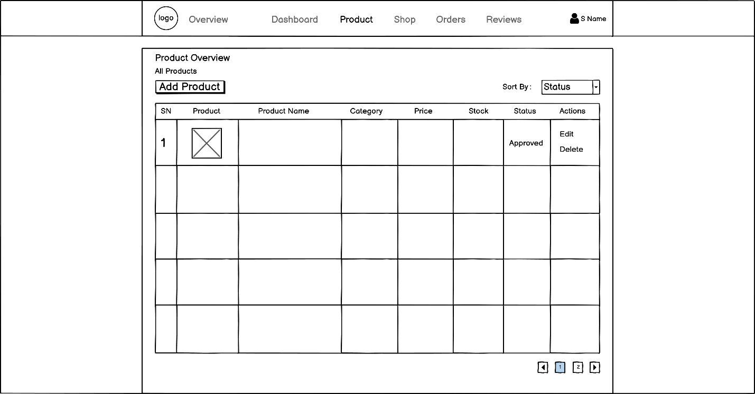

Trader review

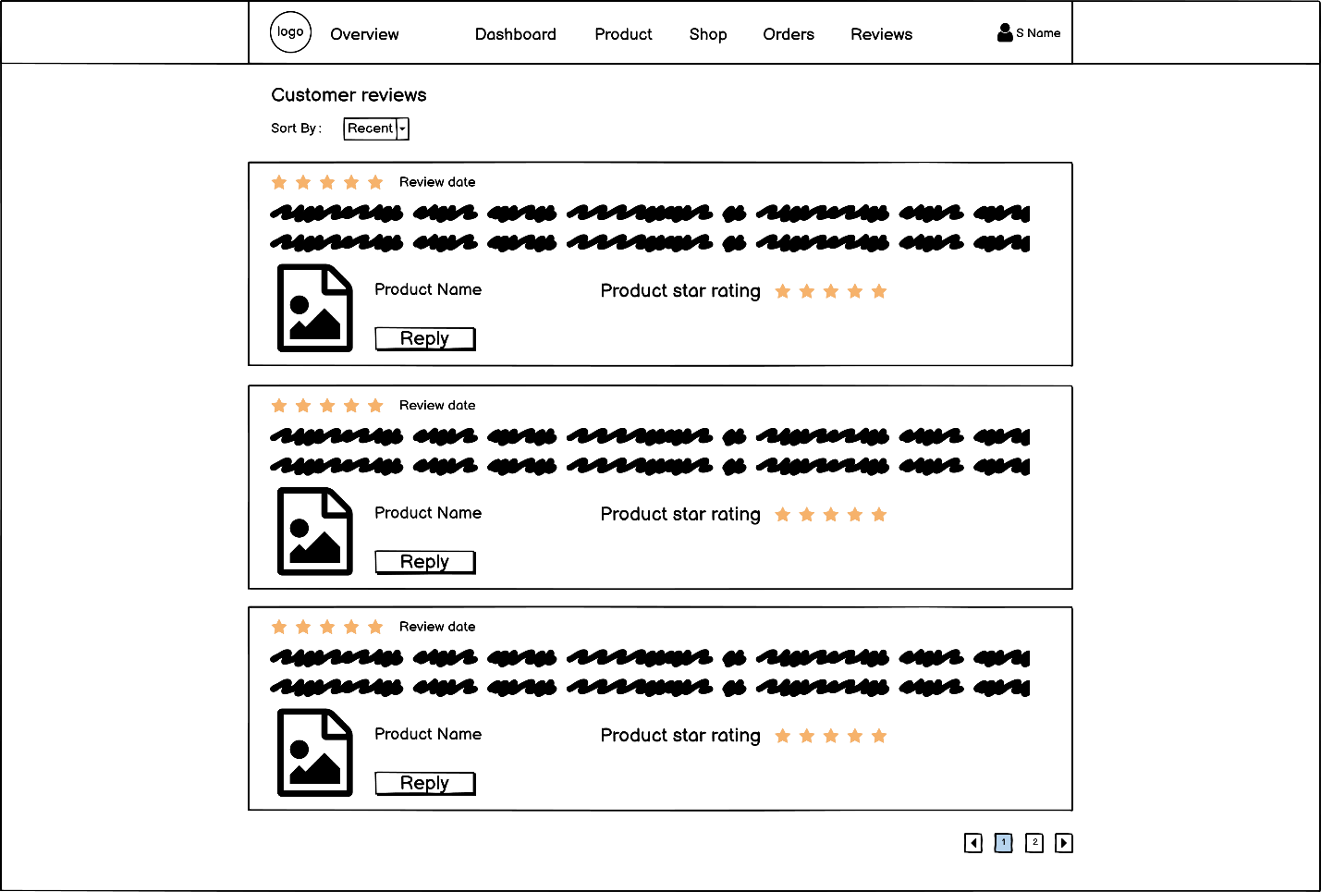

Trader Shop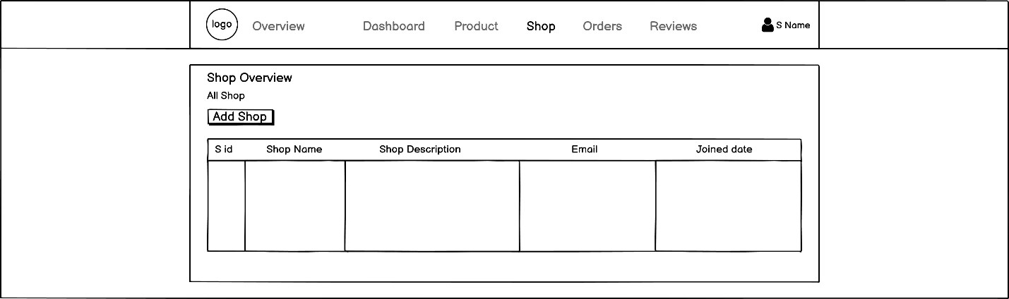

About Us

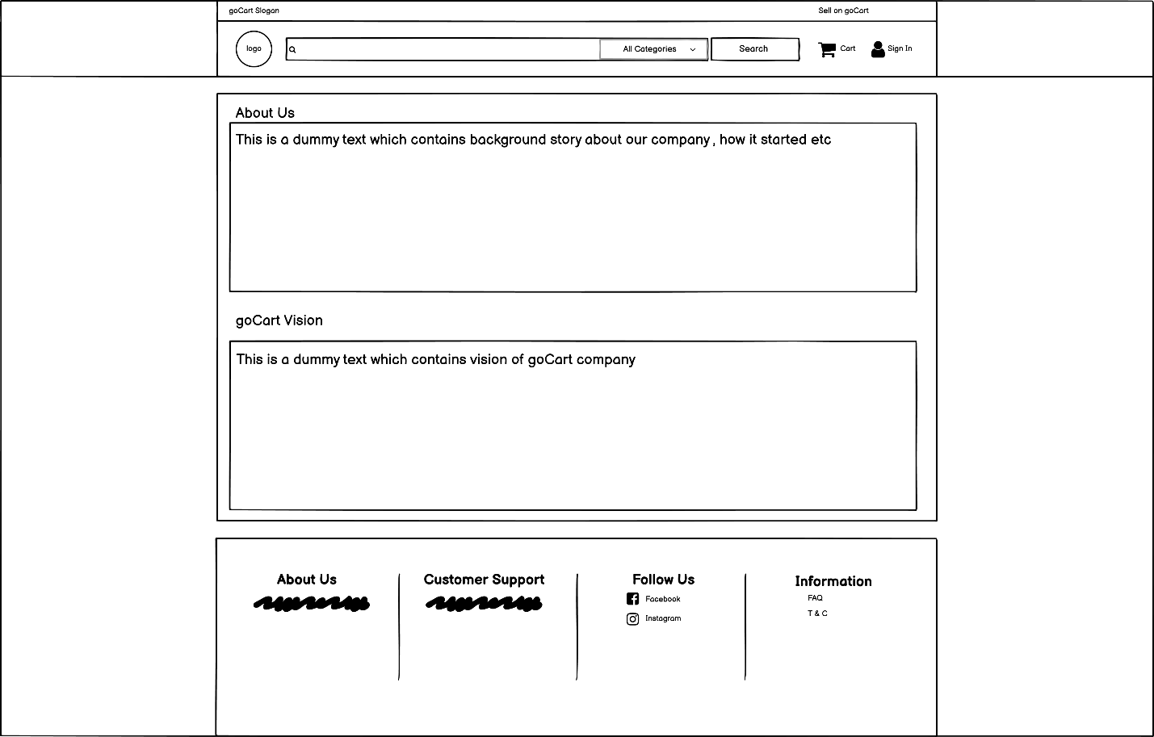

03) Product Development

Screenshots

Users PHP

Homepage:

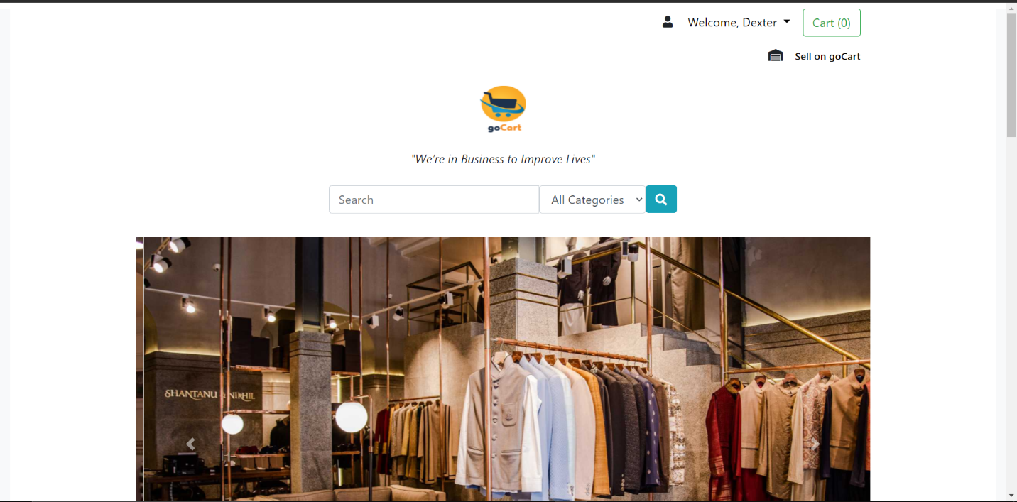

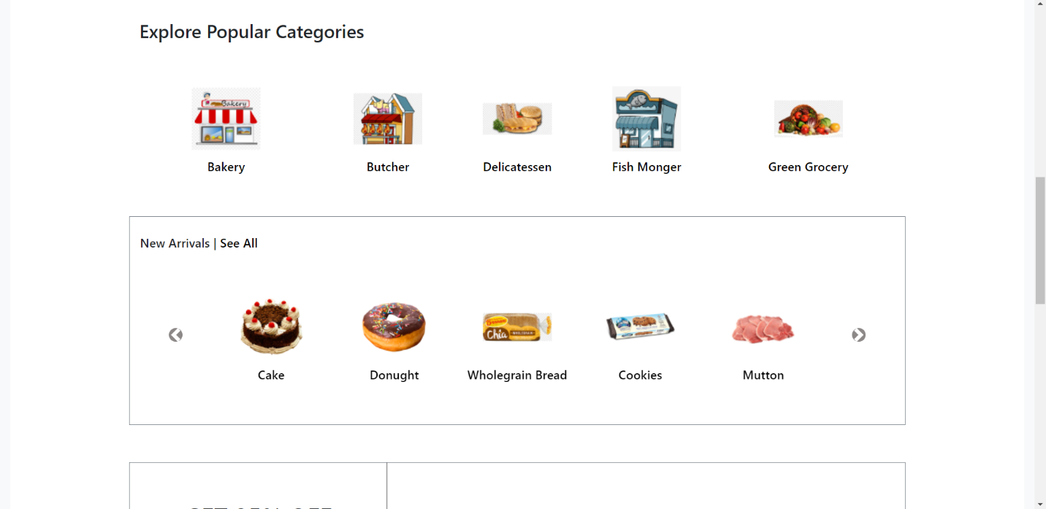

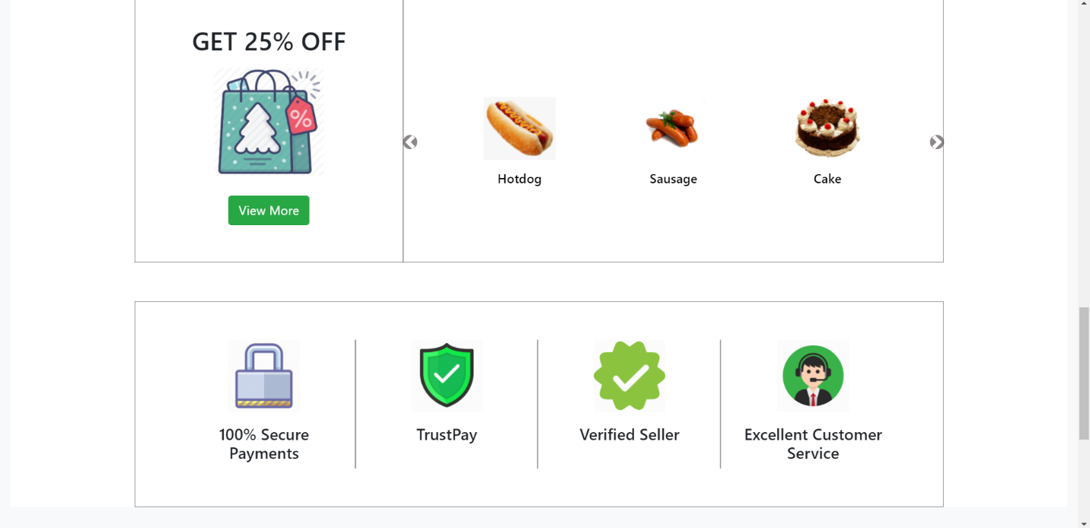

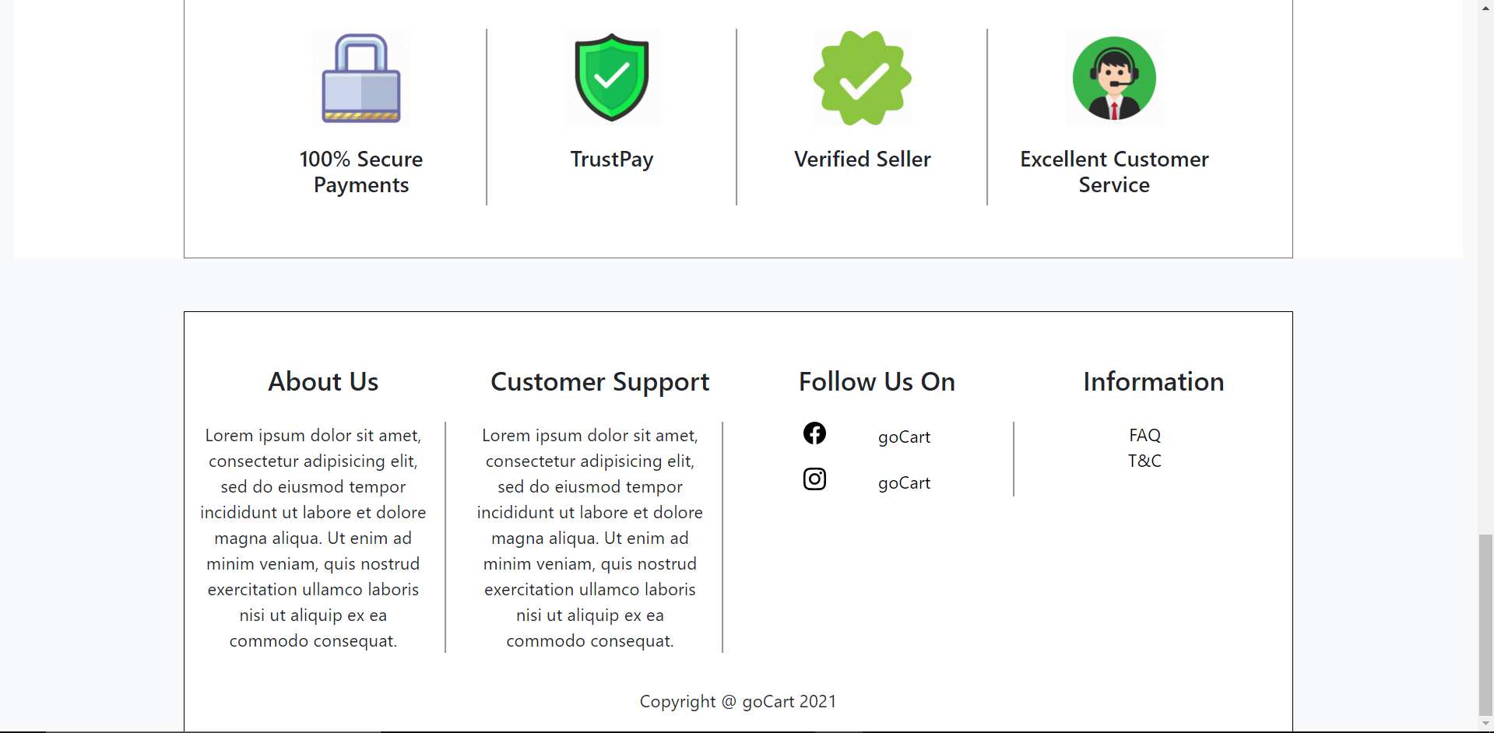

**Register:**

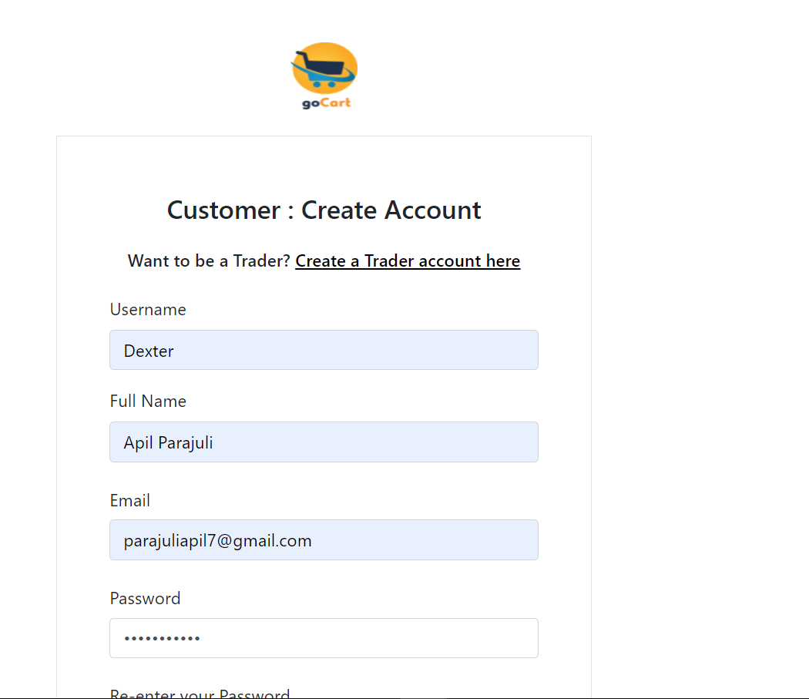

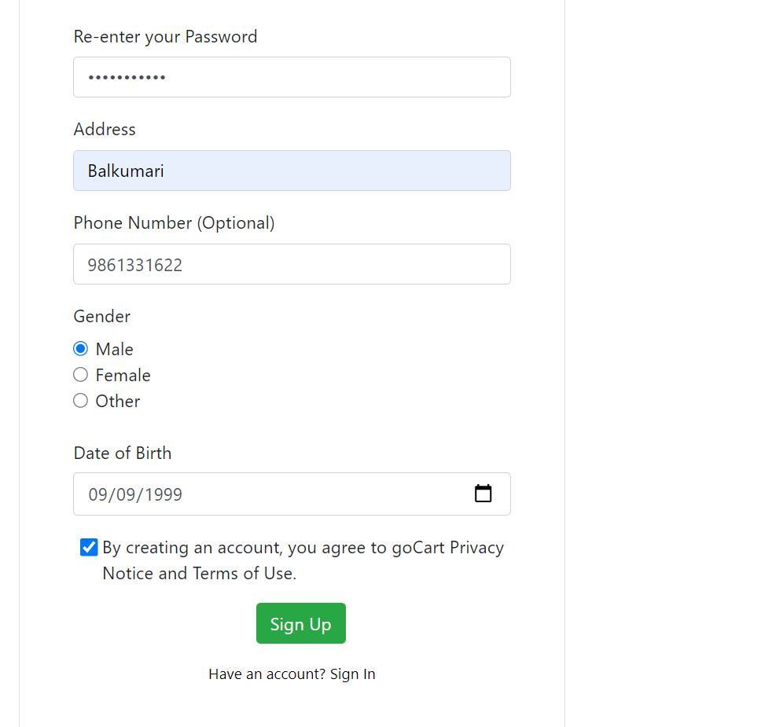

Email Verification:

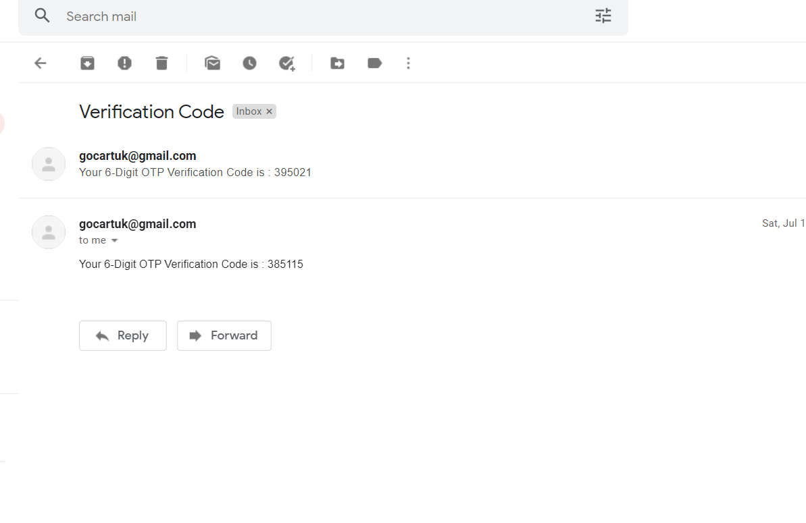

Sign in:

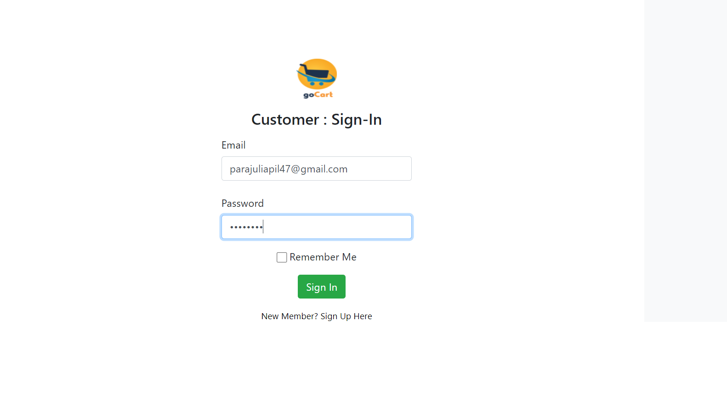

User Profile:



User Account:

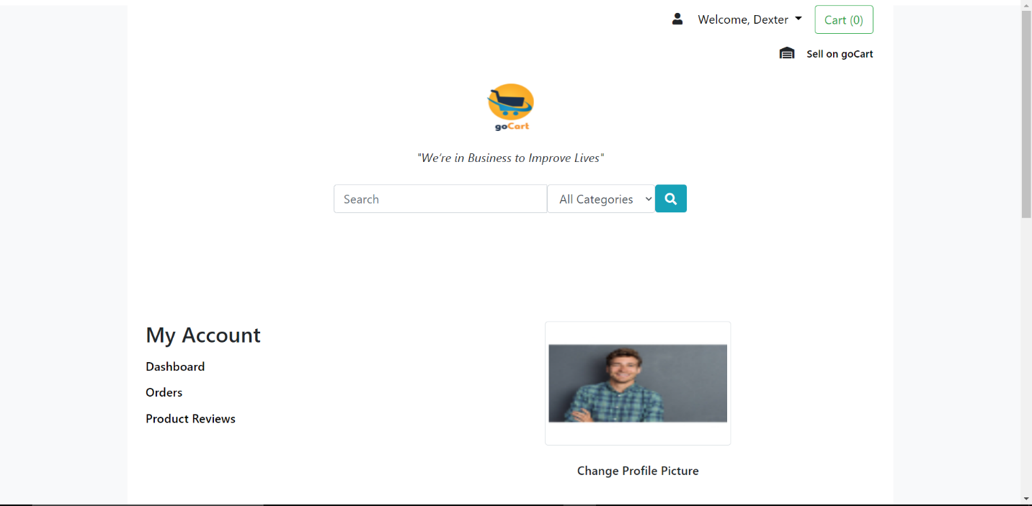

Shop:

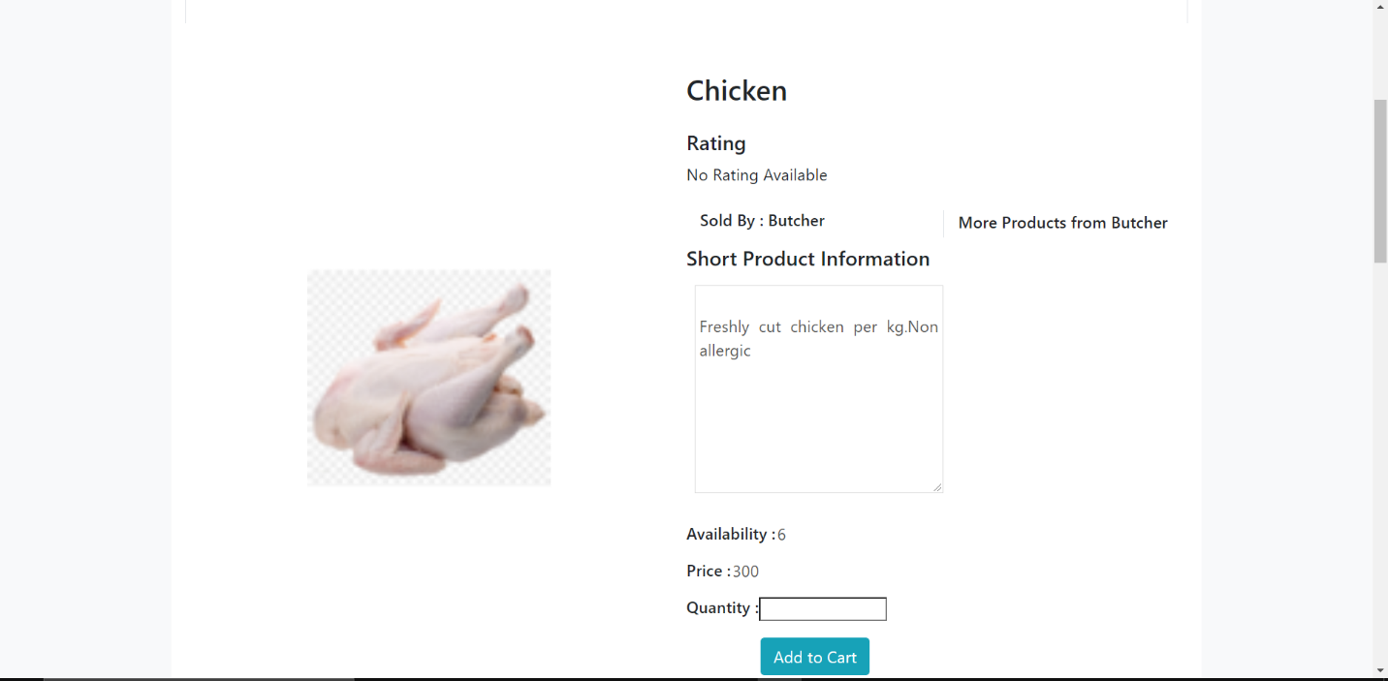

Product Description and Review:

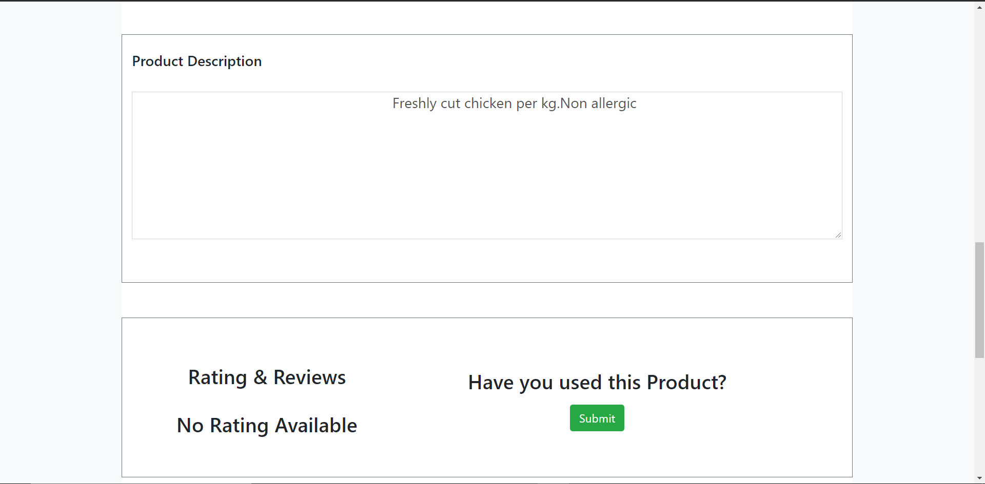

Product with Category:

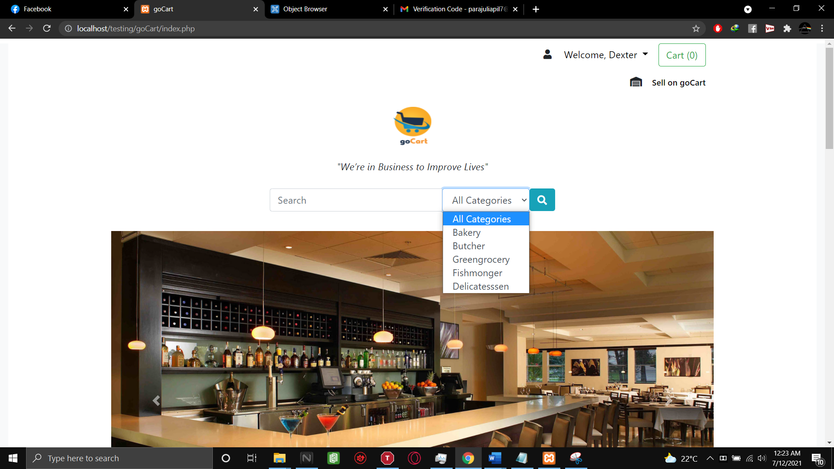

Cart:

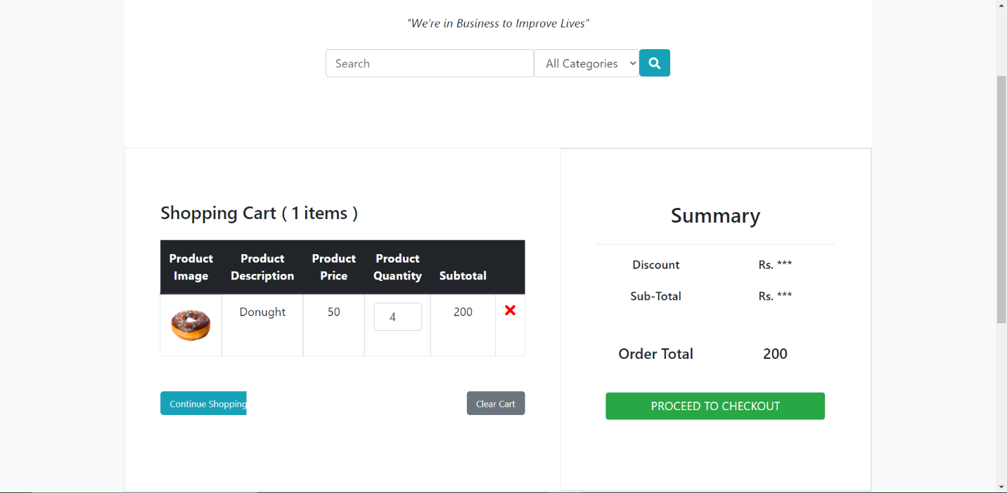

Paypal:

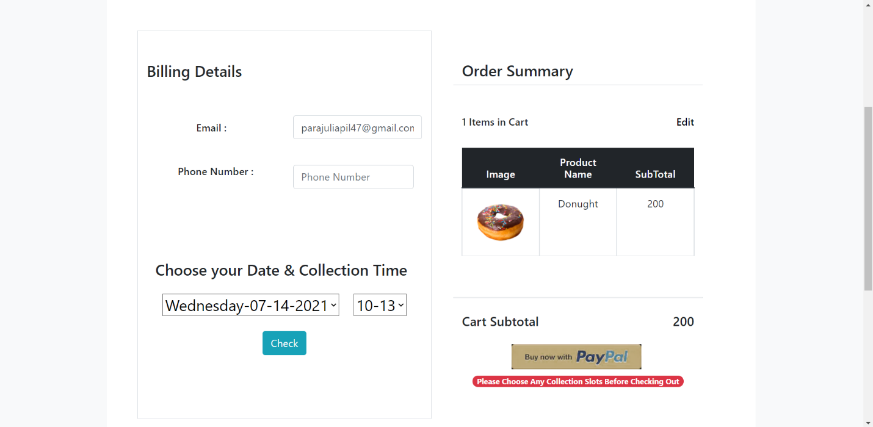

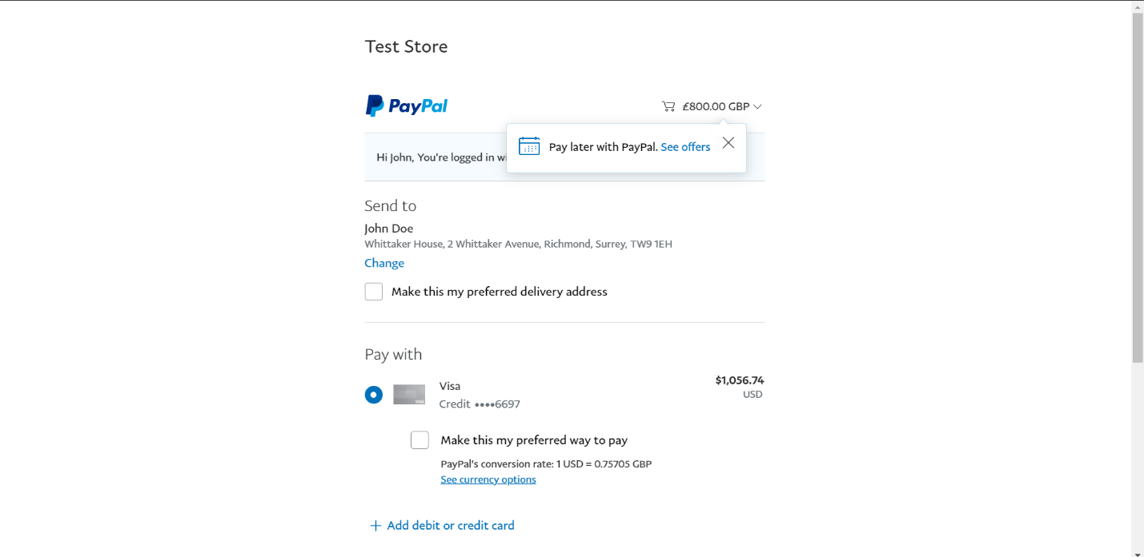

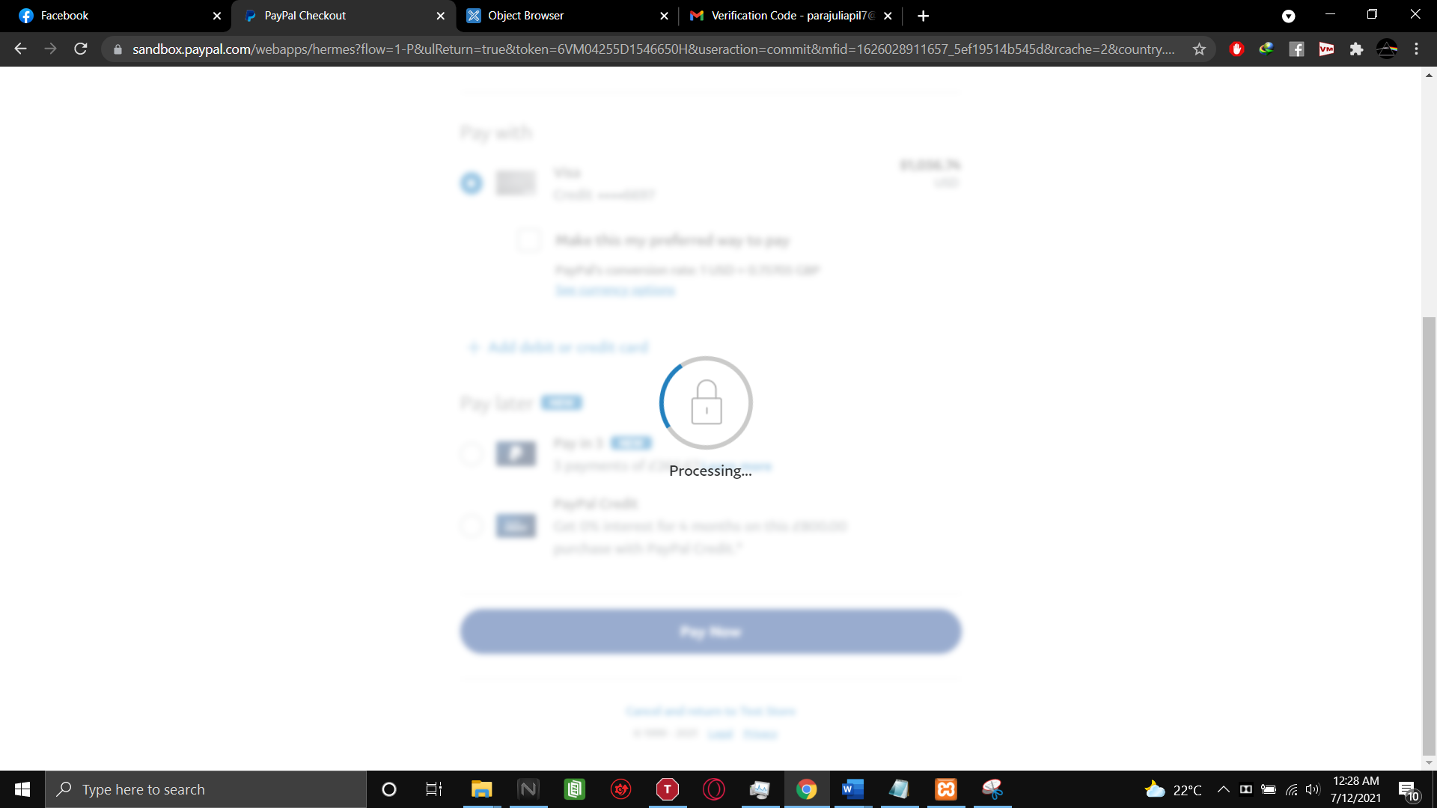

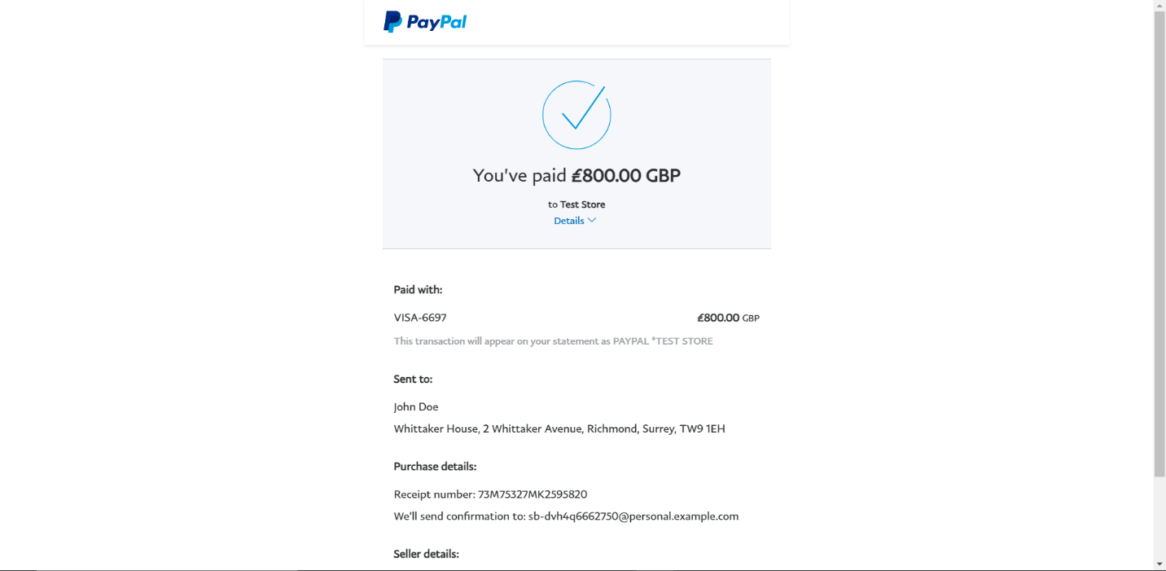

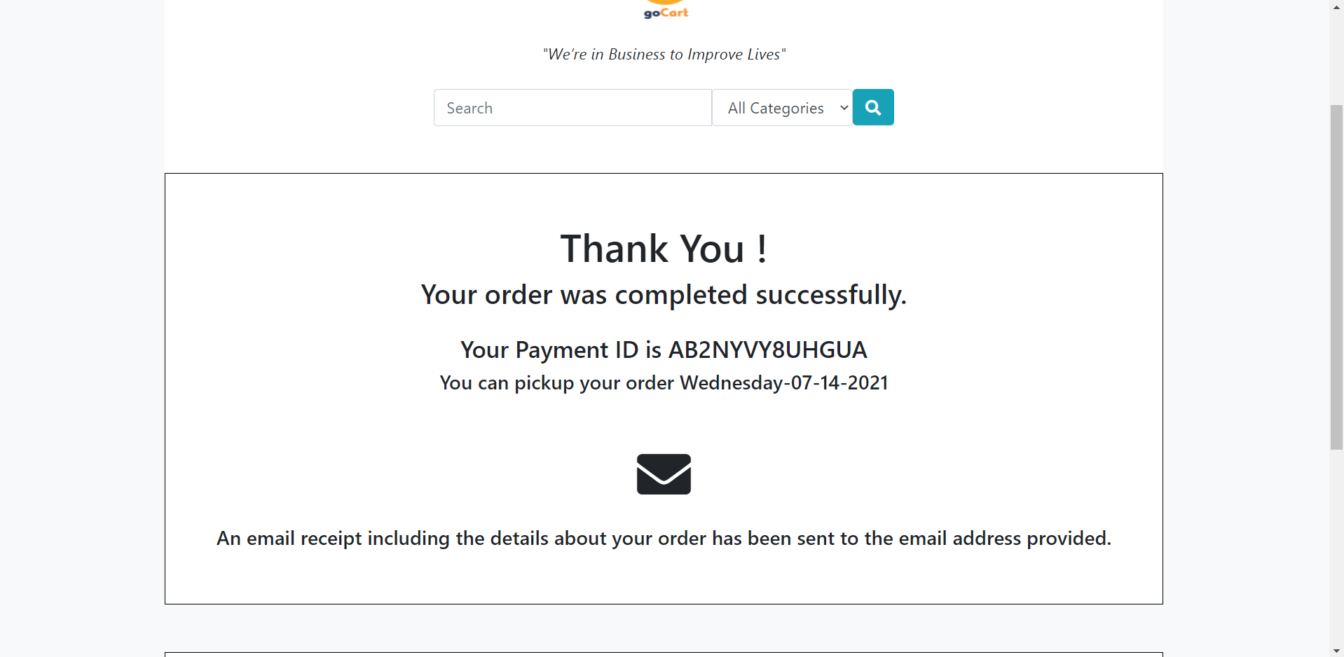

User Invoice:

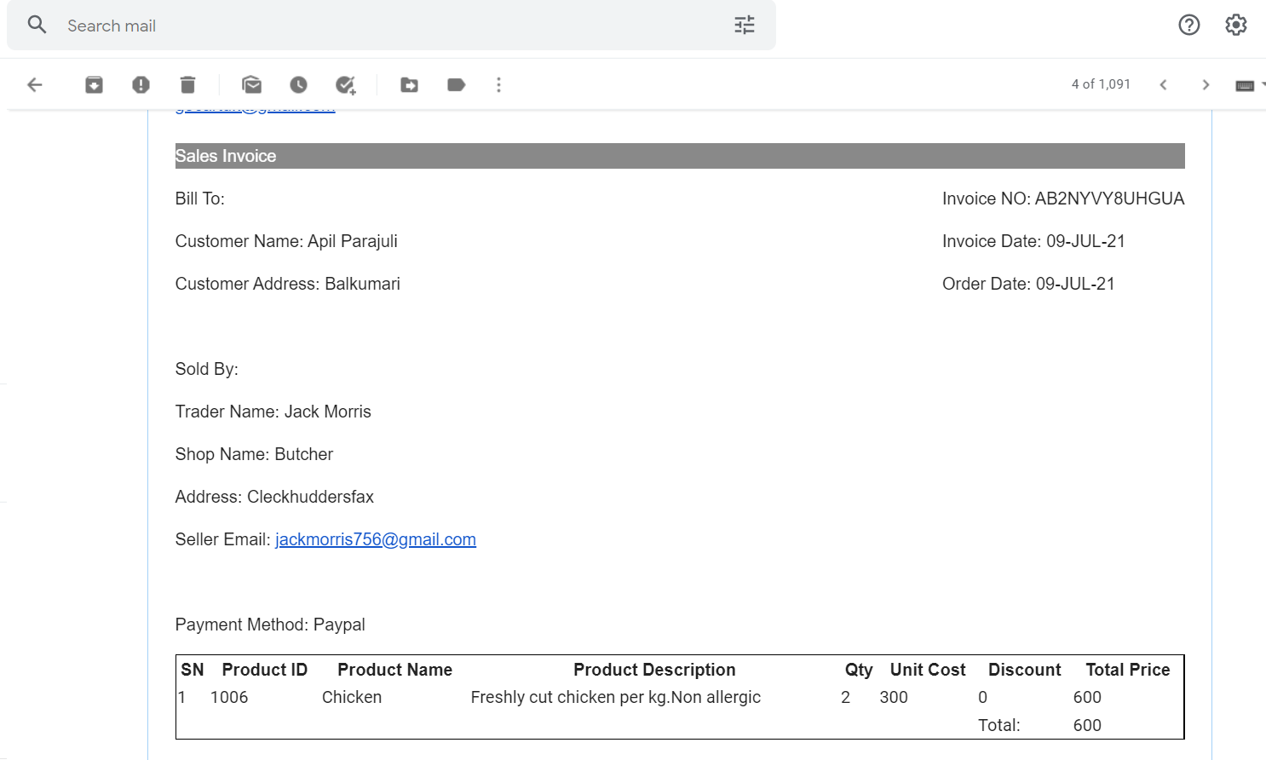

Evaluation:

|  |  |  |  |
| --- | --- | --- | --- |
|  |  |  |  |
| Login |  |  |  |
|  | Wrong information entered | Error message displayed | Pass |
|  | Valid information is entered | User signs in and moves into homepage. | Pass |
|  |  |  |  |
| Shop |  |  |  |
|  | Product display | Products can be viewed in different forms | Pass |
|  | Add to cart | Clicking on the add to cart button moves the item to the users cart. | Pass |
|  | Product Description | Clicking on a products image takes the user to the product description page | Pass |
|  |  |  |  |
| Cart |  |  |  |
|  | Cart Products | User can add, remove and make an order. | Pass |
|  | Checkout | Ordered products and a PayPal invoice are shown. | Pass |
|  | PayPal | The user logs into PayPal and pays the amount. | Pass |
|  | Invoice | User receives an invoice in their mail. | Pass |

Trader Interface (PHP):

Register Login:

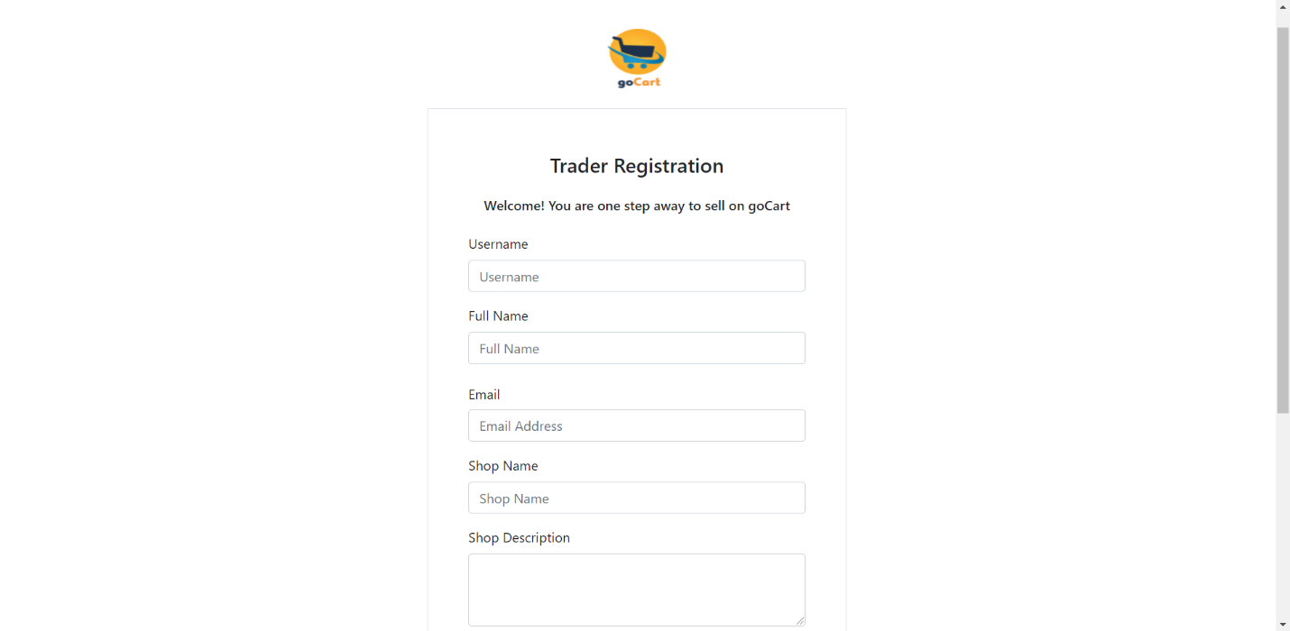

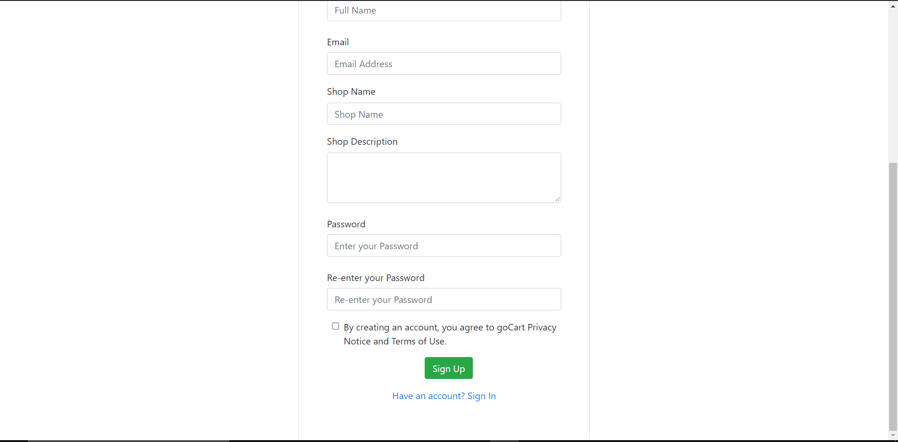

Invalid Credentials:

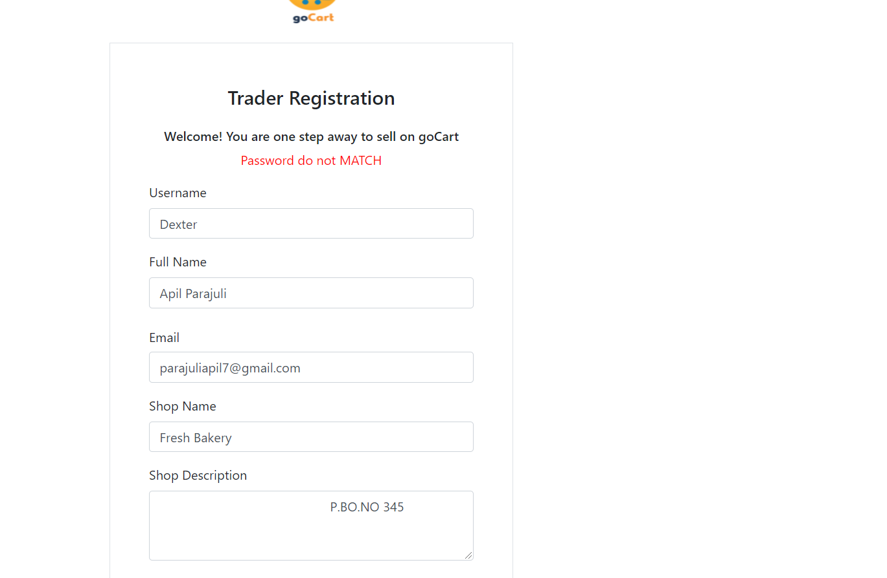

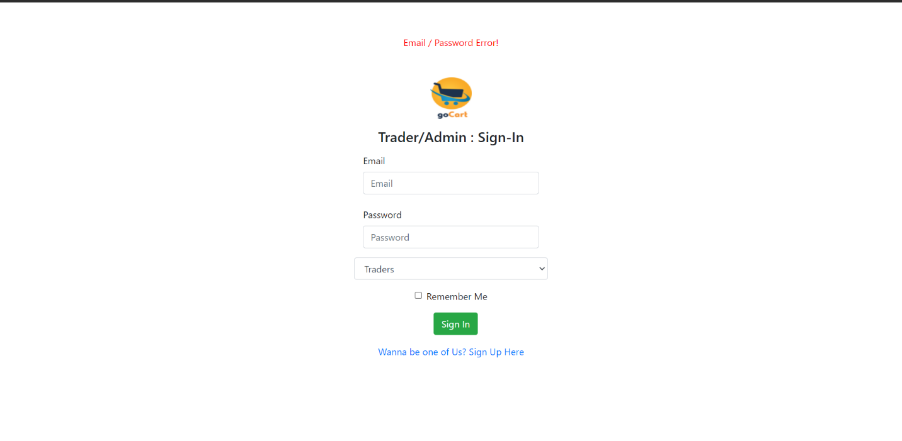

Trader’s Dashboard:

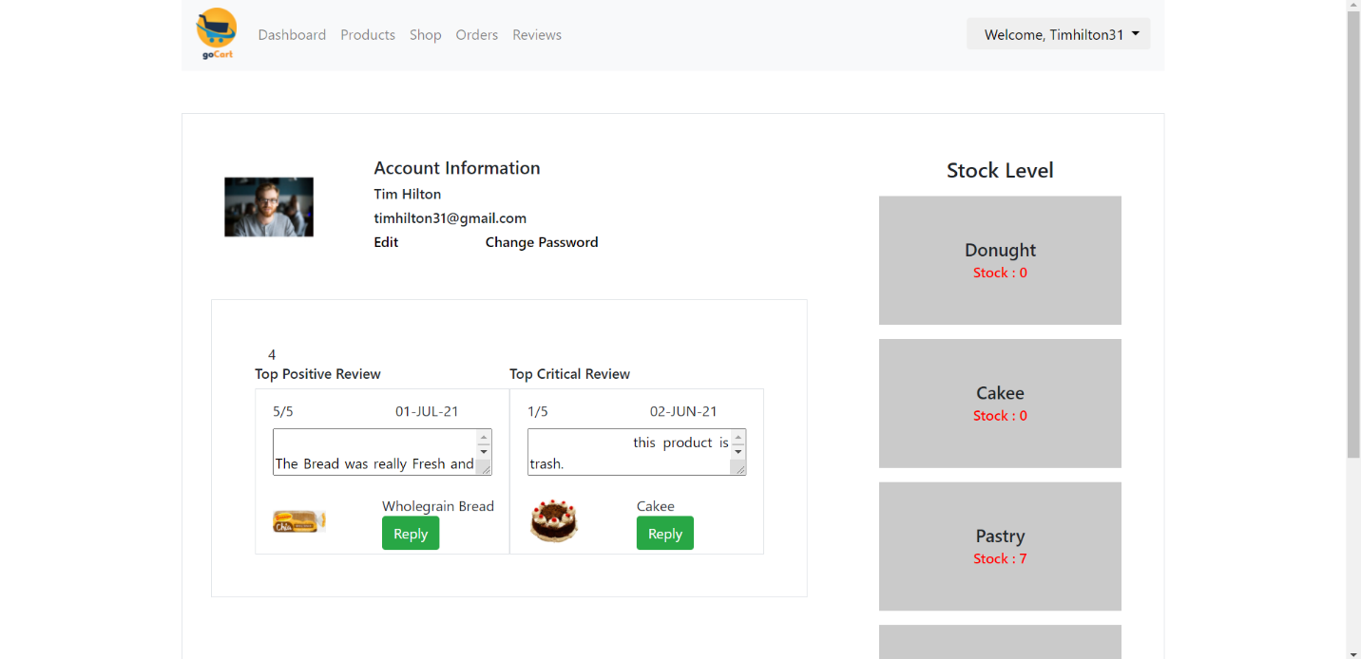

Edit Account:

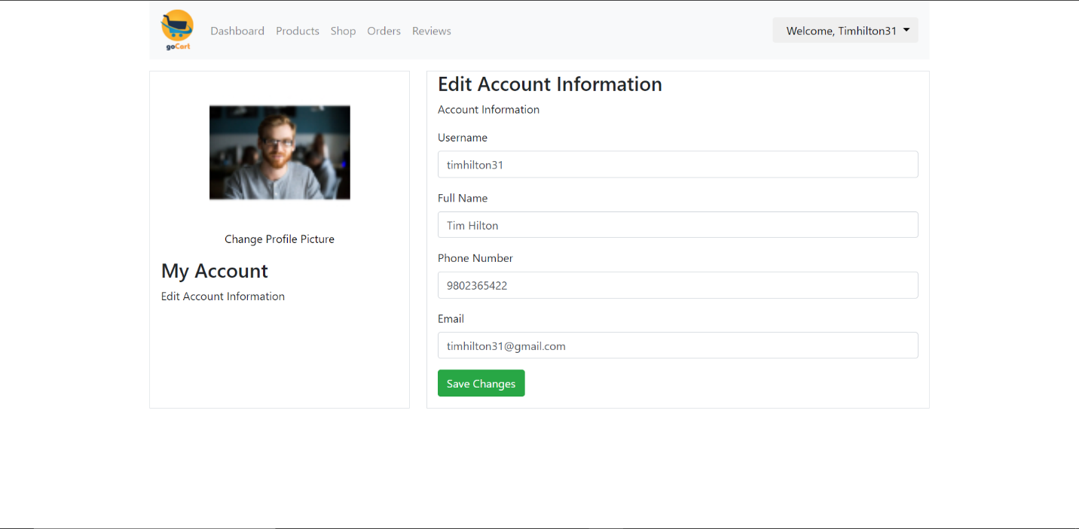

Add Shop:

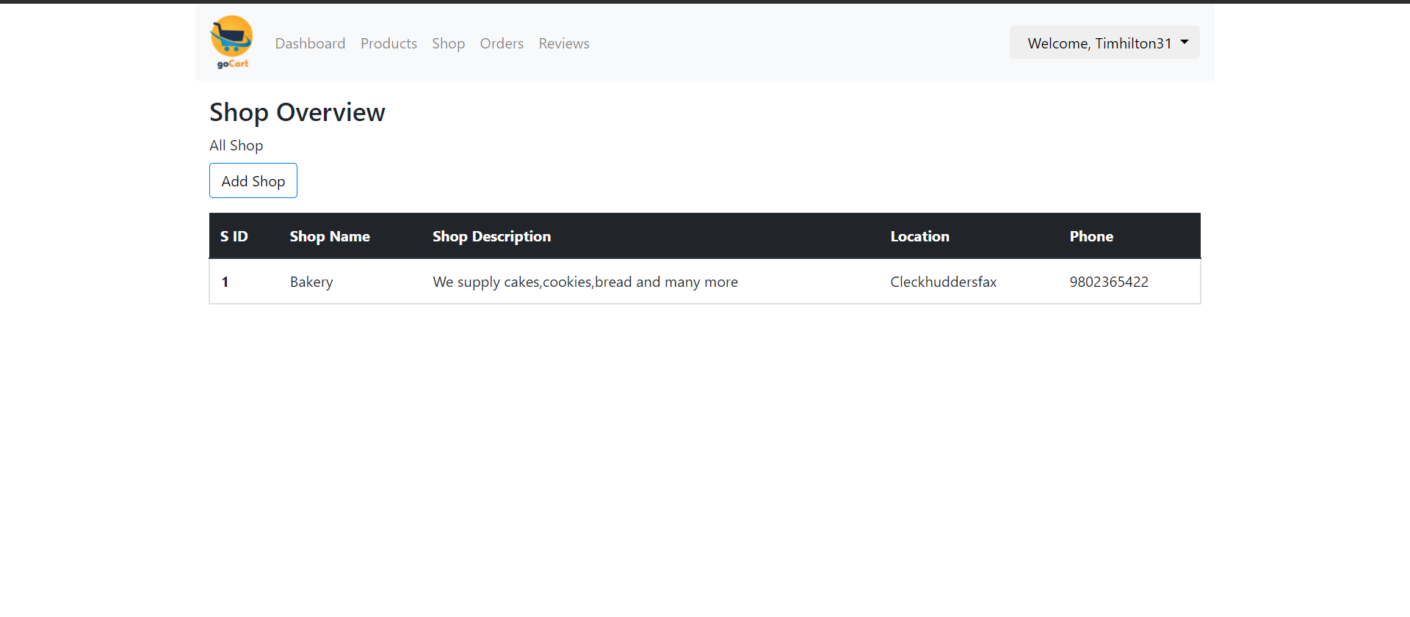

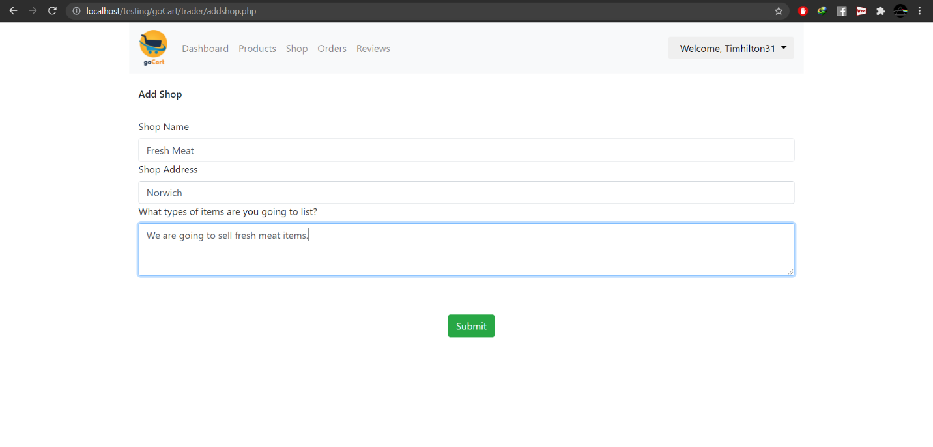

Products:

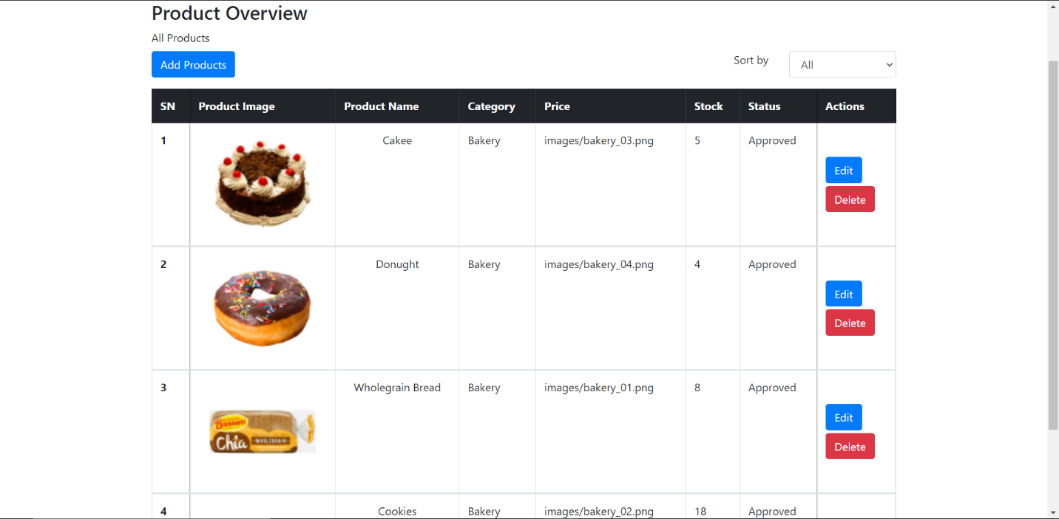

Add Products:

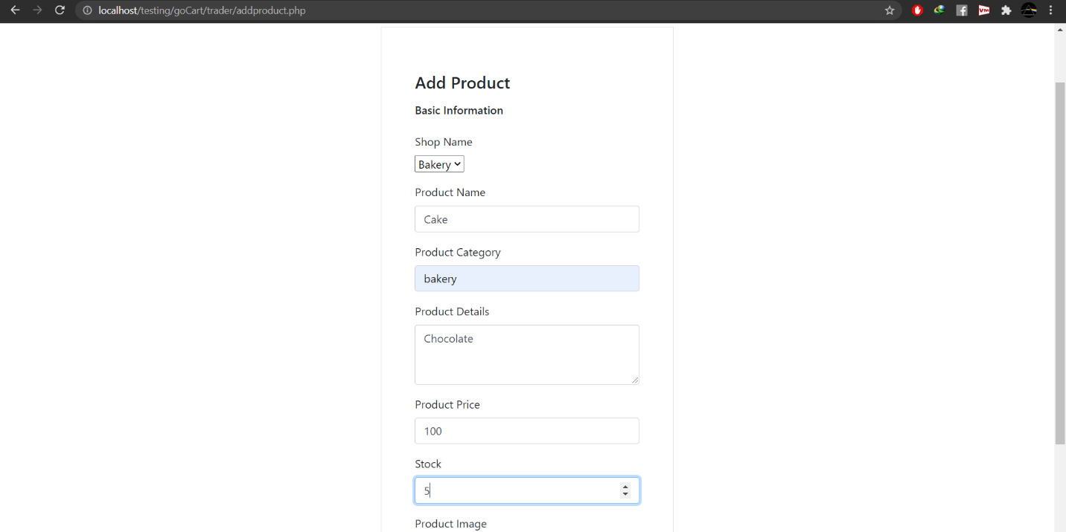

Edit Products:

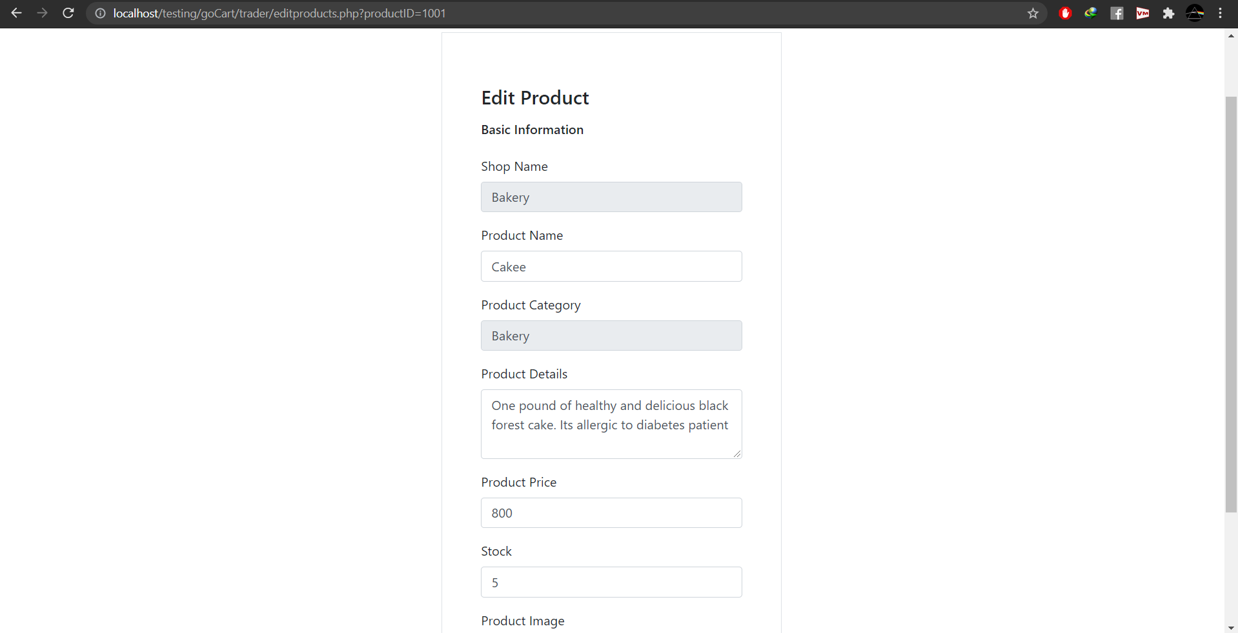

Orders:

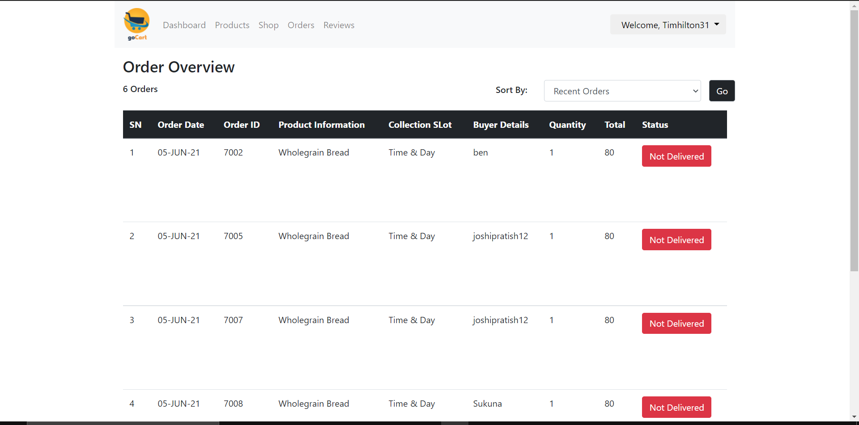

Reviews:

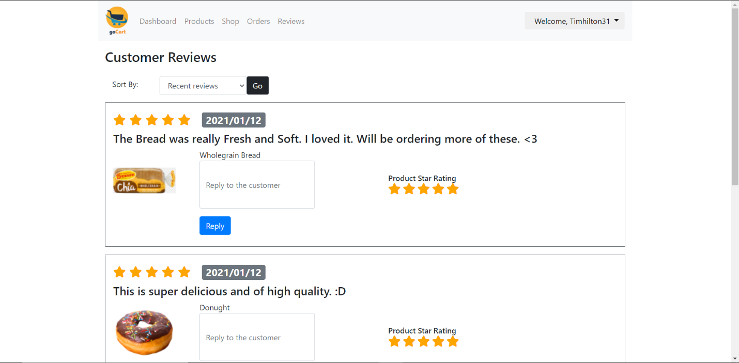

### Evaluation:

|  |  |  |  |
| --- | --- | --- | --- |
| **Description** | **Step** | **Expected Result** | **Pass/Fail** |
| Register |  |  |  |
|  | Enter invalid credentials | Error message is displayed | Pass |
|  | Enter valid credentials | Wait for admins approval. | Pass |
|  |  |  |  |
| Login |  |  |  |
|  | Valid credentials are entered | Trader is redirected to login page. | Pass |
|  |  |  |  |
| Add Shop |  |  |  |
|  | Form is filled incorrectly | Error message is displayed. | Pass |
|  | Form is filled correctly | new shop is added under the traders name. | Pass |
|  |  |  |  |
| Products |  |  |  |
|  | Filling out the add product form correctly | Product is added to shop. | Pass |
|  | Filling out the add product form incorrectly | Error message is displayed. | Pass |

Trader Dashboard (Oracle)

Login:

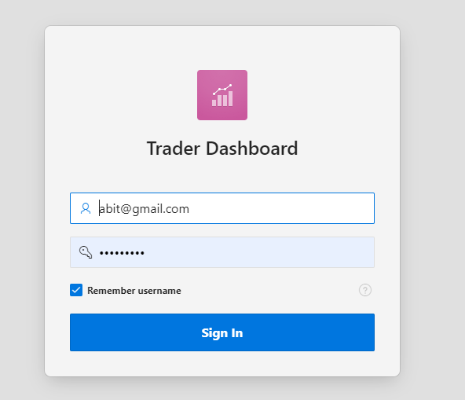

Login Invalid:

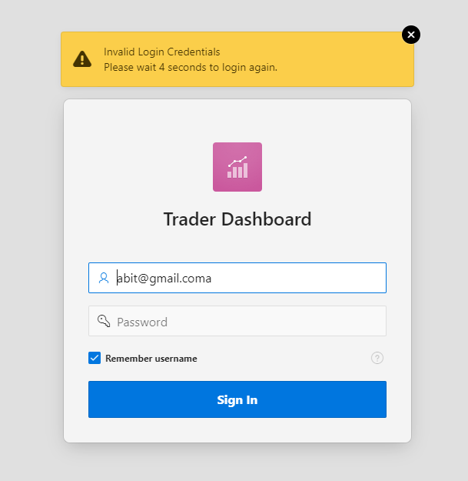

Trader Dashboard:

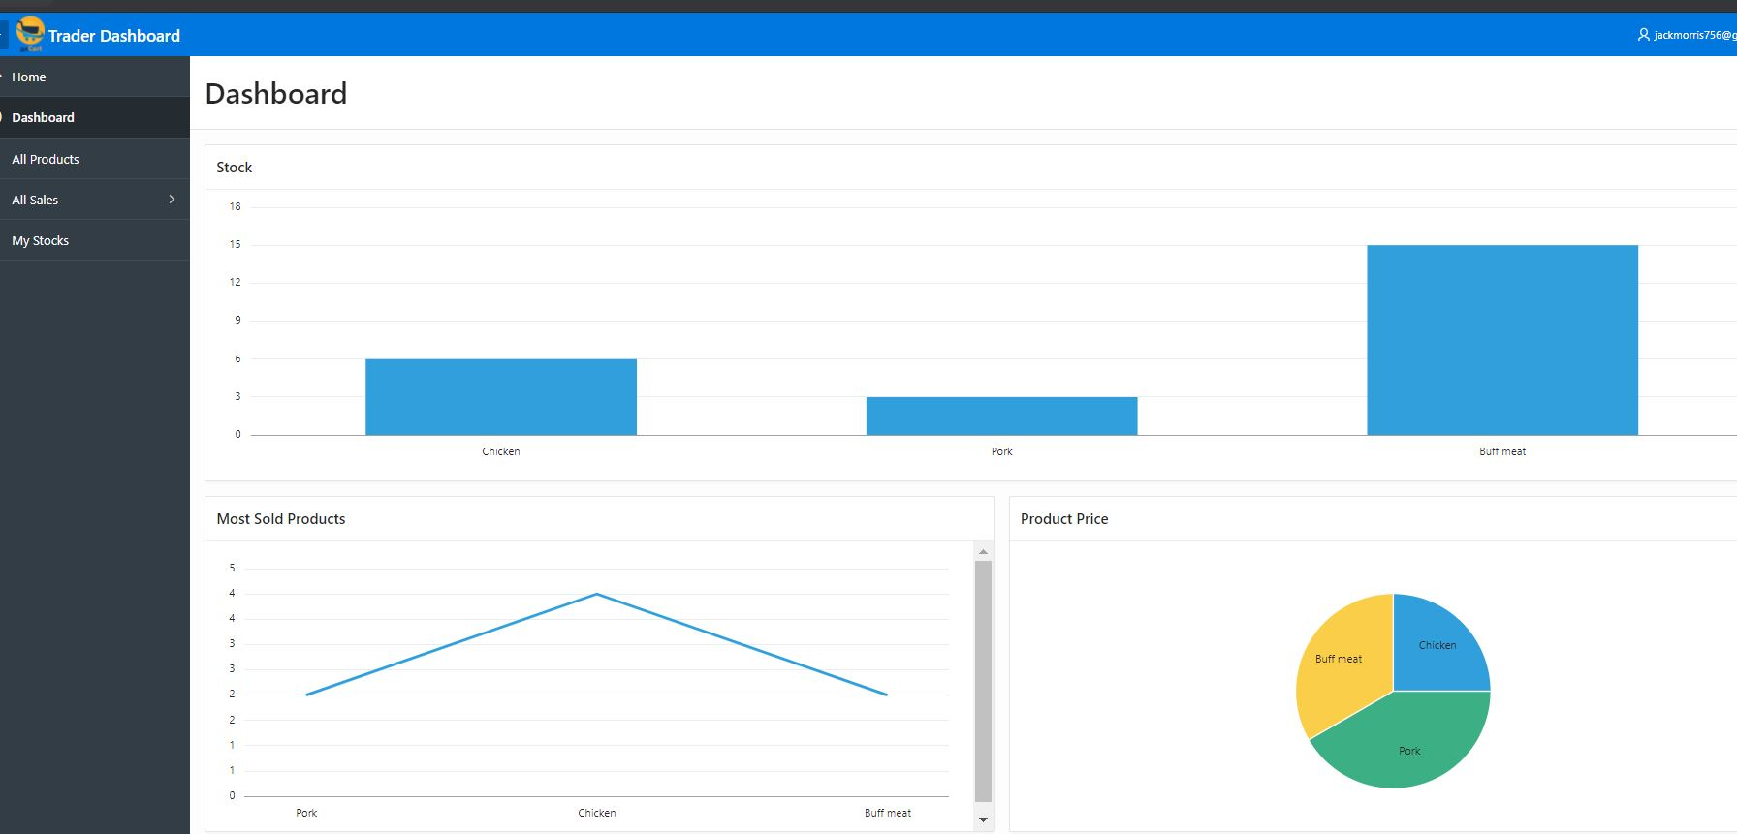

Daily Sales:

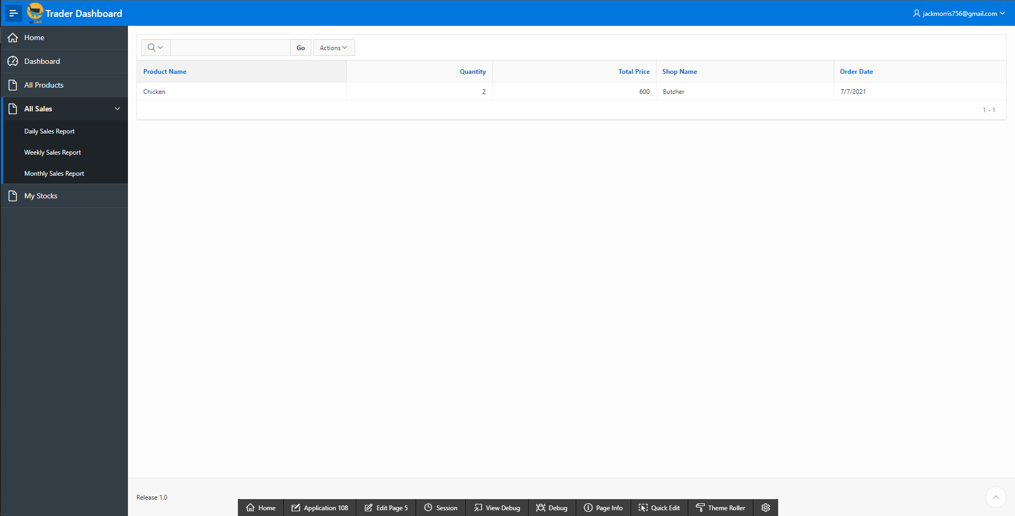

Weekly Sales:

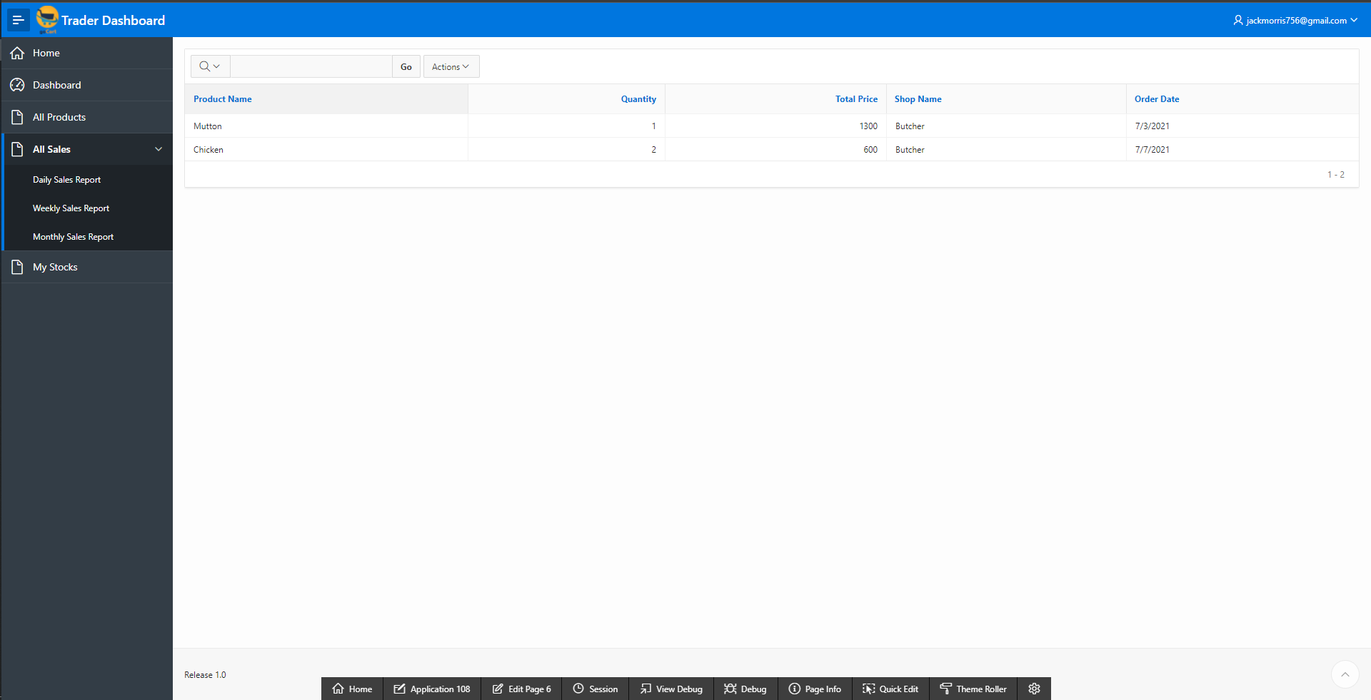

Monthly Sales:

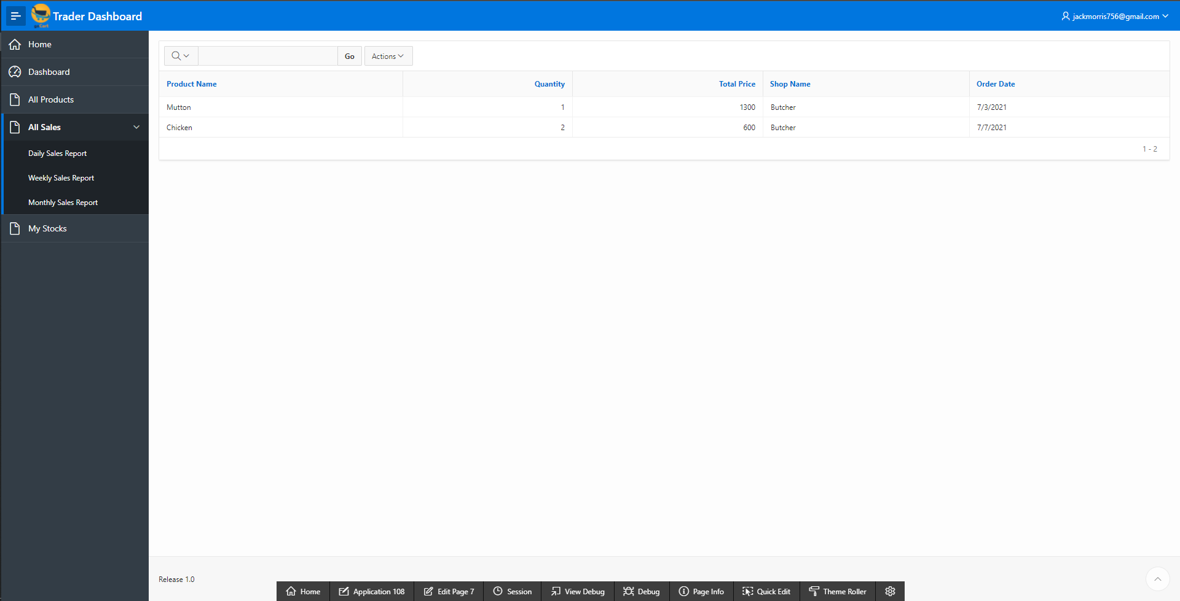

Products:

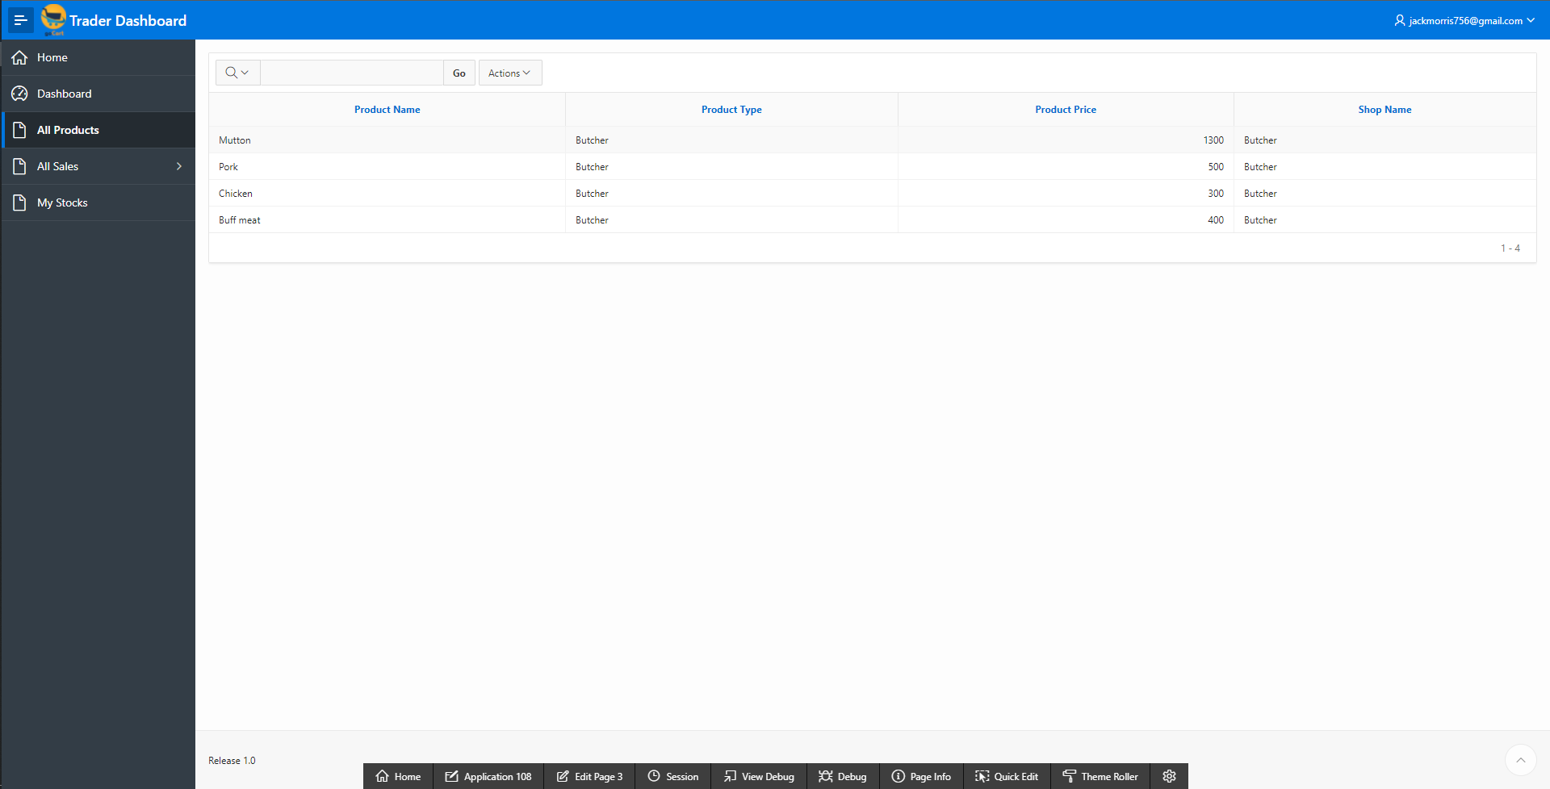

Stocks:

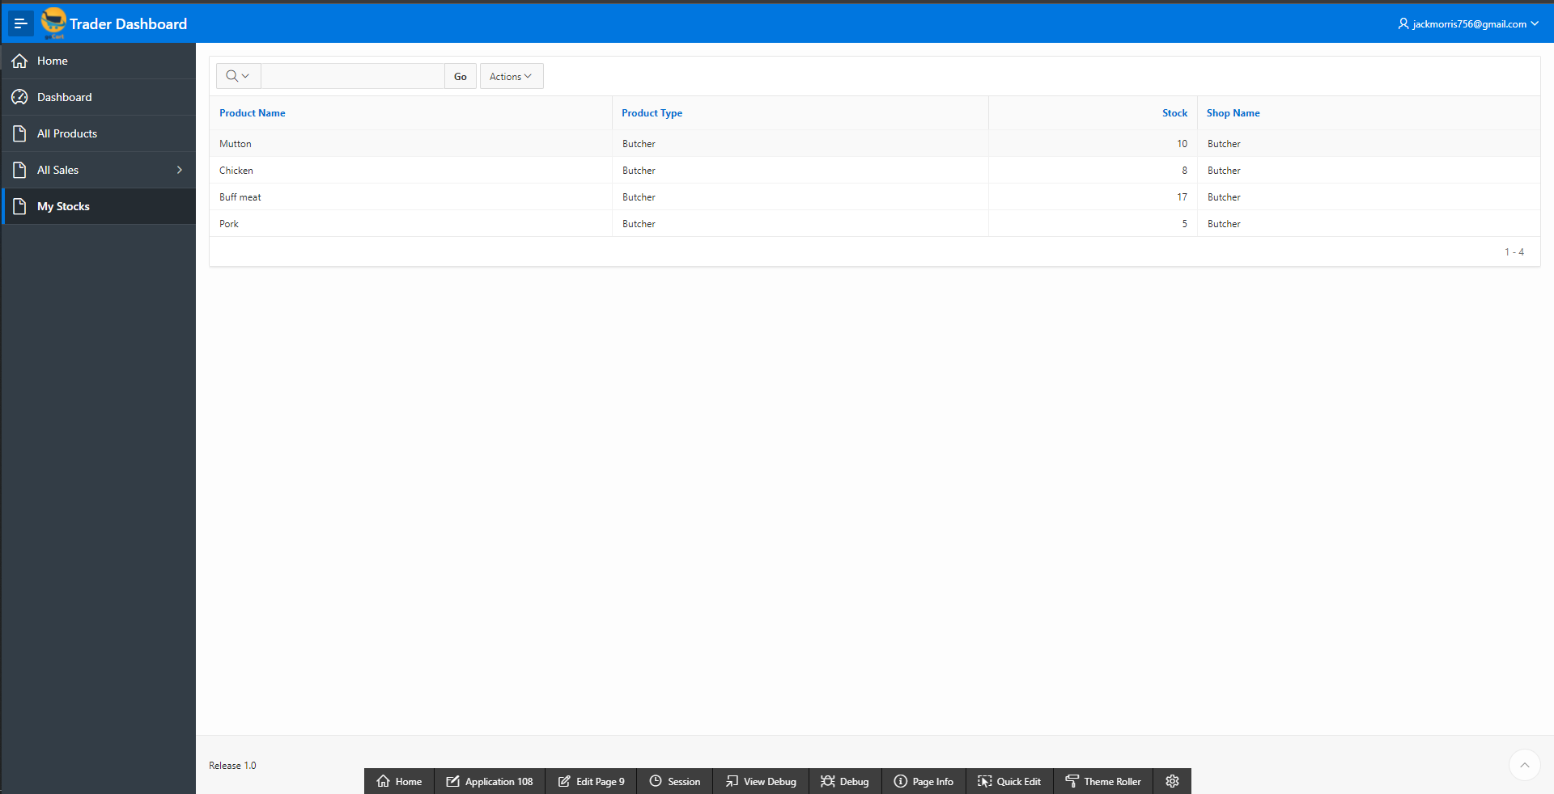

### Evaluation:

|  |  |  |  |
| --- | --- | --- | --- |
| **Description** | **Step** | **Expected Result** | **Pass/Fail** |
| Login |  |  |  |
|  | Login with wrong information | An error message of invalid login credentials is shown and asks the trader to wait 5 seconds before trying to log in again. | Pass |
|  | Login with valid credentials | The trader is directed towards the trader dashboard | Pass |
|  |  |  |  |
| Trader Dashboard |  |  |  |
|  | Home Page | Various statistics and graphs of the products and how well they are doing will be displayed. | Pass |
|  |  |  |  |
| Report |  |  |  |
|  | All Sales | The total sales report will be displayed. | Pass |
|  | Daily Report | Orders of that particular date will be displayed. | Pass |
|  | Weekly Report | Sales of the week will be displayed. | Pass |
|  | Monthly Report | Sales of the month will be displayed. | Pass |
|  |  |  |  |
| Product and Stocks |  |  |  |
|  | All Products | All the products of the trader along with their price will be displayed. | Pass |
|  | My Stocks | The stocks left on the products are displayed. | Pass |

Admin Interface (PHP)

Admin Login:

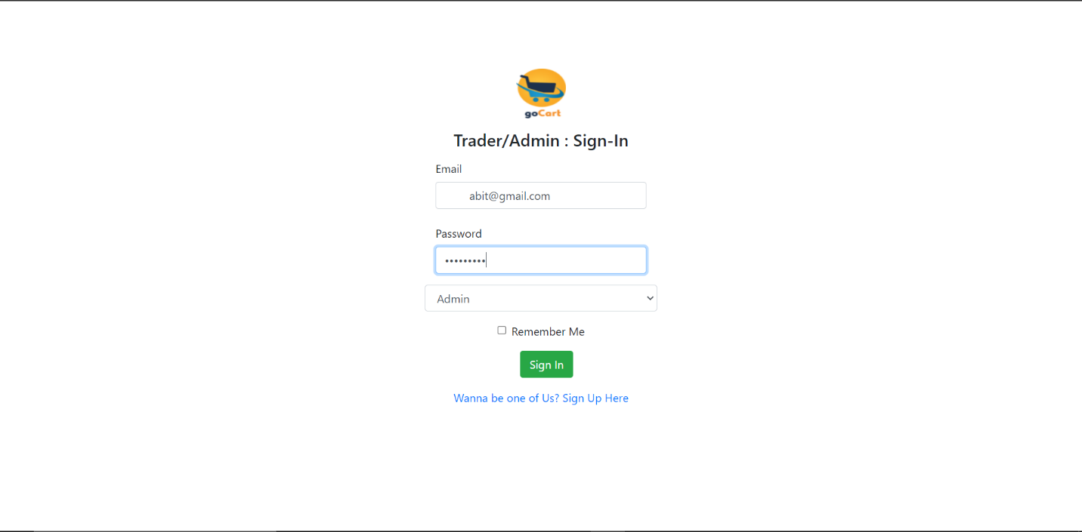

Invalid Sign In:

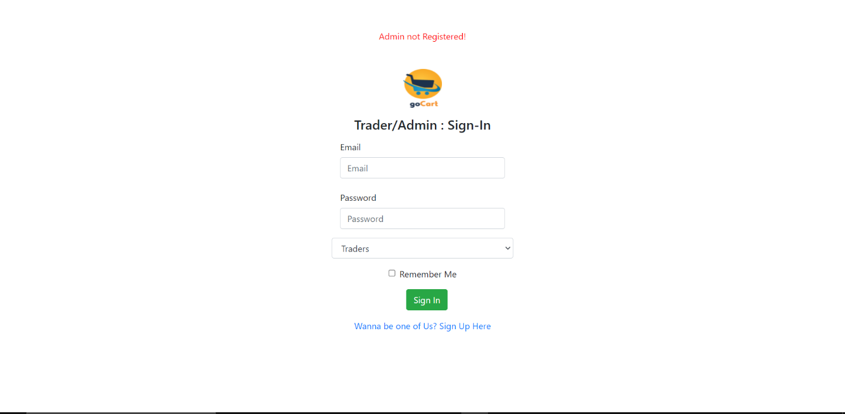

Admin Redirecting to Dashboard:

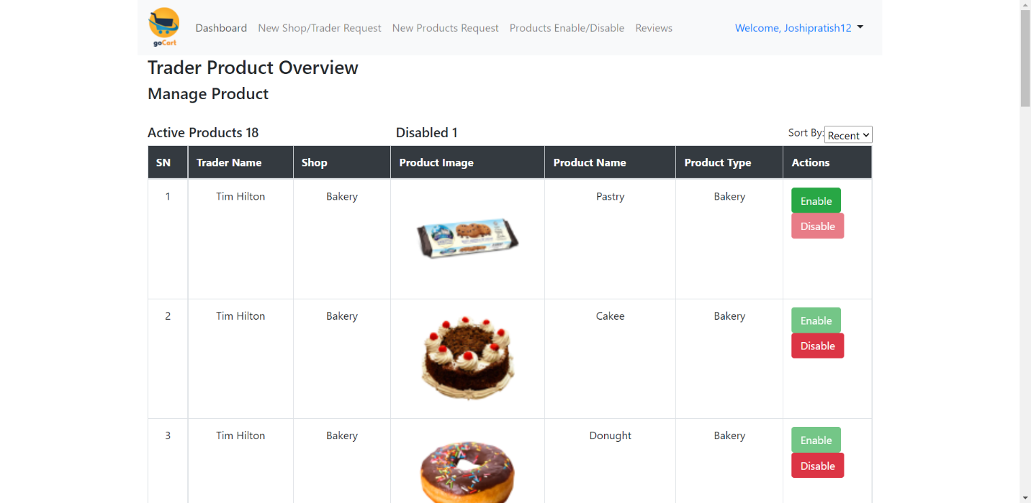

Approving Trader:

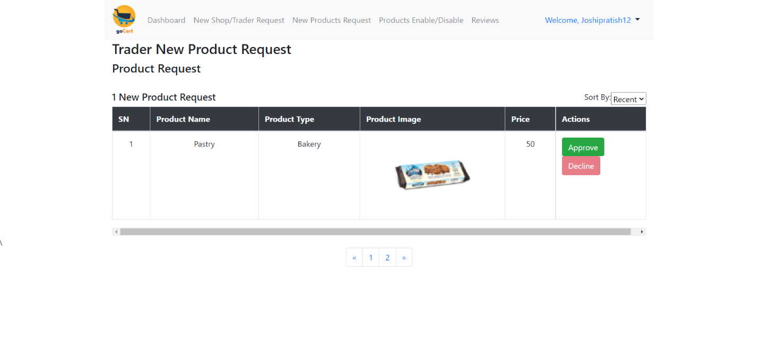

Manage Products:

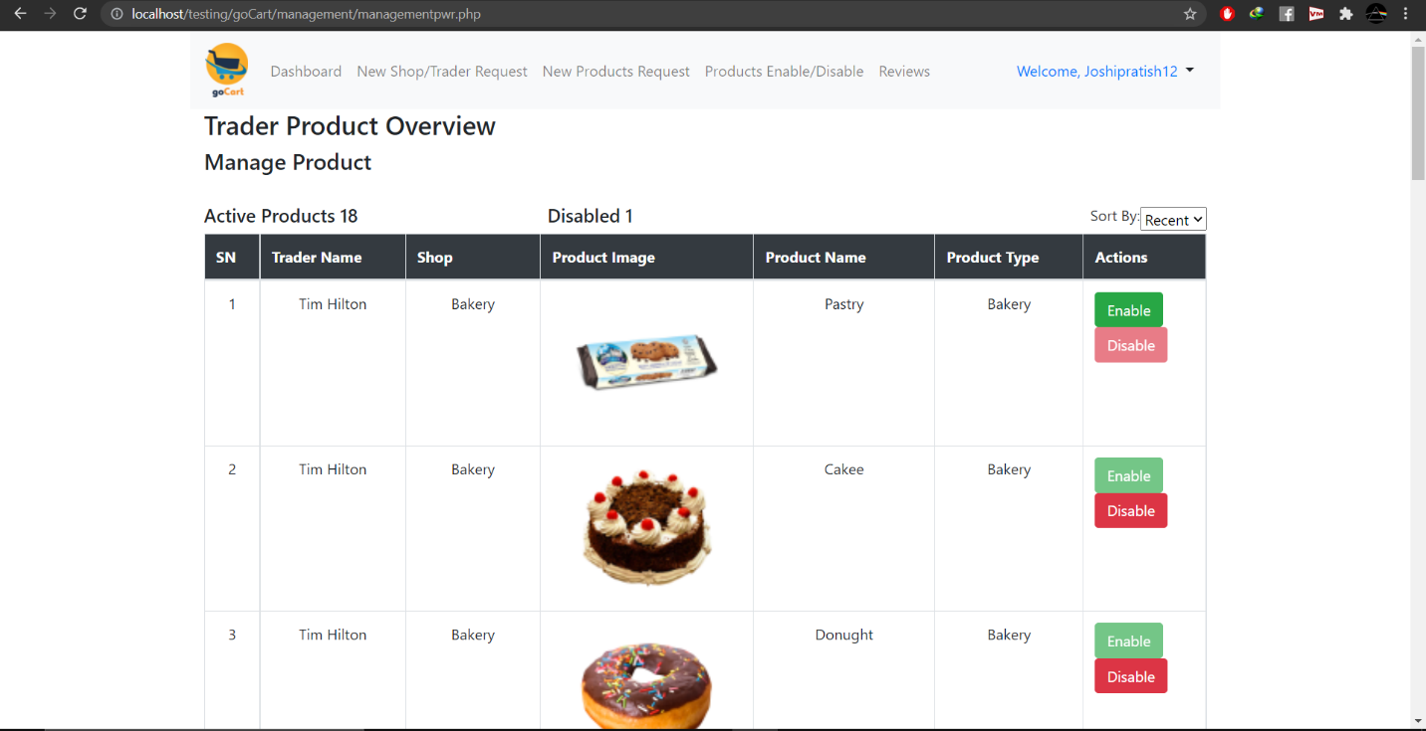

Reviews:

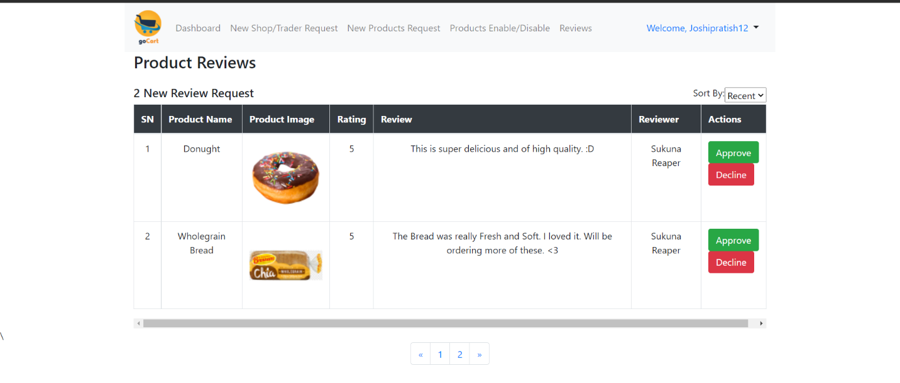

### Evaluation:

|  |  |  |  |
| --- | --- | --- | --- |
| **Description** | **Step** | **Expected Result** | **Pass/Fail** |
| Login |  |  |  |
|  | Login page | User is directed to the login page | Pass |
|  | login with wrong information | Invalid credentials are displayed. | Pass |
|  | Register with correct information | Redirected to Admin dashboard | Pass |
|  |  |  |  |
|  |  |  |  |
| Add Category |  |  |  |
|  | Add category picture | Picture add | Pass |
|  | add Category title | title added | Pass |
|  | add category description | Description added | pass |
| Approve Trader |  |  |  |
|  | Go to manage new trader and press approve button | Trader Approved | Pass |
|  |  |  |  |
|  |  |  |  |
| View category |  |  |  |
|  | Click on All categories | all Categories shown | Pass |
|  |  |  |  |
|  |  |  |  |
| Edit category | Click edit category | Category edited | Pass |

ADMIN DASHBOARD (ORACLE):

Invalid Login Credentials:

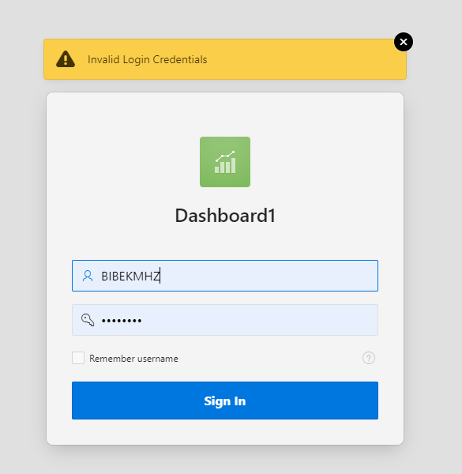

Correct Login Credentials:

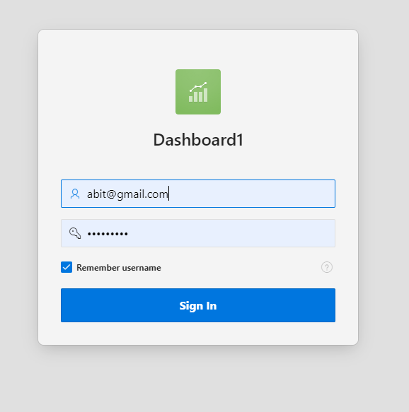

Dashboard:

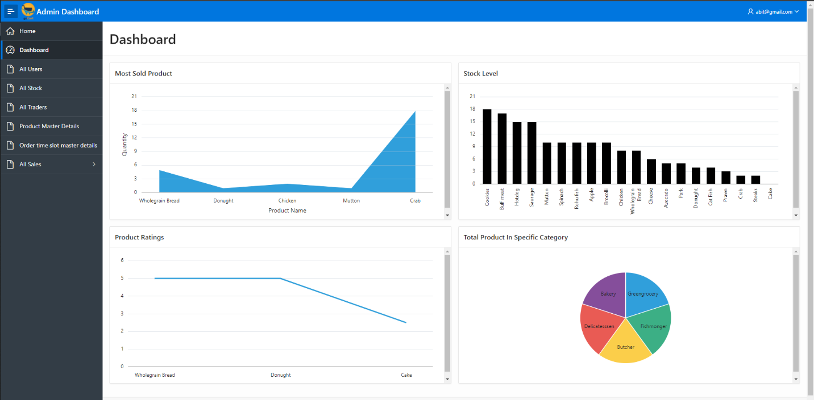

### Evaluation:

|  |  |  |  |
| --- | --- | --- | --- |
| **Description** | **Step** | **Expected Result** | **Pass/Fail** |
| Login |  |  |  |
|  | Login with wrong information | An error message of invalid login credentials is shown and asks the user to wait 5 seconds before trying to log in again. | Pass |
|  | Login with valid credentials | User is directed towarda admin dashboard | Pass |